

**SMT201 Geographic Information Systems for Urban Planning**

**AY2022/2023 Term 1**

**G2 Team 7 Project**

* A detailed discussion of the GIS analysis process and functions used.
* A comprehensive discussion of the analysis results.
* A collection of analytical maps (can be statics or interactive web maps)

**Table Of Contents:**

**Relevant Links:** **2**

**1. Overview** **3**

**2. Locations of Schools** **4**

2.1 Primary School 4

2.2 Secondary School 4

2.3 Post-Sec School 5

**3. Change in Accessibility Over Time** **5**

3.1 Primary Schools 6

3.2 Secondary Schools 11

3.3 Post-Secondary Schools 18

**4. Impacts of School Mergers** **22**

**5. Transport Analysis** **22**

**6. Web Maps** **23**

**7. Limitations** **23**

**8. Step-by-Step Guide** **24**

7.1 Data Extraction 24

7.1.1 Extracting the SG boundary 24

7.1.2 Extracting all schools from the 2019 merger onwards 27

7.1.3 Extracting all schools from 2018 36

7.1.4 Extracting schools which locations are no longer in use 38

7.1.4 Extracting road network layer. 40

7.2 Data Preparation 42

7.2.1 Separating schools into their education levels 42

7.2.2 Separating roads according to education levels 47

7.2.2.1 Primary School Road Network 47

7.2.2.2 Secondary and Post-secondary Road Network 50

7.3 Preparing Maps for Analysis 53

7.3.1 Creating a hexagonal grid with centroids for Singapore 53

7.3.2 Network accessibility analysis 59

7.3.3 Creating a changes map 65

7.3.4 Symbolization of schools 70

7.4 Creating Printed Map Layouts 76

8 Additional: **76**

# *Relevant Links:*

Github: <https://github.com/ShuYing0506/GISProject>

Setting up Netlify: <https://app.netlify.com/sites/smtgroup7/settings/domain>

Netlify: <https://smt201group7.netlify.app/>

Slack workspace: <https://smt201group7.slack.com>

# **1. Overview**

The theme that our group has chosen is Theme 2: ‘Geography of Accessibility with GIS-based Network Analysis’ and we decided to focus on Sub-Theme 1: ‘Impact of Closures or Mergers of Education Institutions on Equity of Access’. Reasons for this choice can be found in our meeting minutes.

The purpose of this project is to find out the impact of merging education institutions on the equity of access by people. After extensive research, we decided to compare Years 2018 (before 2019 mergers), 2019 (representing schools currently existing) and 2024 (after future mergers). Future mergers refer to all mergers announced on 7 Apr 2021 ([MOE, 2021](https://www.moe.gov.sg/news/press-releases/20210407-school-mergerschool-mergers.ashx?la=en&hash=F52BA582E438A9320B252F070762E621B059B854)). Between 2019 and 2022, there were no mergers that occurred, possibly due to the outbreak of the COVID-19 pandemic.

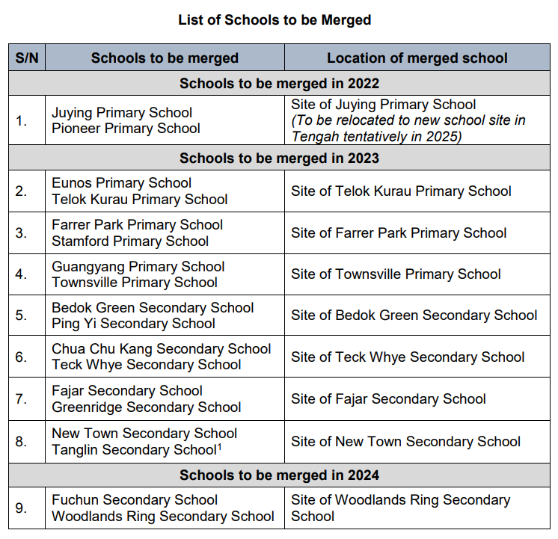

*Figure 1*

# 

# **2. Locations of Schools**

## *2.1 Primary School*

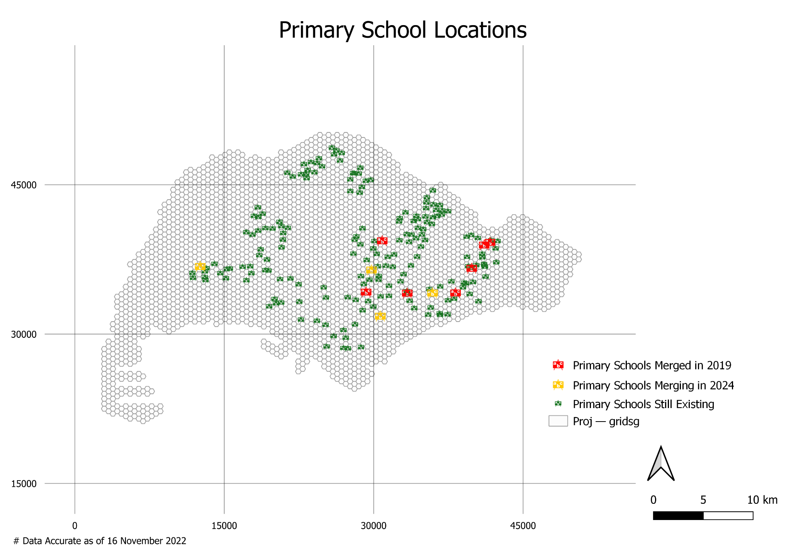

## *2.2 Secondary School*

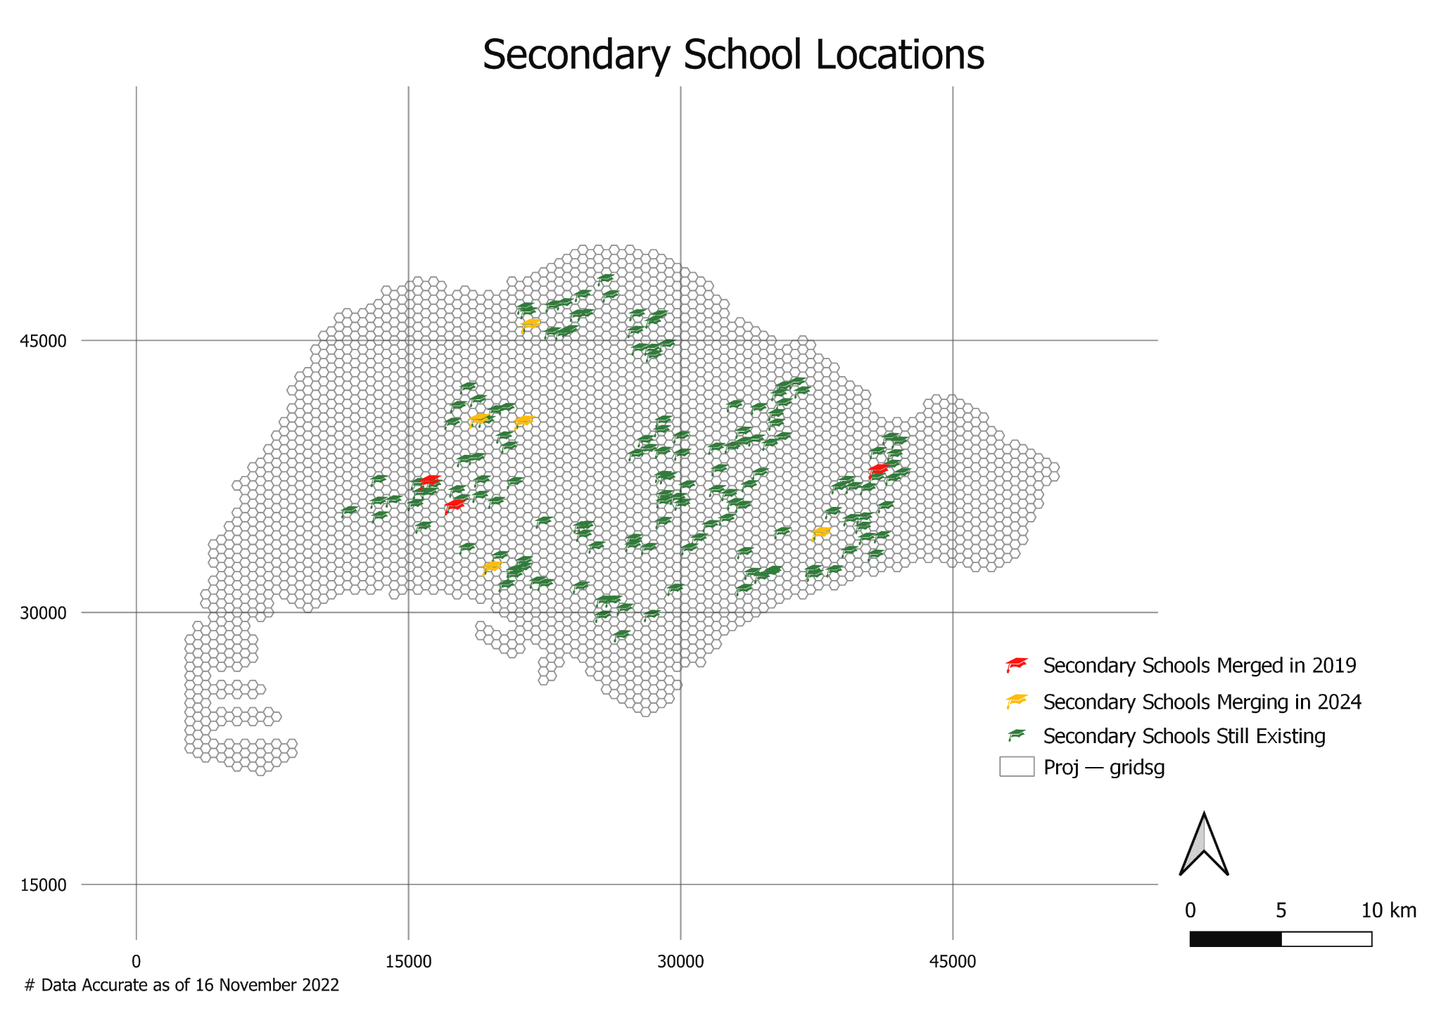

## *2.3 Post-Sec School*

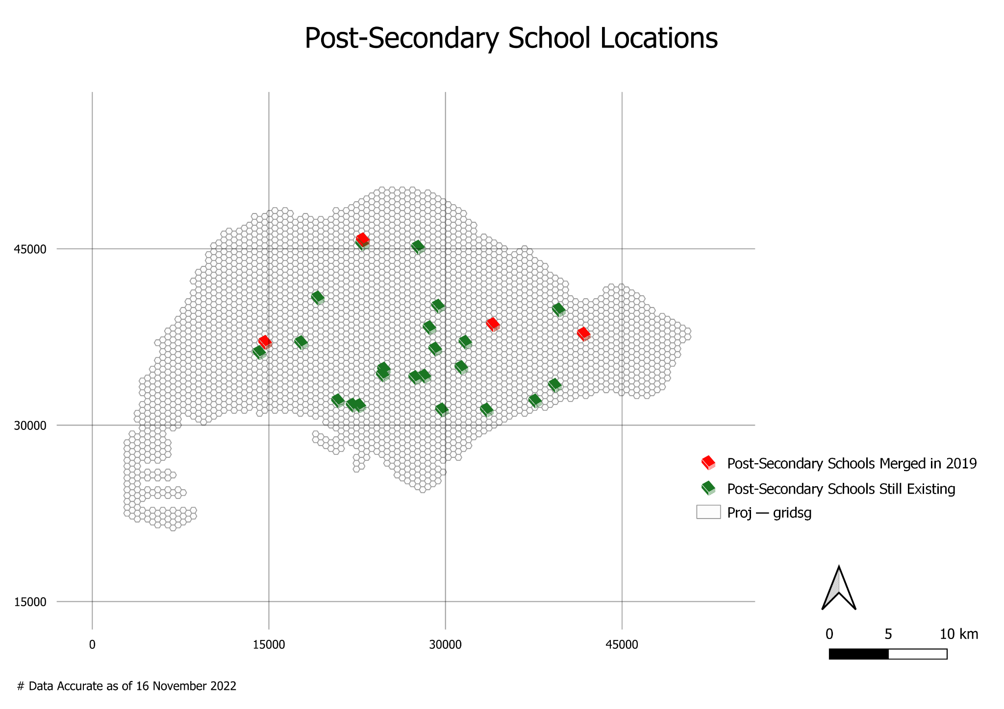

The locations of the schools currently existing are represented by green icons, schools that have merged in 2019 are represented by red icons and the schools that are merging in the future years are represented by yellow icons.

For Post-Secondary Schools, there have not been any announced future mergers as of November 2021, hence our data and analysis include only mergers that occurred in 2019 and currently existing institutions.

These locations have been provided as separate from the accessibility maps to be discussed later to avoid confusion and allow greater clarity on them.

# **3. Change in Accessibility Over Time**

The accessibility maps were created using hexagon grids as they can tessellate to cover an entire area with an evenly spaced grid and have a low sampling bias due to its low perimeter-to-area ratio. The mode used for classification is Natural Breaks (Jenks) as it finds natural groupings of the data, and units for the legends is metres.

## *3.1 Primary Schools*

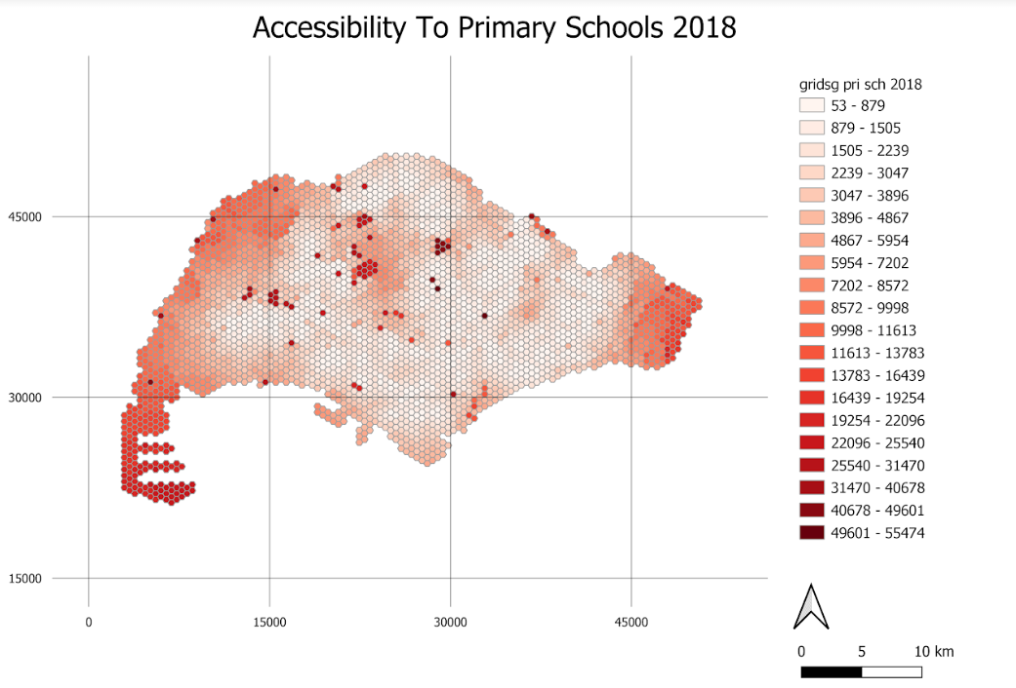

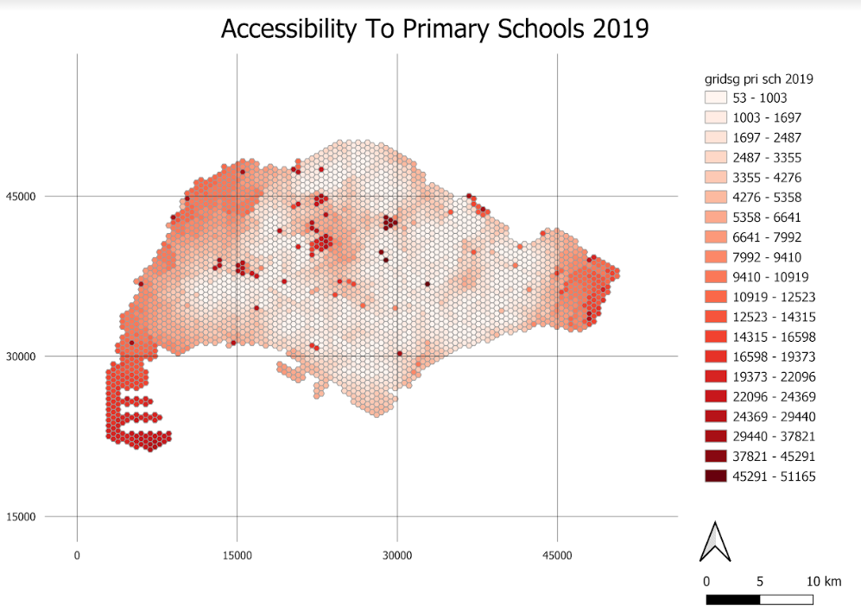

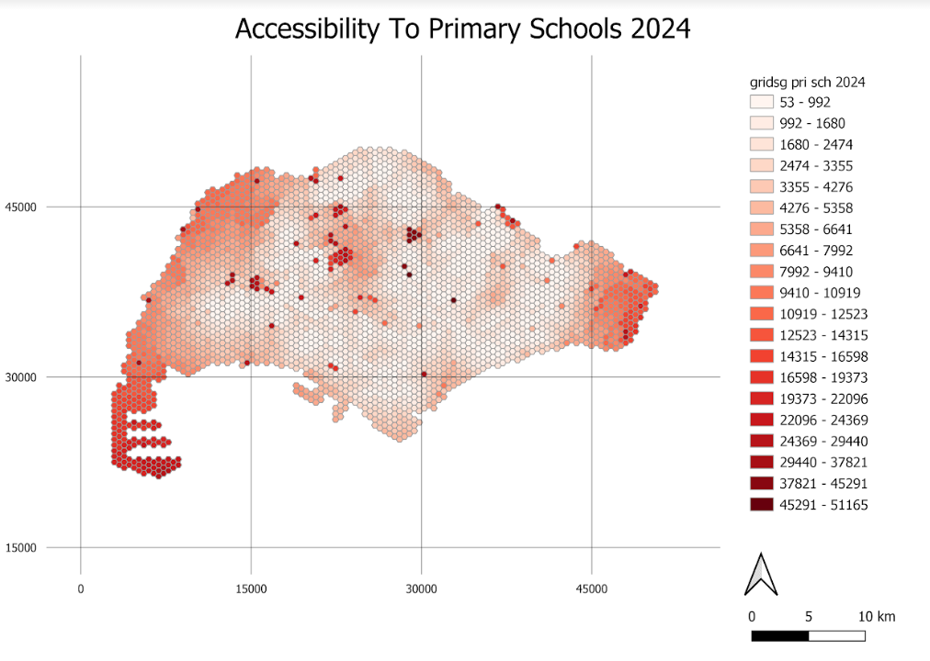

The maps created show the distribution of access in Singapore to primary schools. Overall, it appears that the shortest distance to a primary school increases towards the edges of Singapore, but is also high in the middle of the map, where various catchment areas and nature reserves reside. This owes to the fact that roads are not present or readily available in these areas and can reduce its accessibility to a school.

It should also be noted that some hexagons have a shortest distance value of over, which is likely due to errors such as orphaned roads and the nearest road that travels one way only to a dead end. These arose in the data preparation stage, since only paths deemed ‘walkable’ were used. They could carry forward in subsequent maps and should be disregarded.

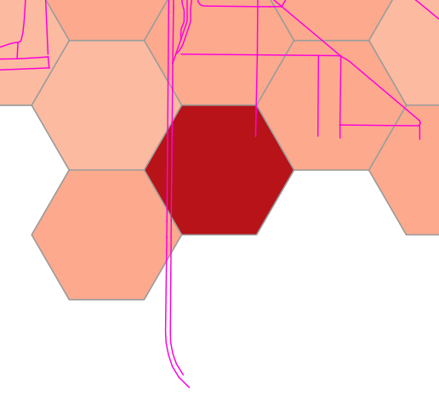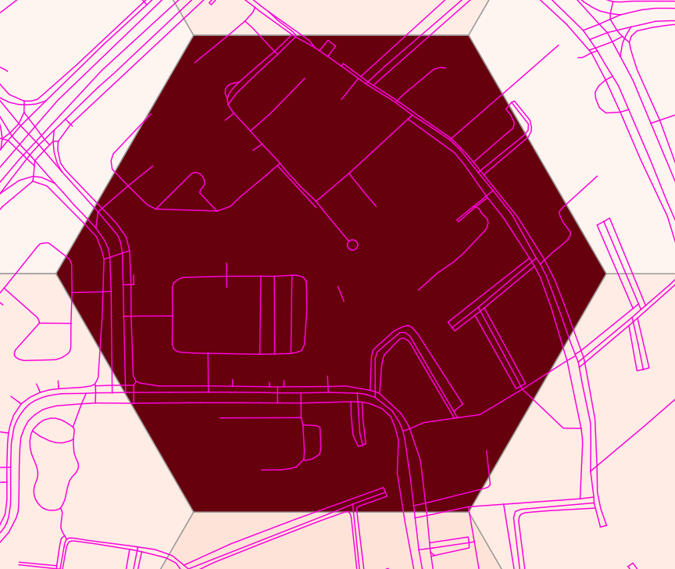

Figure 1: Examples of Errors

The differences between the maps over time are not obvious in these maps as the changes were not drastic. Some areas may experience an increase in shortest distance to a school but the change may not be big enough to warrant a shift in class. Hence, we created maps to showcase the differences between 2 different time periods.

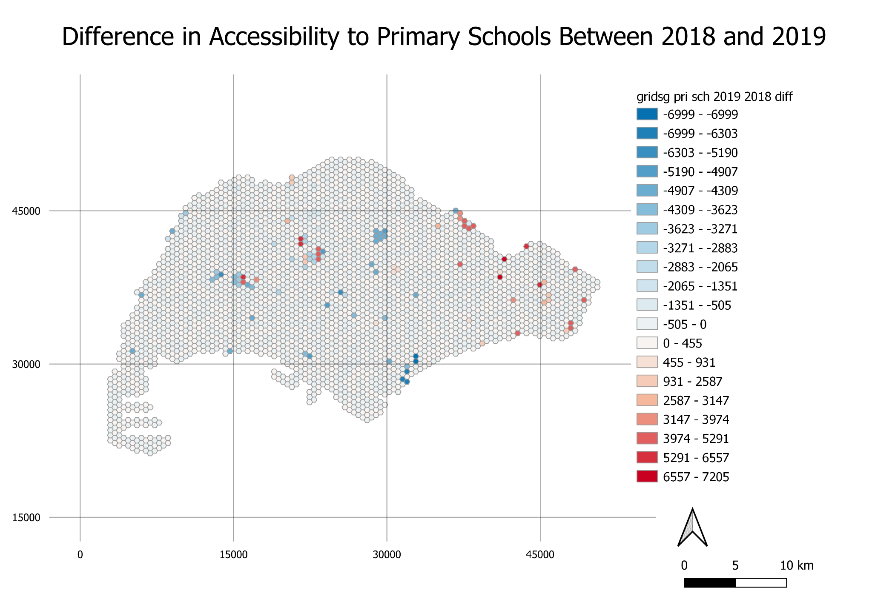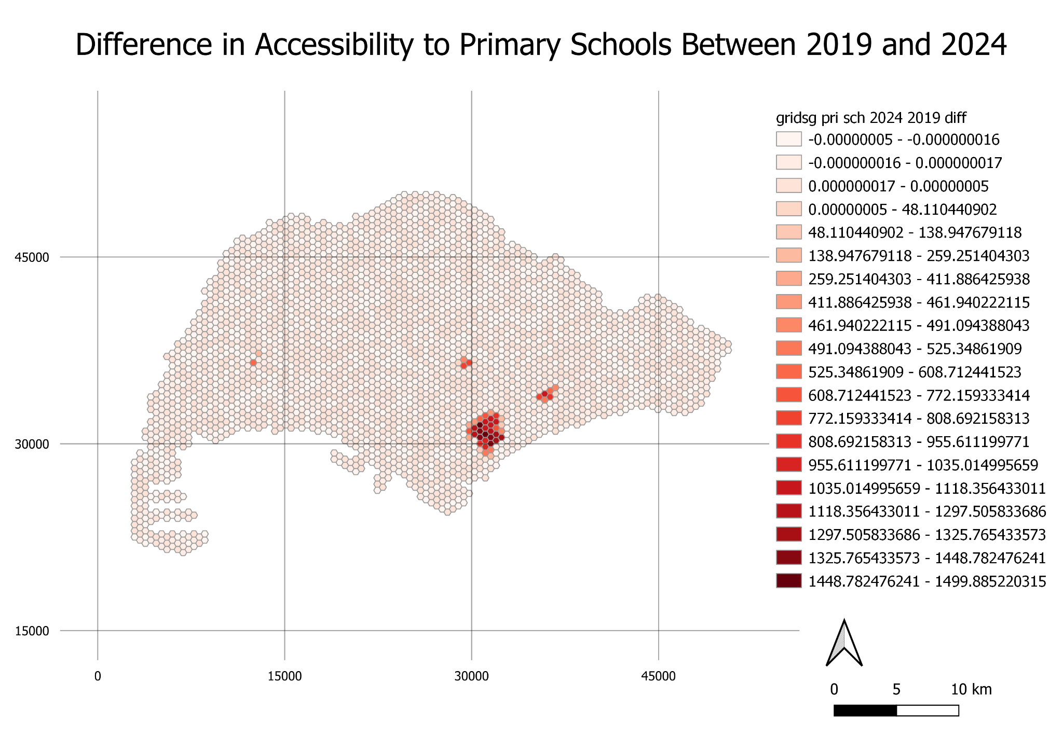

From these maps, it is clear that for the most part of Singapore, there was not much change in shortest distance to a school and increases in distance are concentrated in areas where a school closed down due to a merger.

For the difference in accessibility between 2018 and 2019, there appears to be no particular pattern in change of shortest distance to a school when comparing the map to locations of primary school mergers in 2019 (Figure 1). Random changes in the shortest distances to a school could be due to errors in data collection or preparation.

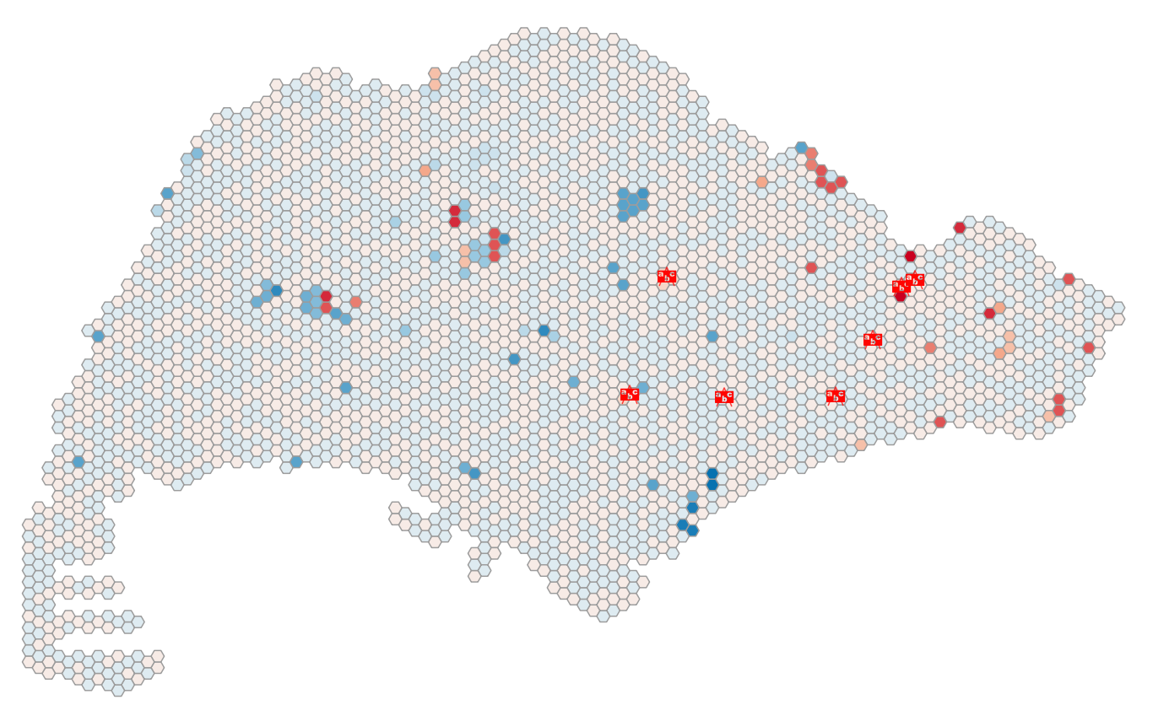

*Figure 2: Difference in Accessibility of Primary Schools between 2018 and 2019, with locations of schools that closed due to 2019 mergers*

Between 2019 and 2024, there appears to be specific areas affected by the school closures. When compared to the locations of schools that will be closing due to future mergers (yellow icons), the clusters appear to correlate (Figure 2).

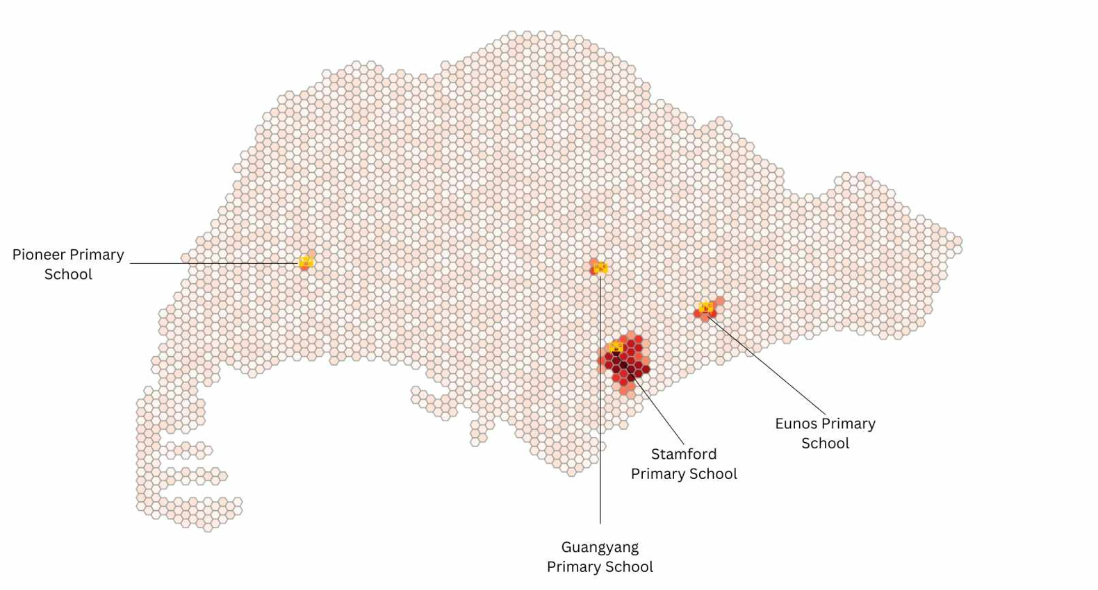

Figure 3: *Difference in Accessibility of Primary Schools between 2019 and 2024, with locations of schools that will close due to future mergers*

From figure 3, it can also be seen that the closure of Stamford Primary School will have a disproportionately higher impact on the area surrounding it as compared to the other schools. This could be because there are no other schools located in that area so people staying in that area would have to travel further to reach a school.

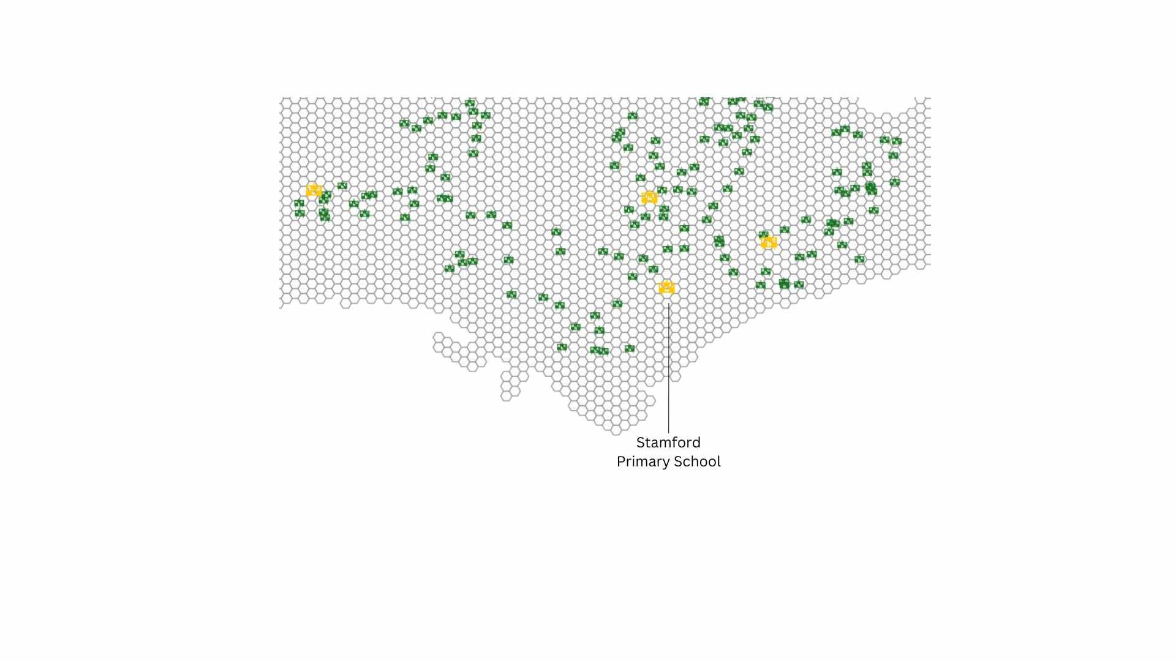

*Figure 4: Zoom in to Primary School Locations*

When analysed alongside the residential buildings (blue polygons) in the area surrounding the school, it can be observed that the impact of the closure of Stamford Primary School is not as great as the accessibility map implies.

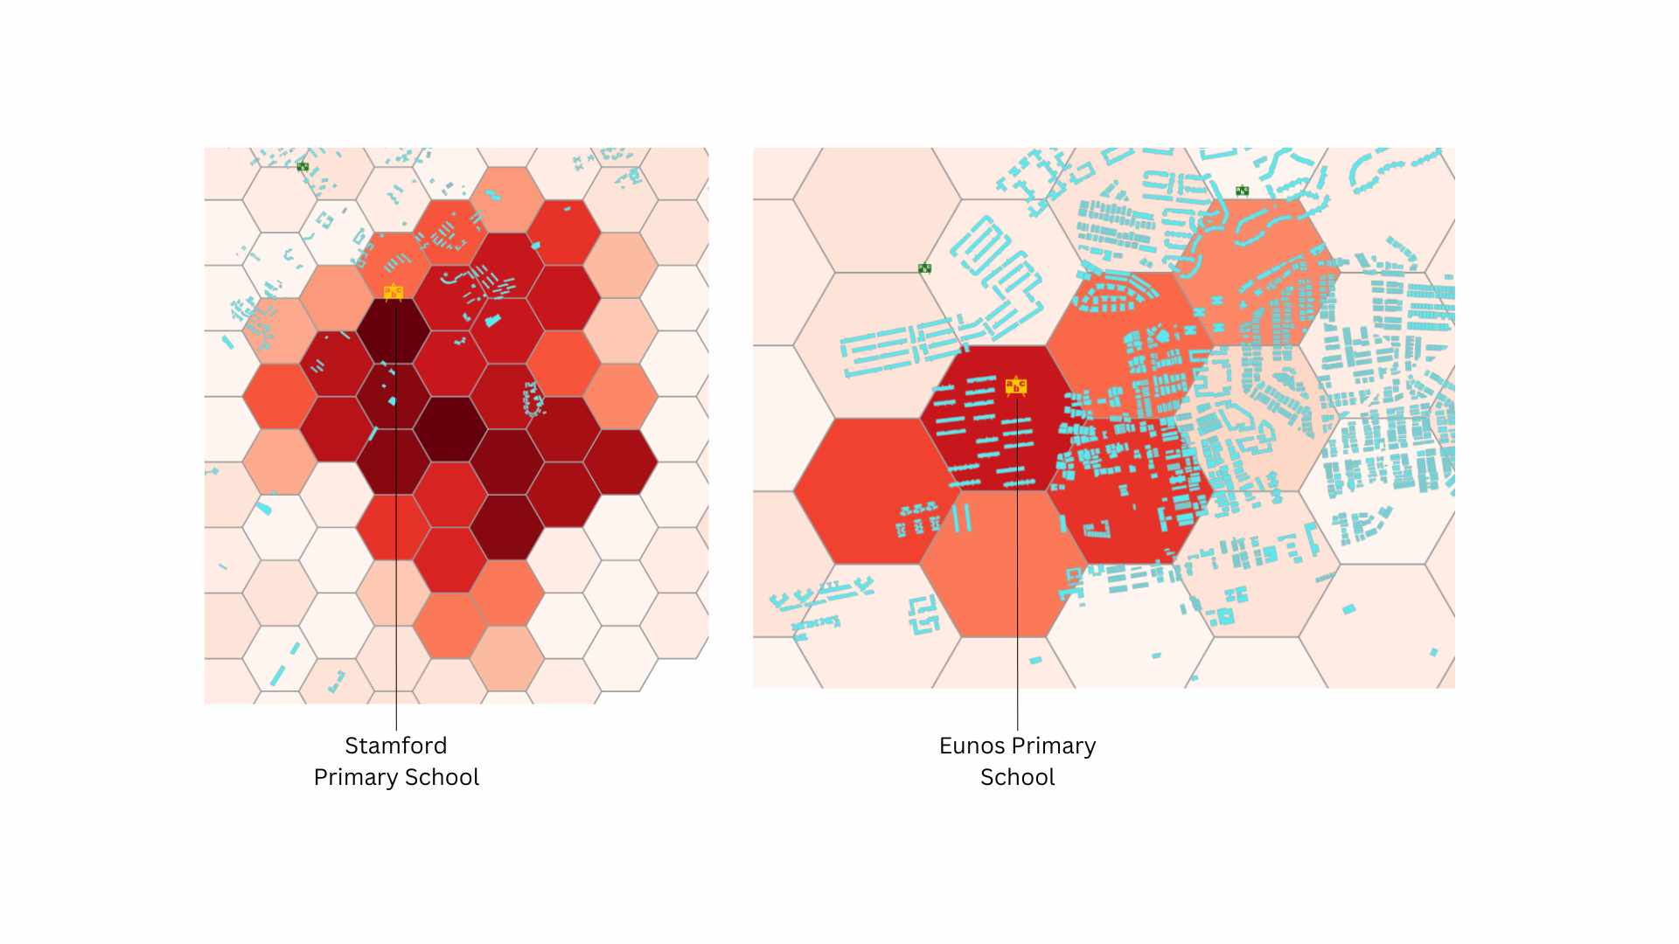

*Figure 5: Comparison between Stamford and Eunos Primary School*

Residential buildings located in the area affected by the closure of Stamford Primary School are sparse and far less in number as compared to that in the area affected by the closure of Eunos Primary School. Hence, it is pertinent to analyse our accessibility maps alongside the locations of residential buildings to get a clearer picture of the impact of school closures on the area.

## *3.2 Secondary Schools*

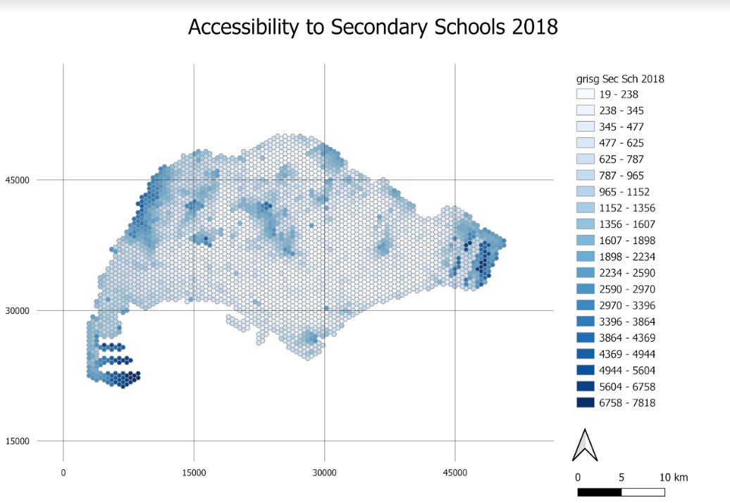

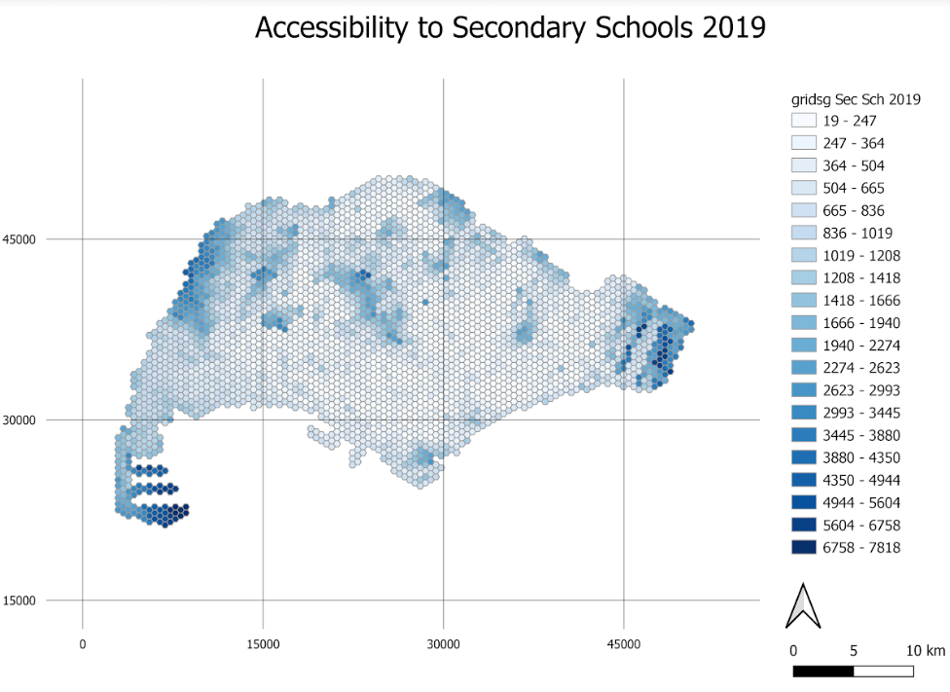

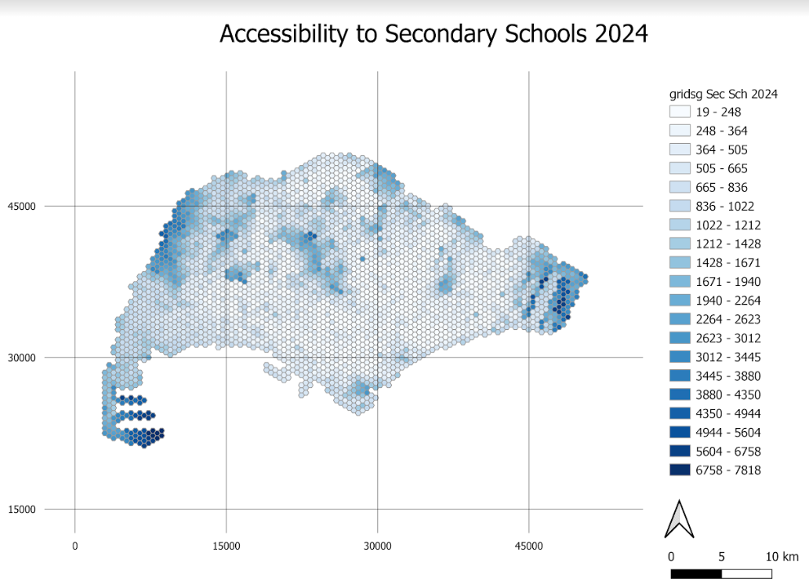

The maps created show the distribution of access in Singapore to secondary schools. Similar to the primary schools, overall, it appears that the shortest distance to a secondary school increases towards the edges of Singapore, but is also high in the middle of the map, where various catchment areas and nature reserves reside.

Errors in this dataset are less prevalent, as can be seen in the legend going up to only 7818 metres. This is because all road networks were used, with the exception of bridleways, so it is unlikely for orphaned roads and dead ends to occur. It should also be noted that the road networks included railways to better represent the transport network students use to get to school (Mass Rapid Transport).

The differences between the maps over time are not obvious in these maps as the changes were not drastic. Some areas may experience an increase in shortest distance to a school but the change may not be big enough to warrant a shift in class. Hence, we created maps to showcase the differences between 2 different time periods.

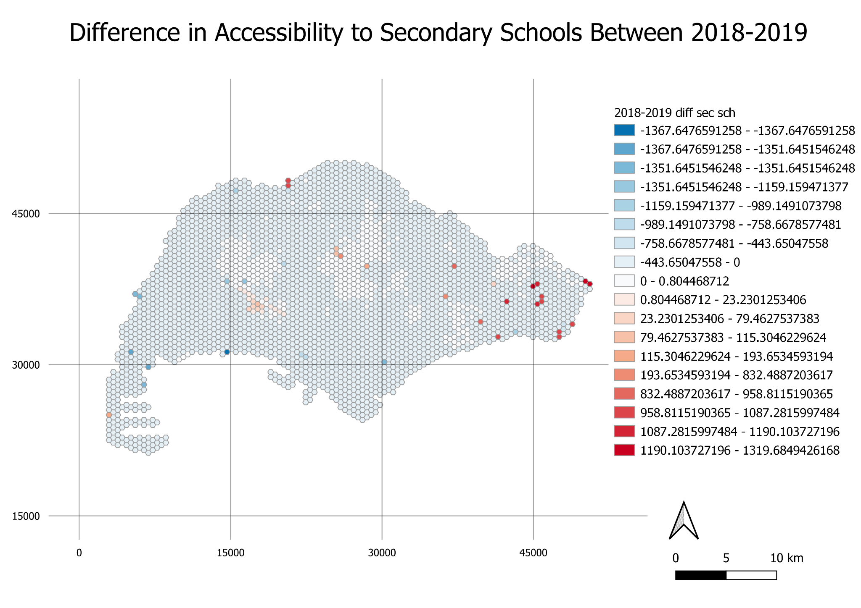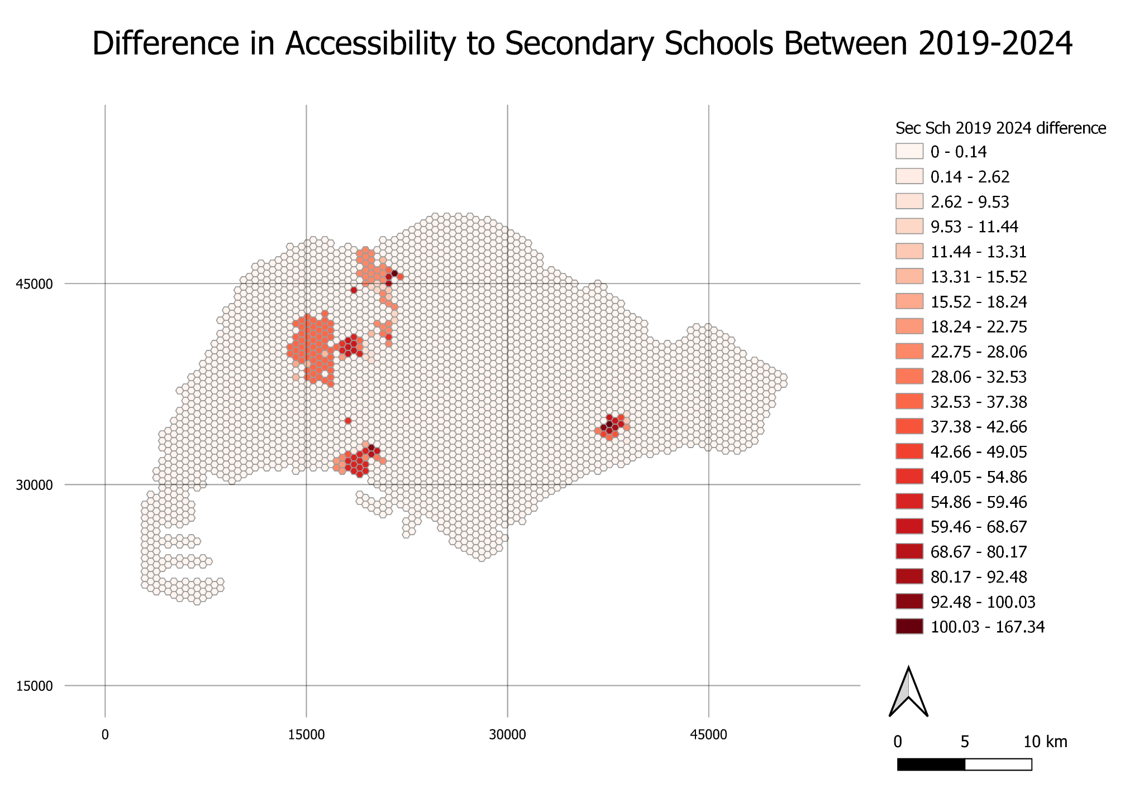

From these maps, it is clear that for the most part of Singapore, there was not much change in shortest distance to a school and increases in distance are concentrated in areas where a school closed down due to a merger.

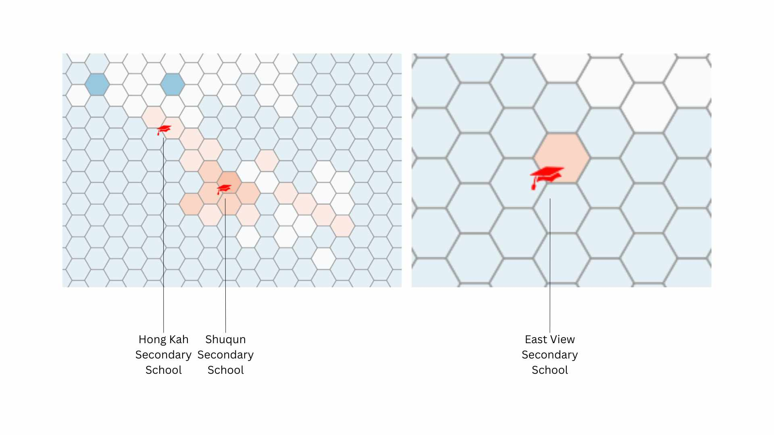

*Figure 6: Difference in Accessibility of Secondary Schools between 2018 and 2019, with locations of schools that closed due to 2019 mergers*

For the difference in accessibility between 2018 and 2019, it appears that the impact of the closures of the schools due to mergers is not that high on the area surrounding it. The increase in the shortest distance to a school ranges from 10 to 120 metres. The close ups also imply that the closures of Hong Kah and Shuqun Secondary Schools have an impact on a wider area than that of East View Secondary School.

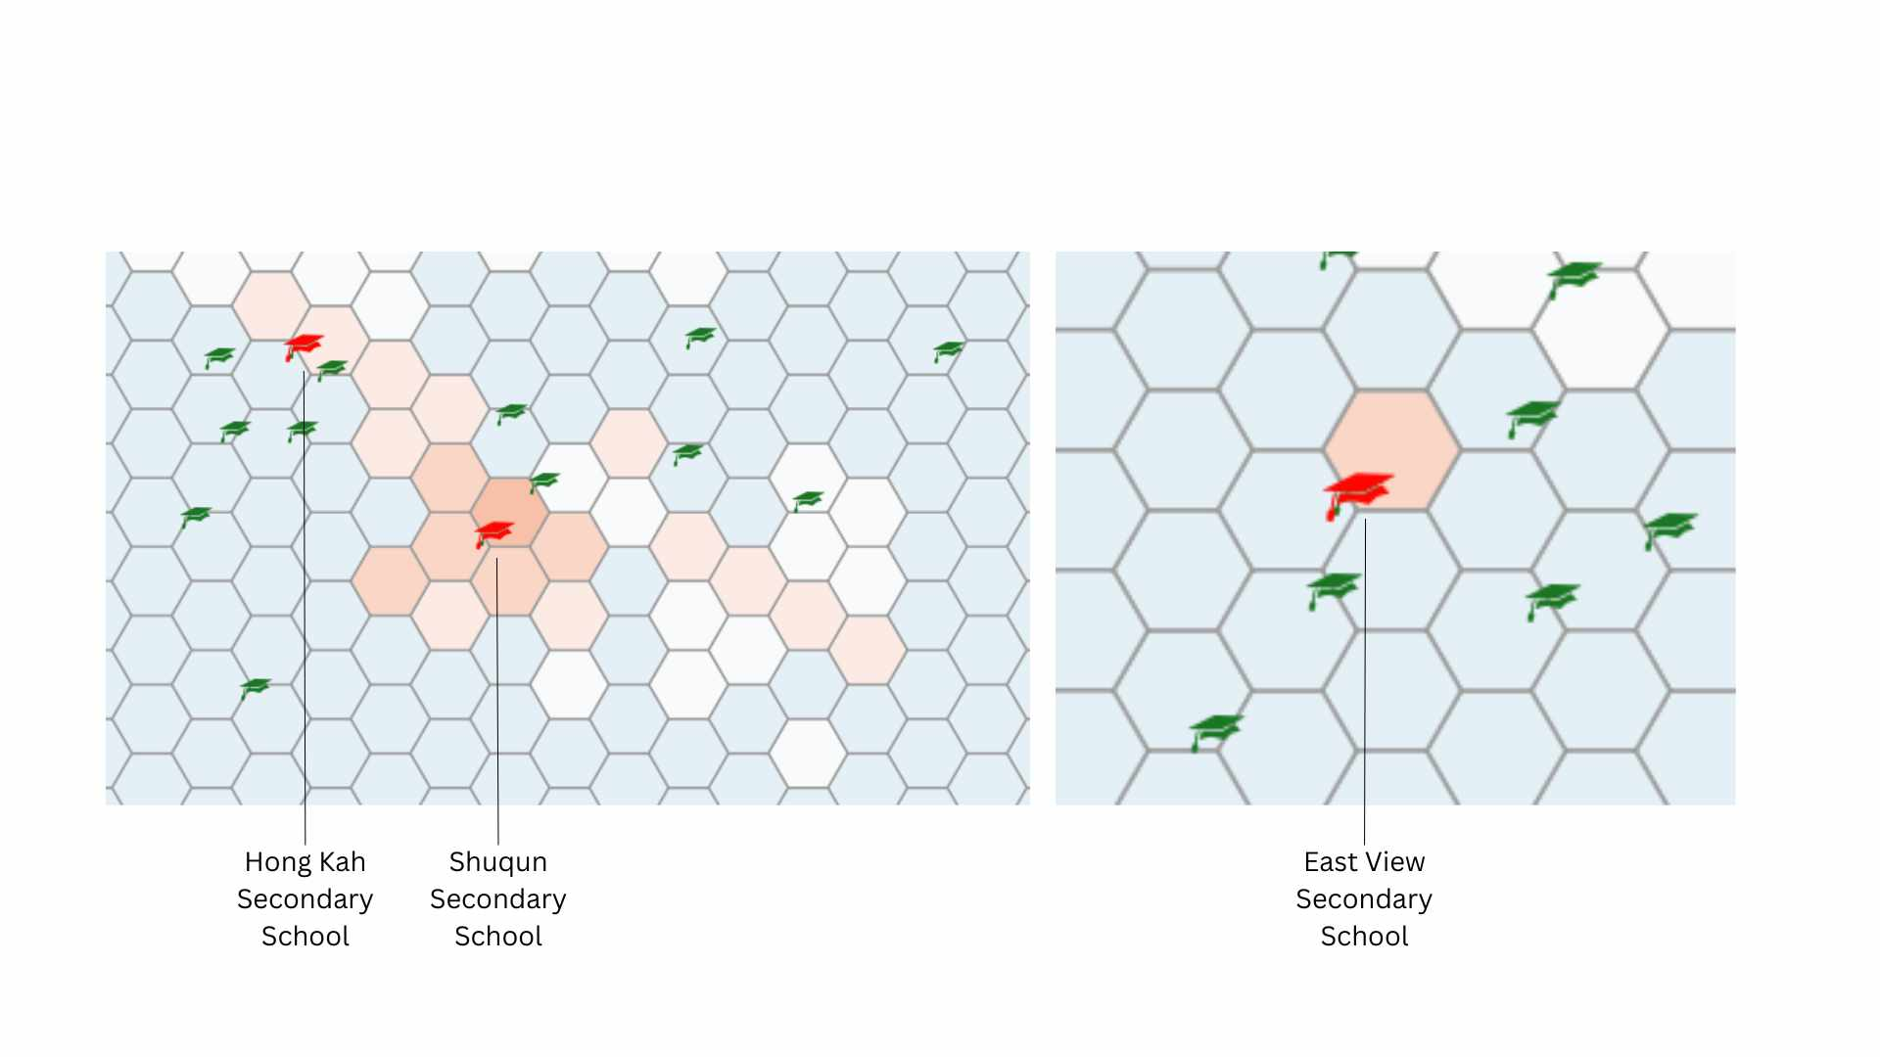

*Figure 7: Zoom in to Secondary School Locations*

On further analysis with the schools currently surrounding the merged schools, it appears that the abundance of secondary schools surrounding East View Secondary School could have mitigated the impact of the merger with regards to the way we calculated it. For the merger of Shuqun Secondary School, the areas on its bottom right could have had a different school as its nearest school via the road network used and were thus ‘not affected’ by the closure of Shuqun Secondary School.

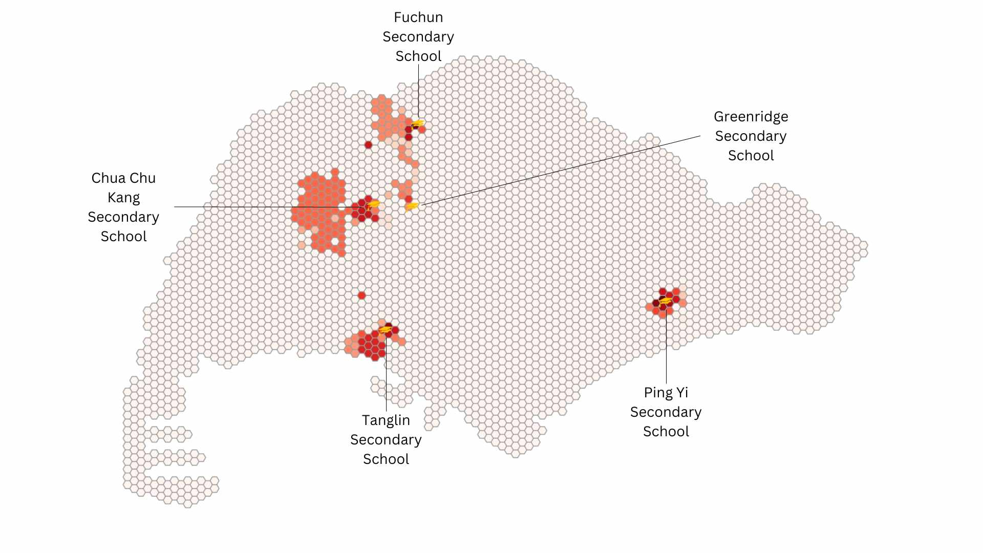

Figure 8: *Difference in Accessibility of Secondary Schools between 2019 and 2024, with locations of schools that will close due to future mergers*

At a glance, the areas around the schools to be closed will experience an increase in the shortest distance to a school. This could be because there are no other schools located in that area so people staying in that area would have to travel further to reach a school. From figure 8, it seems that the closure of Chua Chu Kang Secondary School will have an impact on the largest area around it as compared to the other schools, and hence have the greatest impact.

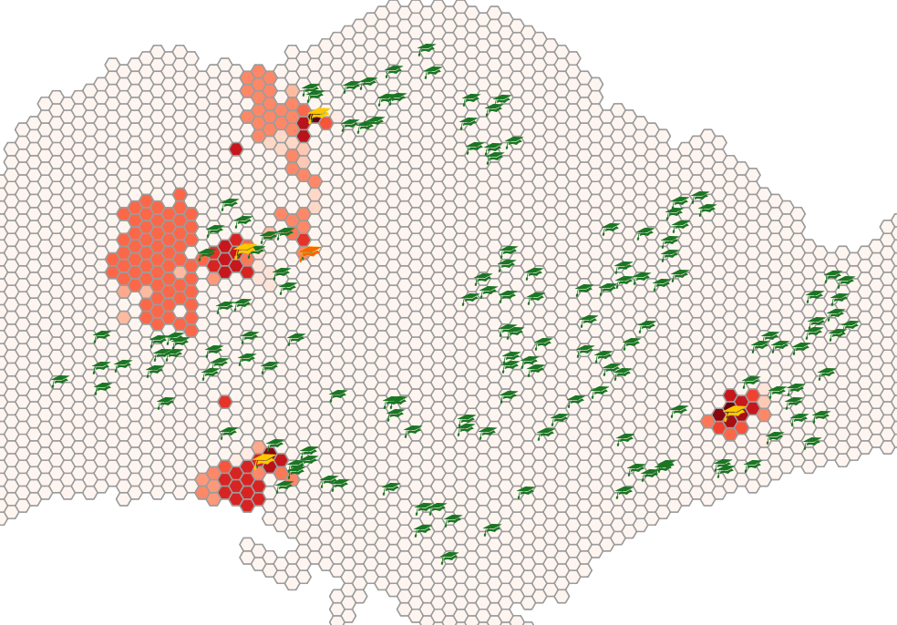

*Figure 9: Zoom in to Secondary School Locations*

When analysed alongside the residential buildings (blue polygons) in the area surrounding the school, however, it can be observed that the impact of the closure of Chua Chu Kang Secondary School is not as great as the accessibility map implies.

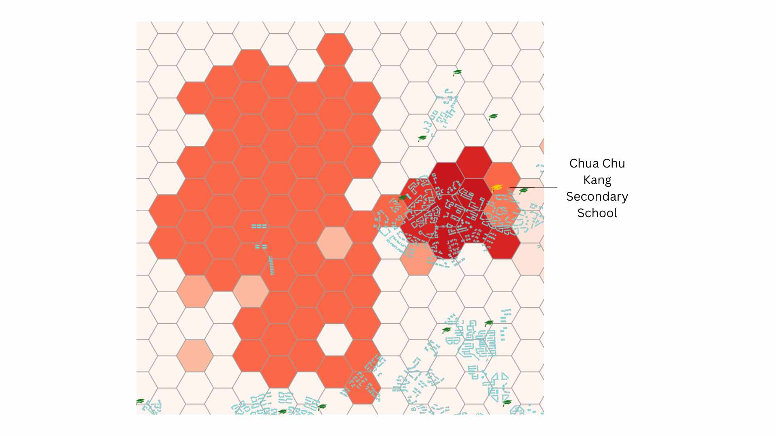

*Figure 10: Homes Located in the Area Affected by Closure of Chua Chu Kang Secondary School*

The huge area affected by Chua Chu Kang on the left side of figure 10 contains only a few houses affected by the closure.

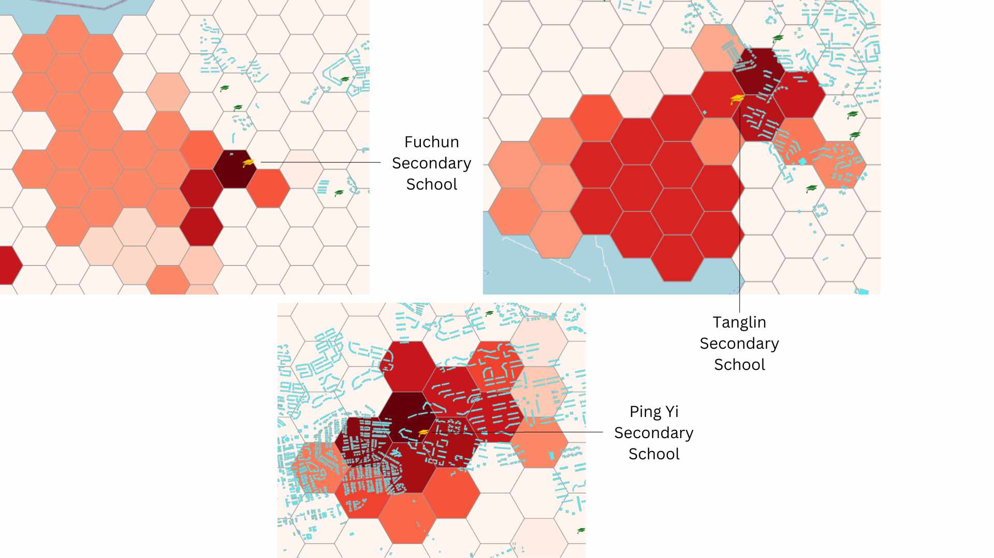

*Figure 11: Homes Located in the Area Affected by Closure of Various Secondary Schools*

After analysing figure 11, though it seems to affect the smallest area, the closure of Ping Yi Secondary School is projected to affect the **most** number of residential buildings as there is a great number of them located within the area affected.

## *3.3 Post-Secondary Schools*

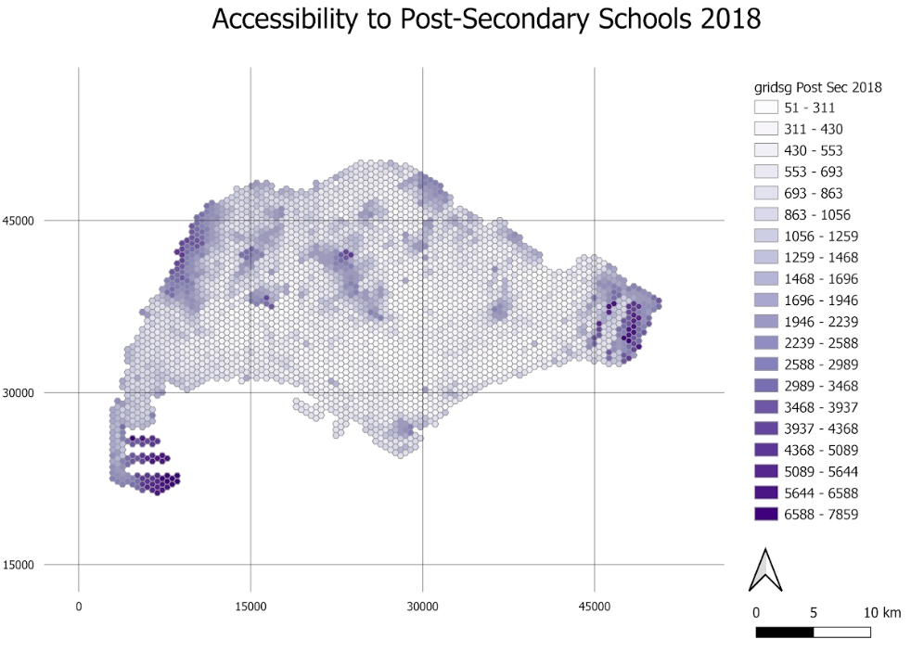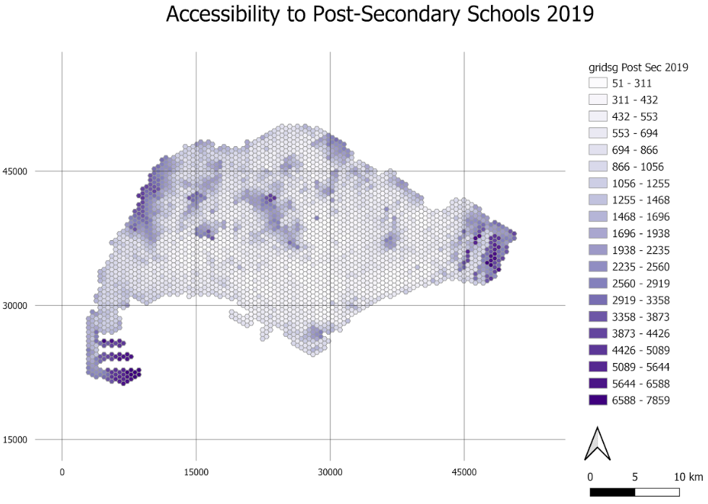

The maps created show the distribution of access in Singapore to post-secondary schools. Similar to the primary and secondary schools, overall, it appears that the shortest distance to a secondary school increases towards the edges of Singapore, but is also high in the middle of the map, where various catchment areas and nature reserves reside.

Similar to that of secondary schools, errors in this dataset are less prevalent, as can be seen in the legend going up to only 7859 metres. This is because all road networks were used, with the exception of bridleways, so it is unlikely for orphaned roads and dead ends to occur. It should also be noted that the road networks included railways to better represent the transport network students use to get to school (Mass Rapid Transport).

The differences between the maps over time are not obvious in these maps as the changes were not drastic. Some areas may experience an increase in shortest distance to a school but the change may not be big enough to warrant a shift in class. Hence, we created maps to showcase the differences between 2 different time periods.

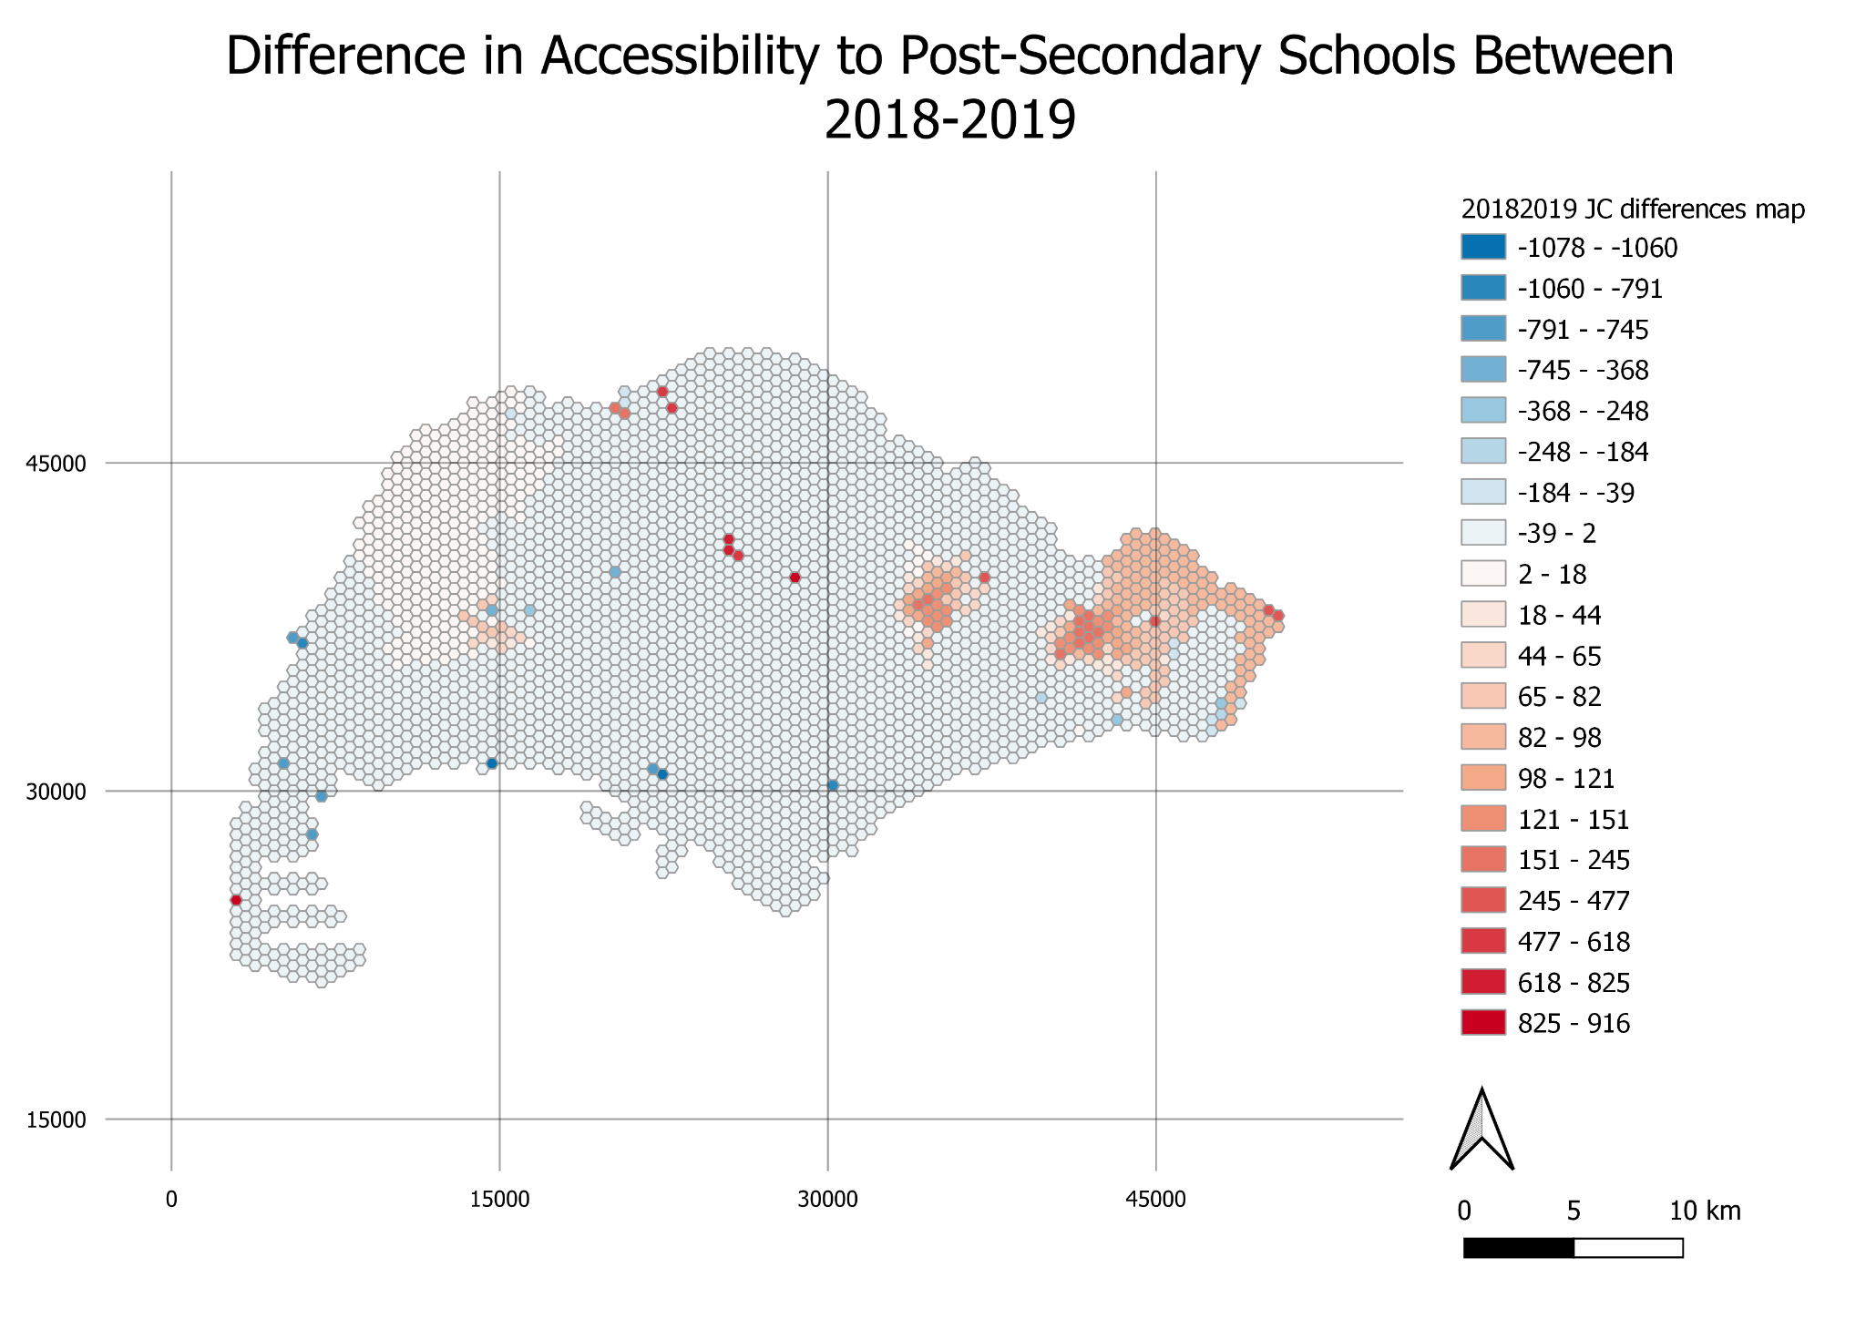

From this map, it is clear that for the most part of Singapore, there was not much change in shortest distance to a school and increases in distance are concentrated in areas where a school closed down due to a merger.

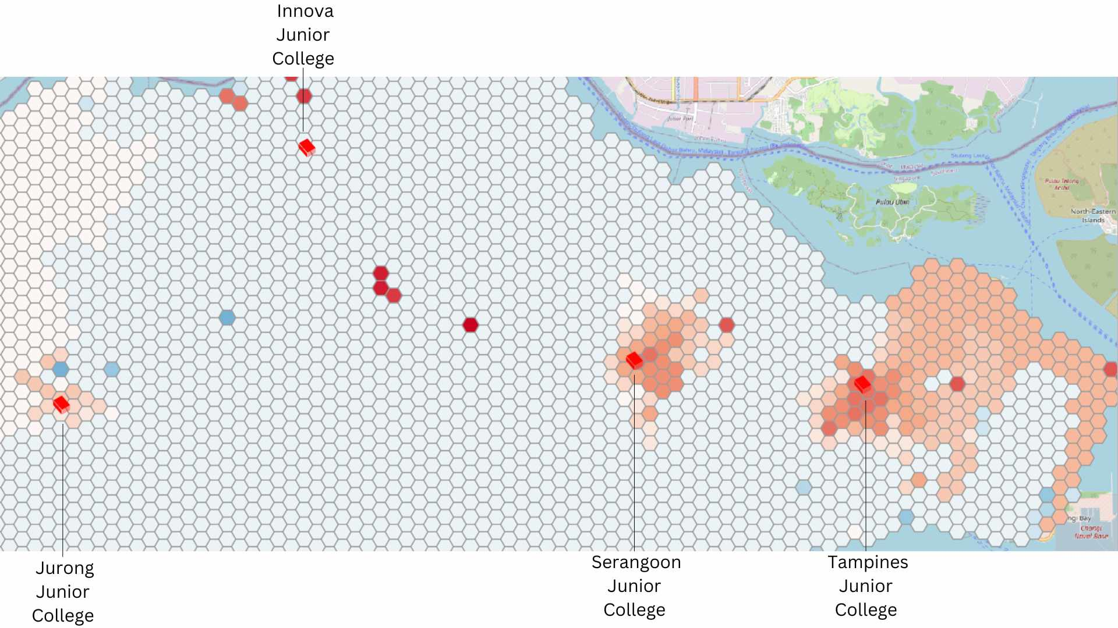

*Figure 12:Difference in Accessibility of Post-Secondary Schools between 2018 and 2019, with locations of schools that closed due to 2019 mergers*

As before, we should look into reasons for the varying differences caused by the closures of these schools. The closure of Tampines Junior College seems to affect the largest area as seen from figure 12, while the closure of Innova Junior College appears to have had no effect on the area around it.

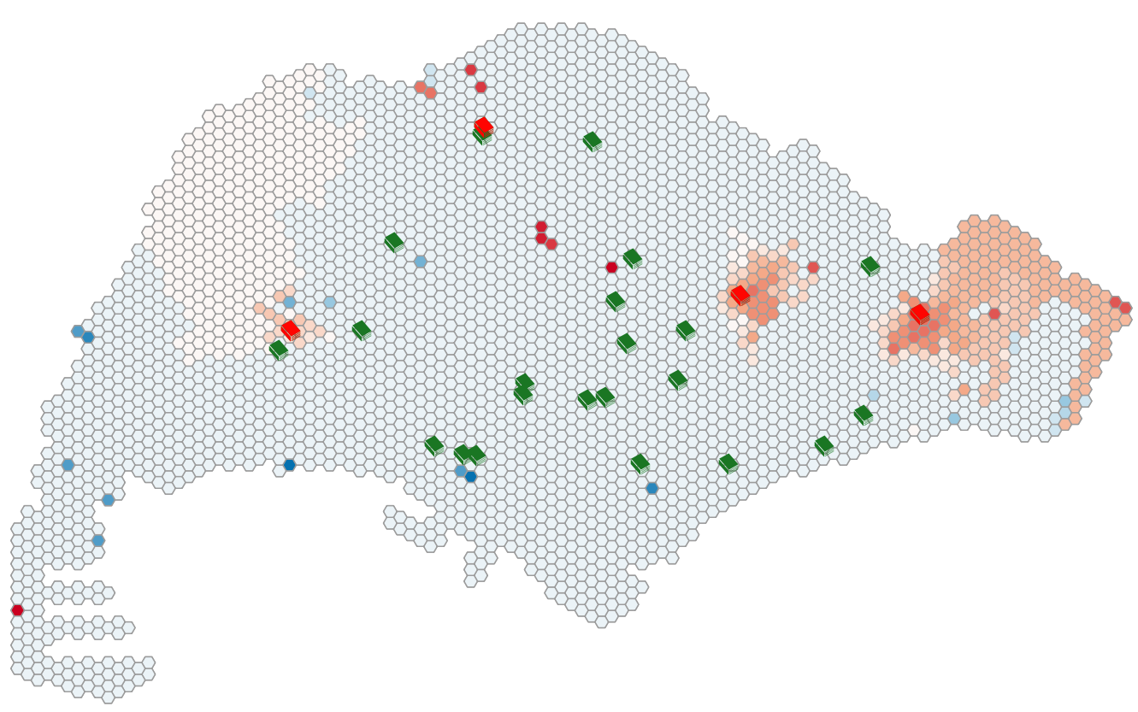

*Figure 13: All Post-Secondary School Locations*

From figure 13, we can infer that it is because Tampines JC is the school located on the easternmost part of Singapore, so it is the nearest school for a large portion of Eastern Singapore. Very near Innova JC is Singapore Sports School which could explain why our map identifies no change in accessibility for the area surrounding Innova JC.

To find out if the closure of Tampines Junior College indeed has the highest impact on Singapore, we should analyse it alongside the locations of residential buildings (blue polygons).

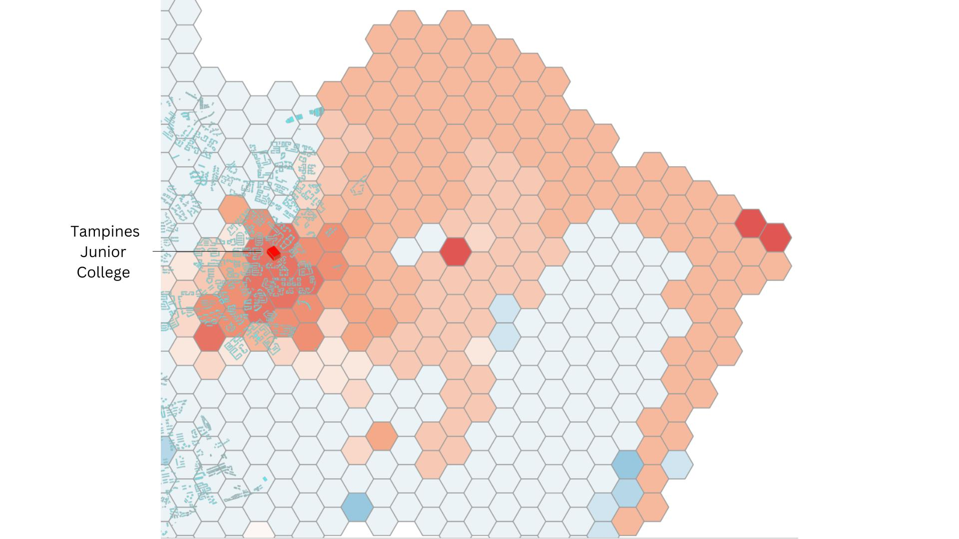

*Figure 14: Homes Located in the Area Affected by Closure of Tampines Junior College*

While its closure definitely affects a good number of homes nearest to it, it is not as large as the area we had seen to be affected. Majority of the area indicated to be affected by the closure does not contain any residential buildings.

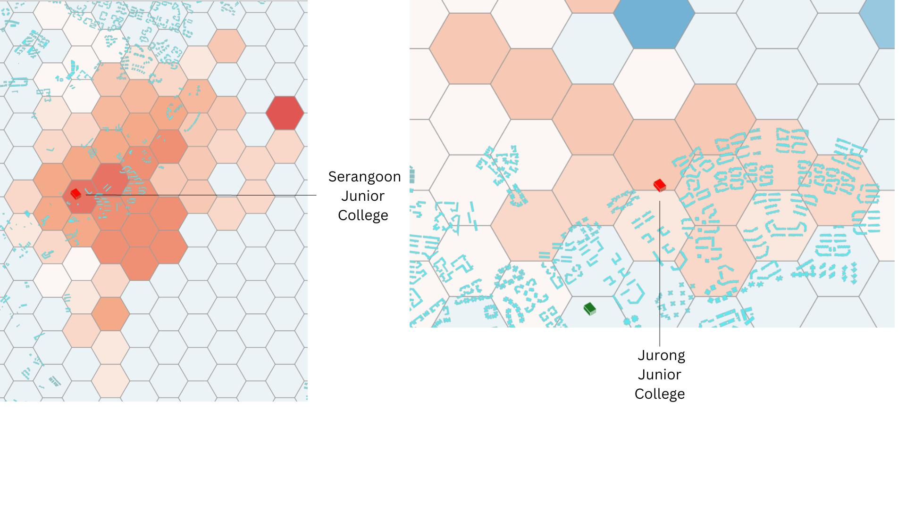

*Figure 15: Homes Located in the Area Affected by Closure of Various Post-Secondary Schools*

After analysing figure 15, it appears that the closure of Tampines Junior College still affects the most number of homes as it has the most residential buildings located in the area affected by its closure. The area is also the most heavily impacted, as the distance to the next nearest Post-Secondary School increased the most as well.

# **4. Impacts of School Mergers**

We know that 9 pairs of schools merging from 2022 to 2024 will cause the accessibility level to decrease drastically and the reasons behind it are caused by falling birth rates and changing demographics in our housing estates.

It is also said by the government (gov.sg) that merging could be beneficial for students as schools with low enrolment find it challenging to offer a wide range of subject combinations, educational programmes and co-curricular activities (CCAs). The mergers will provide schools with the healthy enrolment needed to continue to provide a rich variety of learning programmes and experiences for our students.

# **5. Transport Analysis**

When choosing schools to merge, according to MOE, the site for the merged school is chosen based on quality of infrastructure and accessibility to transport ([Sin, 2017](https://www.straitstimes.com/singapore/education/school-mergers-2019-why-were-the-8-government-jcs-the-ones-selected-for-merger)). To test this, we will analyse the selection of the site of Anderson Junior College over the site of Serangoon Junior College in their mergers to form Anderson Serangoon Junior College.

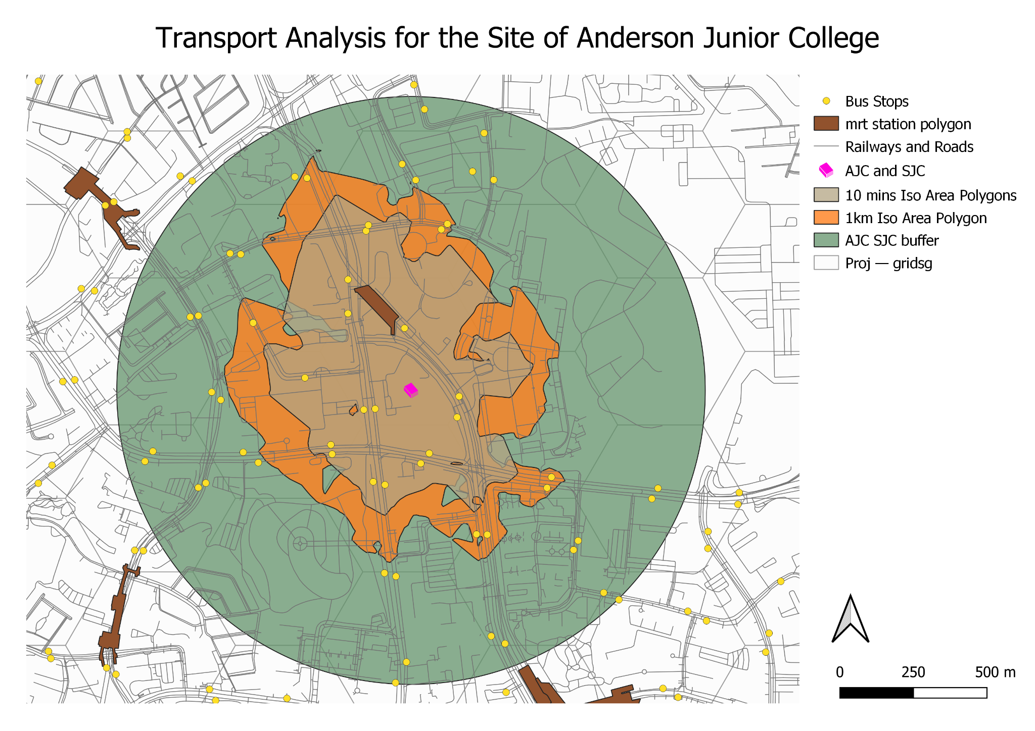

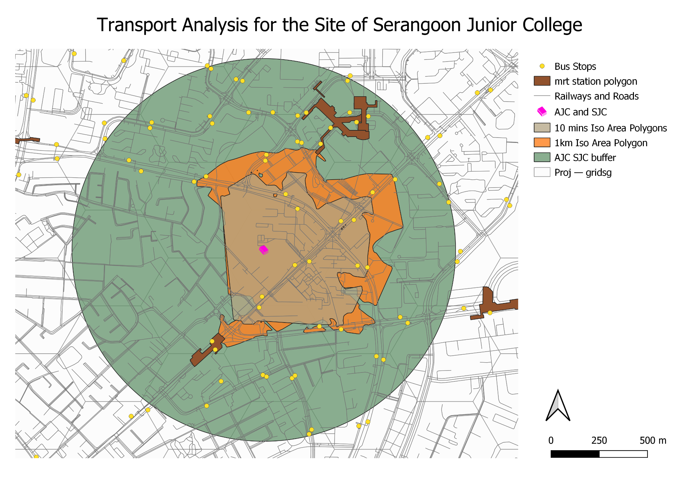

From the print layouts, we can see how many bus stops and MRT Stations are located within walking distance of the junior colleges. Walking distance has been represented with 1 km buffer zones, 1 km Iso-Area Polygons and 10 minutes Iso-Area Polygons.

For the site of Anderson JC, there are 16 bus stops and 1 MRT station – Yio Chu Kang MRT within the smallest catchment area, the 10 minutes Iso-Area Polygons. For Serangoon JC, only 10 bus stops are within the same catchment area type, and two MRT stations – Hougang MRT and Kovan MRT barely touch the borders of the 1 km Iso-Area Polygon. Hence, it is clear that the site of Anderson Junior College should be the site of the merged school Anderson Serangoon Junior College when considering the aspect of access to transport.

# **6. Web Maps**

# **7. Limitations**

Some of the limitations that our groups faced:

* We did not take into account changes in infrastructure/transport over time. Some road networks/mrt stations could be non-existent in 2018. Similarly, more roads/mrt stations could increase accessibility in 2024 that we did not account for
* In actuality, the accessibility of schools cannot be measured using just the shortest distance to a school, but should take into account accessibility to schools of different academic calibres, school fees if applicable and types (art school, sport school).
* We did not account for any schools that may have closed down due to reasons other than mergers, or schools that could close down by 2024.

# **8. Step-by-Step Guide**

In this section, we will walk through the steps taken to obtain the maps and graphics used for the analysis in the previous sections.

## **7.1 Data Extraction**

Firstly, we need to download the data needed and import them into QGIS.

From data.gov.sg, download these files:

* Master Plan 2019 Subzone Boundary (No Sea)
* School Directory and Information

From Geofabrik, download the latest OSM zip file.

### 7.1.1 Extracting the SG boundary

Open a new project in QGIS and change the CRS of the project to EPSG 3414. Click on control+s and save the QGS file as ‘project’.

From the browse panel, double click on the MP19 subzone boundary to add it into QGIS. Your map should look like Figure 1.

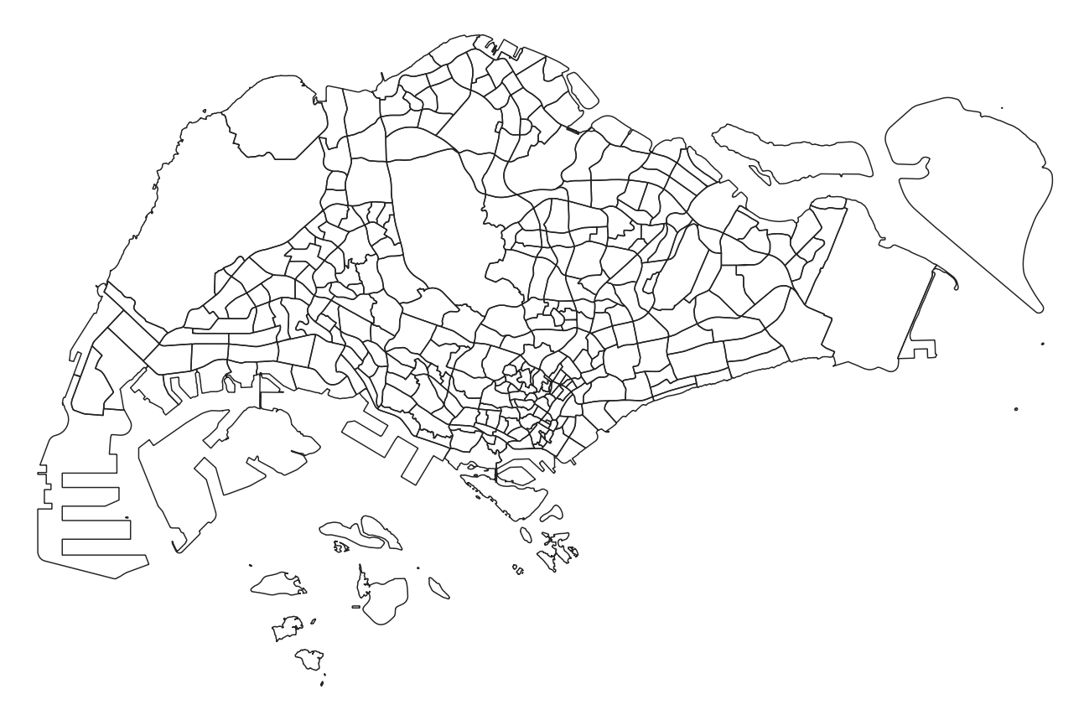

*Figure 1*

We will now remove the islands that are not needed and retain the main island map only. Click on the subzone layer to make it active, and click on the select features icon. Select the islands that we will not be using in this project, as seen in Figure 2.

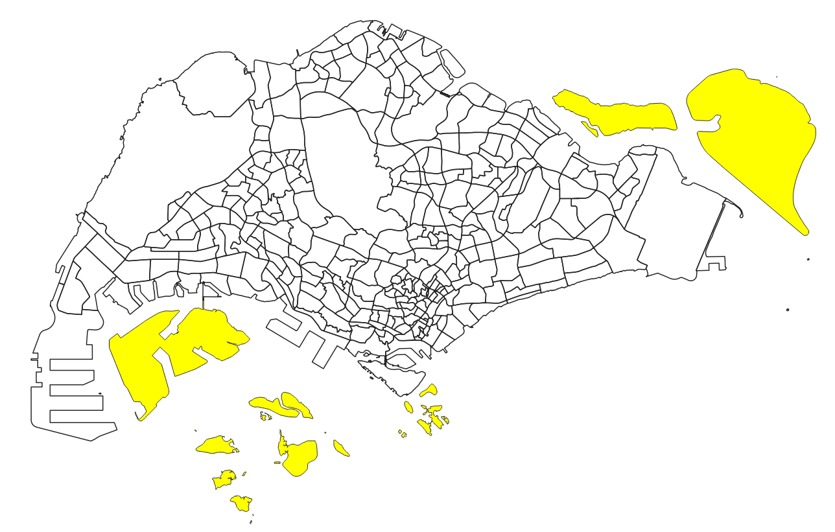

*Figure 2*

Click on the inverse selection button to select the main map instead. . Your screen should look like Figure 3.

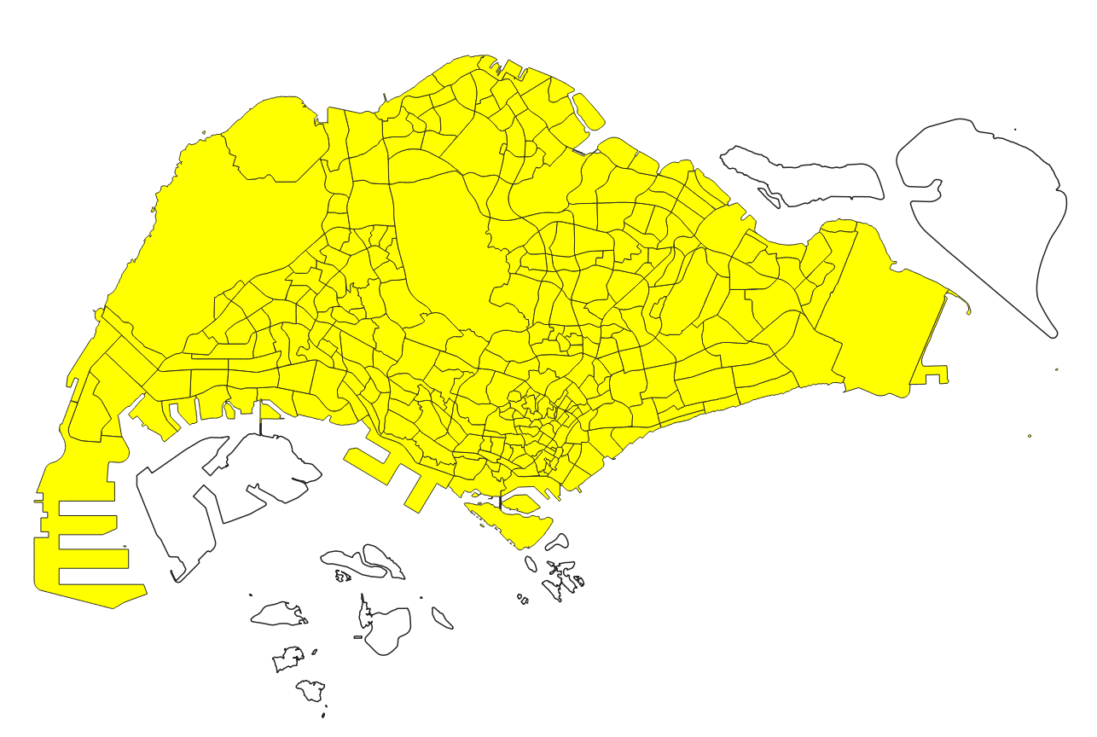

*Figure 3*

Right click on this layer and export the selected features as a geopackage. Name the geopackage as ‘project’ and name this layer as ‘mpsz’. Make sure to set the CRS as EPSG3414 and to tick the checkbox to ‘save selected features only’.

Remove the MP19 subzone layer from QGIS after the geopackage layer has been created.

### 7.1.2 Extracting all schools from the 2019 merger onwards

In the School Directory and Information zip file, open the csv file titled ‘general-information-of-schools’.

Add 2 new columns titled ‘City’ and ‘Country’, and fill in ‘Singapore’ for the entire column. Delete any unnecessary columns as well. You should be left with these columns only:

* School_name
* Address
* Postal_code
* Mainlevel_code
* City
* Country

Your file should look like Figure 4.

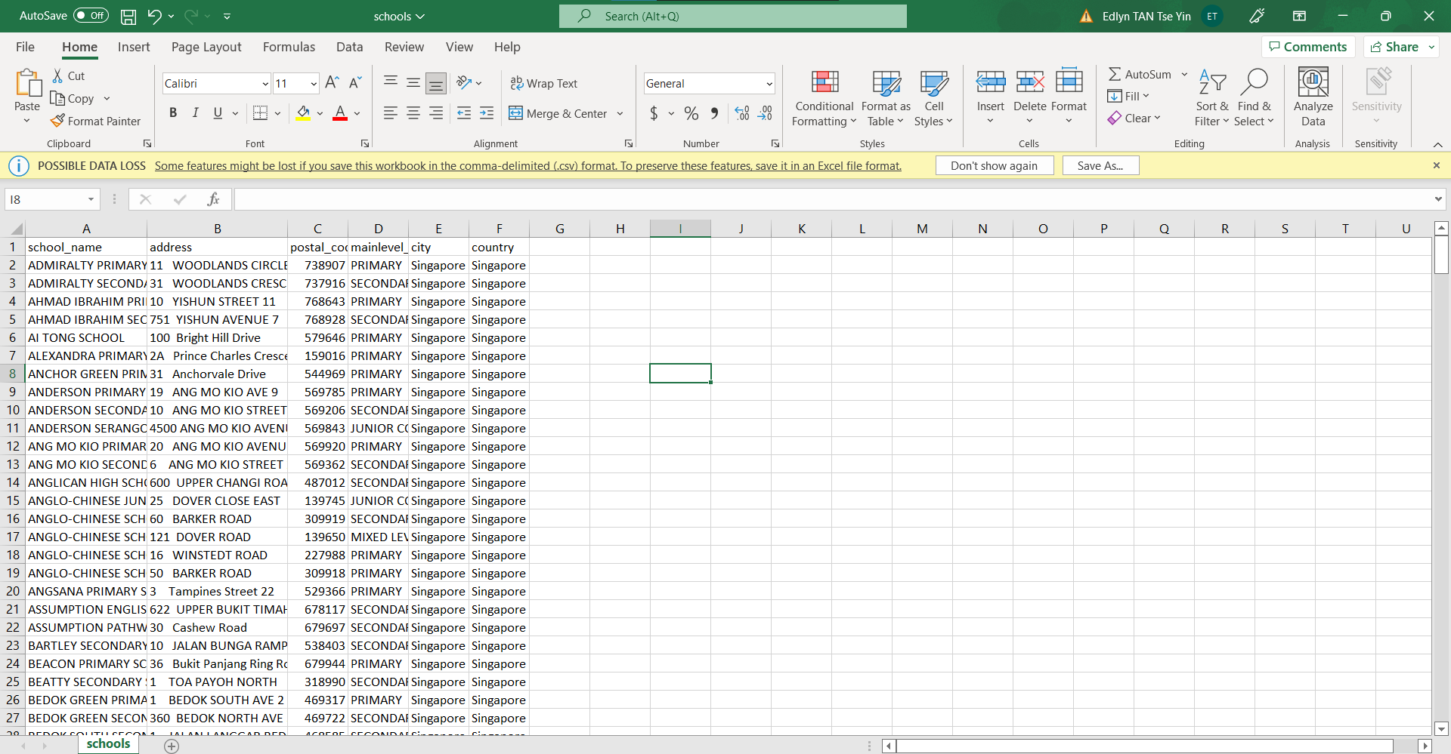

*Figure 4*

Save this as a new csv file, titled ‘schools’

In QGIS, from the menu bar, click on MMQGIS > geocode > geocode csv with web service

When the geocode csv with web service window appears, click on the 3 dots and select the schools csv. Select the address to be the ‘address’ column, city to be the ‘city’ column, and the country to be the ‘country’ column. Select ‘OpenStreetMap/Nominatim’ as the Web Service.

For the output file name, click on the 3 dots and create a new folder in your file explorer. Name this folder ‘geocoding’. Type the file name as ‘geocoded_education1’.

For the not found output list, click on the 3 dots and select the geocoding folder that you have previously created. Type the file name as ‘not_found_education1’

Your panel should look like Figure 5. Click on apply and wait for it to run.

*Figure 5*

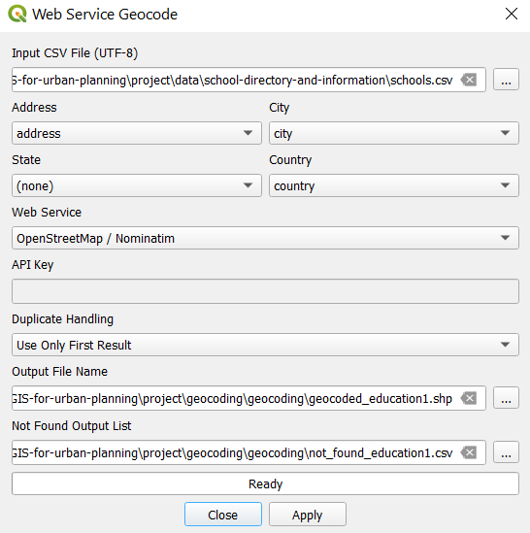

After the process has finished running, a temporary layer should appear in the main screen. Rename this temporary layer to ‘schools’. Your screen should look like Figure 6.

*Figure 6*

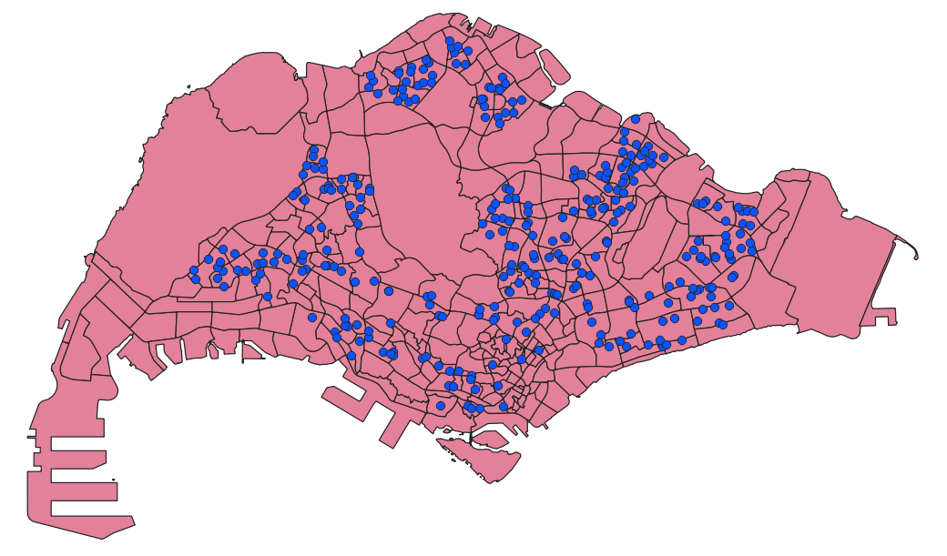

Open the non_found_education1 csv file. Using <https://stevemorse.org/jcal/latlon.php>, get the latitude and longitudes of the school locations by inputting the relevant information into the website.

You should get a csv file similar to the one in Figure 7.

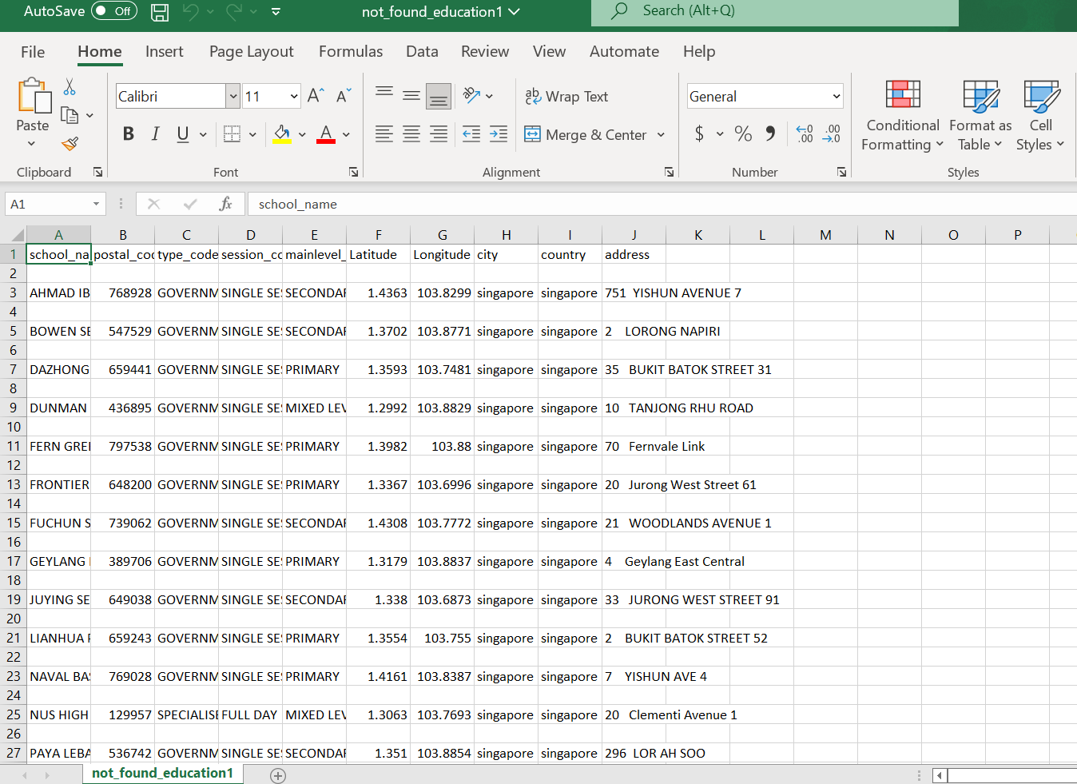

*Figure 7*

To import the schools in the not_found_education1 dataset into QGIS, add the csv file as a delimited text layer. From the menu bar, click on Layers > Add layers > Add delimited text layer.

Select Longitude as the X field and Latitude as the Y field. Select EPSG4326 as the Geometry CRS as well. Your window should look similar to Figure 8. Click on add.

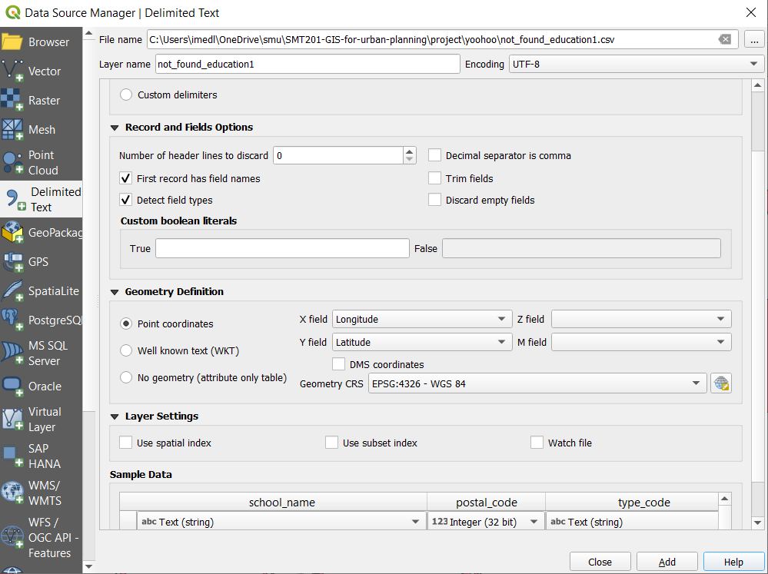

*Figure 8*

To merge all schools together into one layer, we first have to rename the columns, since the column names do not match for both layers. We can check this by opening the attribute table for both layers. This comparison can be seen in Figure 9.

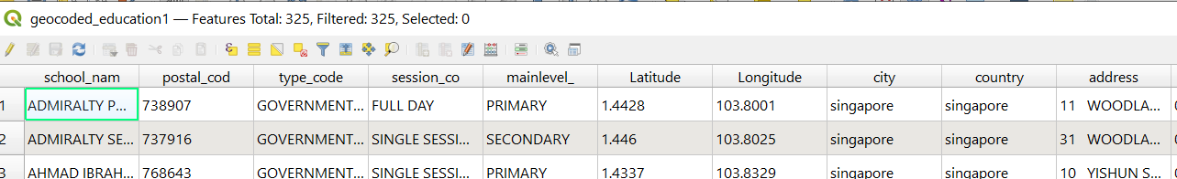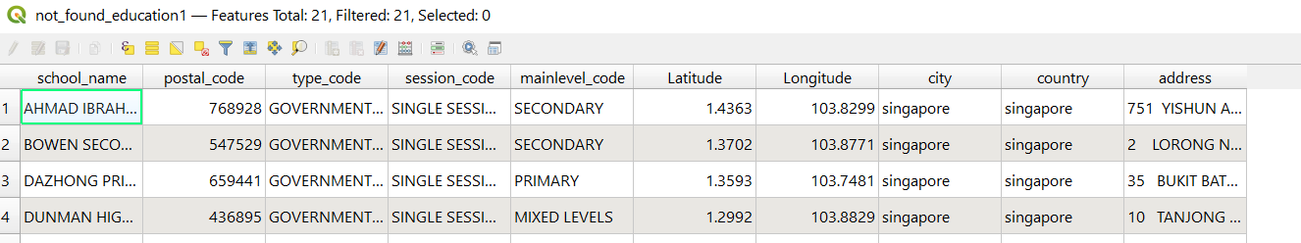

*Figure 9*

From Figure 6, we have to change these column names from the geocoded_schools1 layer.

* School_nam to school_name
* Postal_cod to postal_code
* Session_co to session_code
* Mainlevel_ to mainlevel_code

From the menu bar, click on Geoprocessing > Toolbox > Rename fields.

For the input layer, select geocoded_education1. Select school_nam as the ‘Field to rename’. Input ‘school_name’ as the New field name. Check the open output file after running algorithm checkbox. Your window should look similar to Figure 10. Click on run.

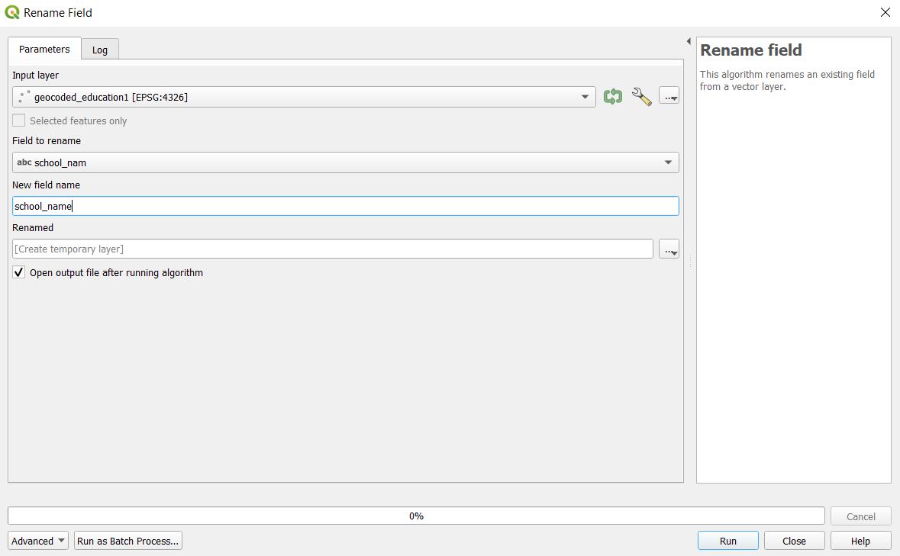

Figure 10

A temporary layer called ‘Renamed’ should be added. Save this layer as a geopackage file and name it ‘geocoded_schools1`. When prompted to, click on Overwrite layer.

Repeat the process for the other columns that have to be renamed.

To merge both layers, from the main panel, click on Vector > Data management tools > Merge vector layers. For the input layers, select ‘not_found_education1’ and ‘geocoded_education1’, as shown in Figure 11

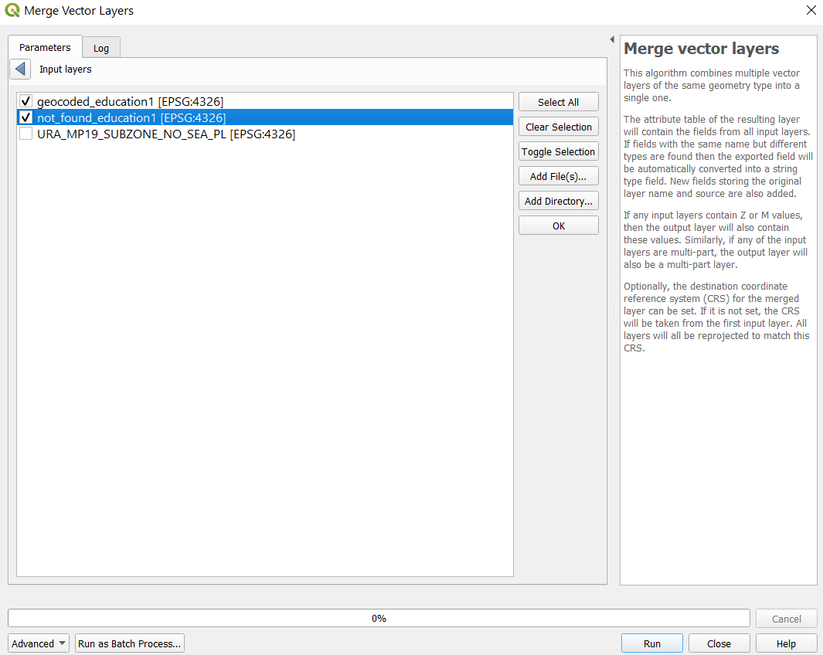

*Figure 11*

Click on ok, then run the process. A new temporary layer should be added into your QGIS. Right click on this layer to open the attribute table. Click on the  icon to organize the table columns. Uncheck the columns that are not necessary, as shown in Figure 12.

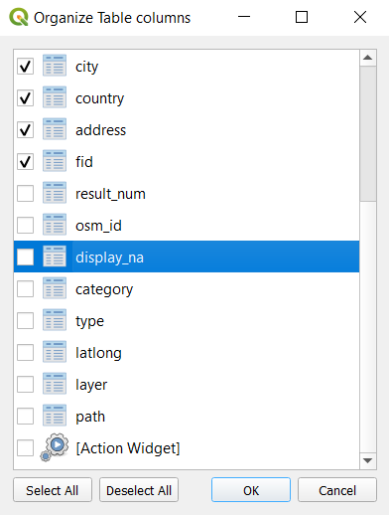

*Figure 12*

Save this merged layer as a geopackage, name it ‘all schools 2021’. Make sure that the CRS is set to EPSG3414.

Right click on the ‘all schools 2021’ layer and open the attribute table. Click on the select features by expression icon . Select the locations of schools that will be merged in 2022 (only select those whose locations will not be used after the merger). An example of the code that should be used is shown in Figure 13.

The list of schools that will be merged in the following years can be found here. <https://www.moe.gov.sg/-/media/files/news/press/2021/annex-school-mergers.ashx?la=en&hash=F52BA582E438A9320B252F070762E621B059B854>

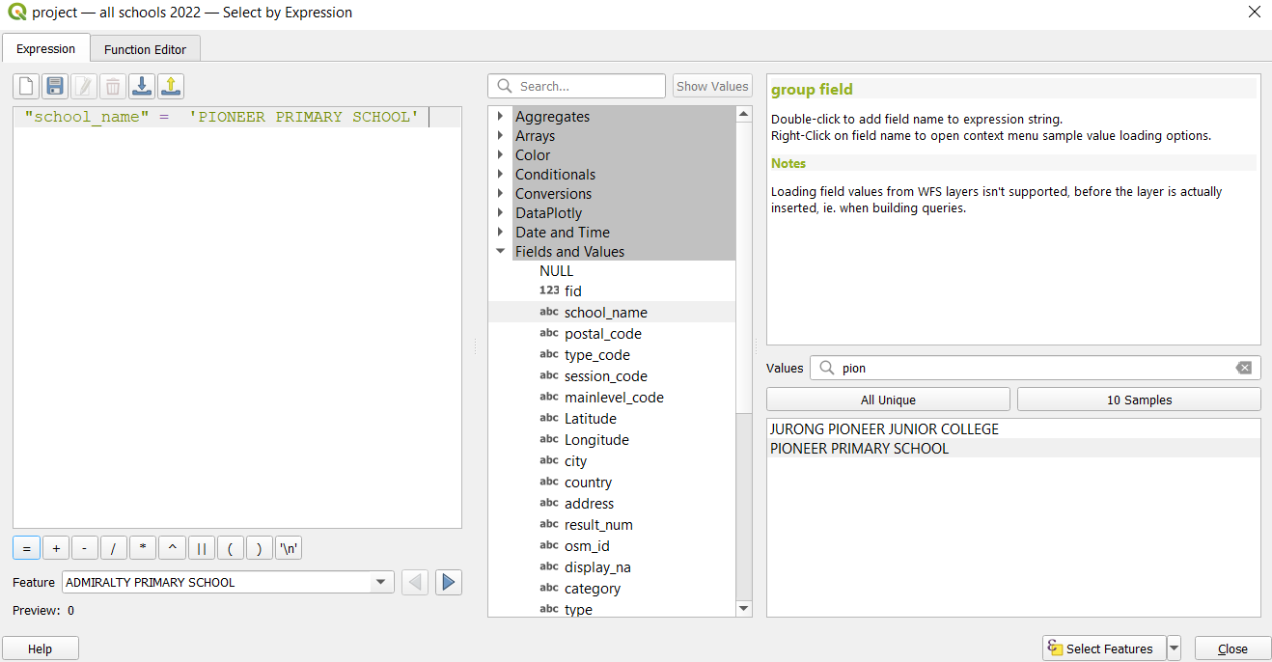

*Figure 13*

Click on select features and close the pop up. The schools that have been selected should be shown in the attribute table as shown in Figure 14.

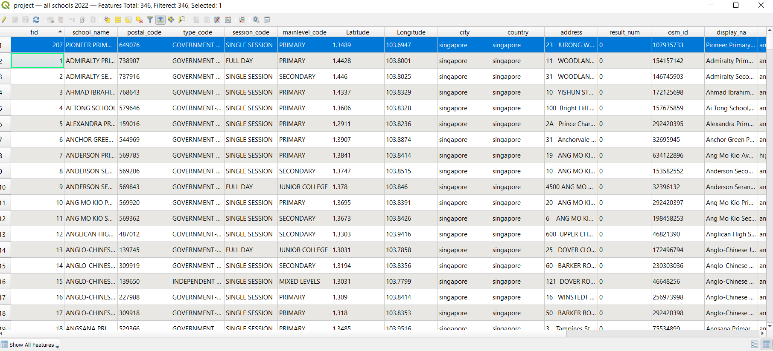

*Figure 14*

Click on the inverse selection  icon. All schools except the one that will be merged are selected instead, as shown in Figure 15.

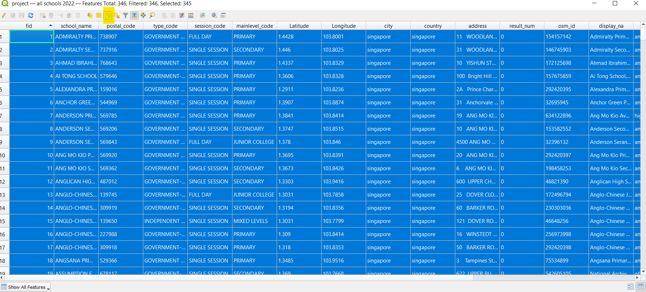

*Figure 15*

Close the attribute table. Right click on the all schools 2021 layer and save selected features only as a geopackage. Make sure that the CRS is set to EPSG3414 and that the ‘save selected features only’ checkbox is ticked. Name this layer ‘all schools 2022’.

Using the same method, extract the schools that will remain after the mergers, in 2023 and 2024.

### 7.1.3 Extracting all schools from 2018

As the data that we have extracted thus far is only applicable to 2021 and later, we will have to extract the schools before the 2019 merger as well.

Using <https://elite.com.sg/school-shift-2019> and google search, manually make a csv file with the schools that have merged in 2019, as shown in Figure 16. The addresses and the postal codes of each school can be sourced online.



Using similar methods as before, geocode this csv to import the dataset into QGIS. Save this layer as a geopackage, and name it ‘geocoded sch’

As there are schools that cannot be found using geocoding as well, find the latitude and longitude of these schools using the same website (<https://stevemorse.org/jcal/latlon.php>) and add it into the not found schools csv file, as shown in Figure 17.



Add this csv file into QGIS by adding it as a delimited text layer, as done before while importing the not_found_schools1 dataset.

Similarly to the 2021 schools data extraction, the column names have to be renamed so as to perform a merge. After merging the 2 layers, unnecessary columns should be removed from the merged layer as well. After that, export this merged layer as a geopackage file, and name it ‘education 2018’.

Right click on this new geopackage layer and open its attribute table. Click on the select features by expression icon  and select the Junior Colleges using the code shown in Figure 18.



Using the tools, select the junior colleges that have already merged and deselect the others. When you open your attribute table, it should look like Figure 19.



Click on the inverse selection icon  and save the selected features as geopackage. Make sure the CRS is set to EPSG3414 and that the ‘save selected features only’ checkbox is ticked. Name this layer ‘no merged JCs’.

From the menu bar, click on Vector > Data management tools > Merge vector layers. Merge the ‘no merged JCs’ layer with the ‘education 2018’ layer. Right click on this layer to open the attribute table. Rename the FIDs such that there is no null value. Click on the edit button to save all changes, and close the attribute table.

Right click on this merged layer and export it as a geopackage. Make sure that the CRS is set to EPSG3414. Name this layer ‘all schools 2018’

### 7.1.4 Extracting schools which locations are no longer in use

Next, we will be extracting the schools whose locations are no longer in use after the mergers.

Using the csv files that we manually made from <https://elite.com.sg/school-shift-2019> and <https://www.moe.gov.sg/-/media/files/news/press/2021/annex-school-mergers.ashx?la=en&hash=F52BA582E438A9320B252F070762E621B059B854>, extract schools into separate layers:

* Primary schools whose locations are no longer in use after the 2019 merger
* Secondary schools whose locations are no longer in use after the 2019 merger
* Post-secondary schools whose locations are no longer in use after the 2019 merger
* Primary schools whose locations will no longer be in use after the 2022-2024 mergers
* Secondary schools whose locations will no longer be in use after the 2022-2024 mergers

We will first be extracting the primary schools whose locations are no longer in use after the 2019 merger.

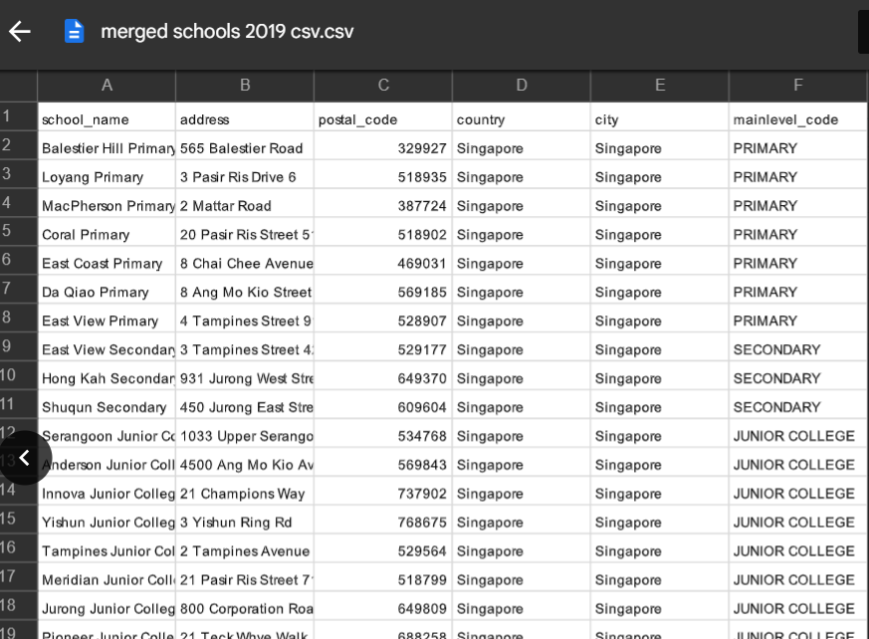

This includes Balestier Hill Primary, Loyang Primary, MacPherson Primary, Coral Primary, East Coast Primary, Da Qiao Primary and East View Primary.

From ‘all schools 2018’ layer, right click to open the attribute table.

Click on the select features by expression icon . Select these schools whose locations will no longer be in use after the 2019 merger, using the code below in Figure 20

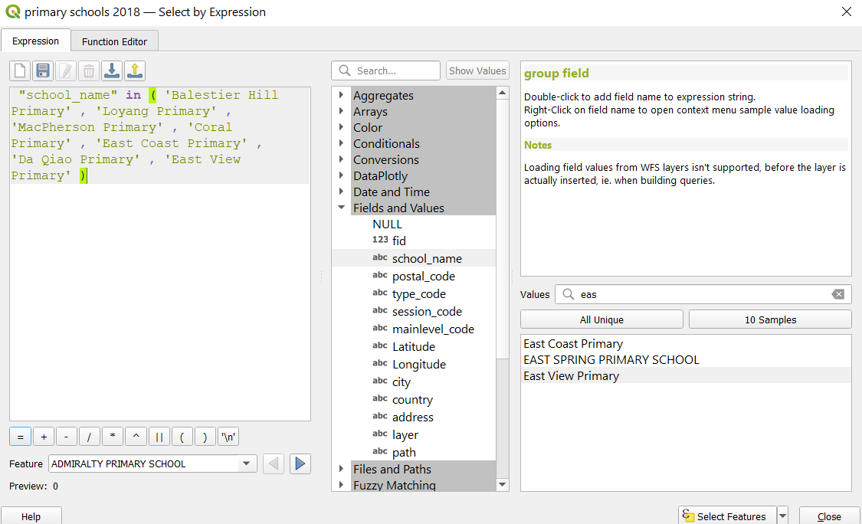

*Figure 20*

Click on select features. Close the attribute table. Right click on the ‘all schools 2018’ layer and export the selected features as a geopackage. Make sure the ‘save selected features only’ checkbox is ticked. Name this layer ‘pri sch 2019 merged’

Repeat the steps in section 6.1.4 for the other layers that were identified.

### 7.1.4 Extracting road network layer.

Open the ‘gis_osm_roads_free_1’ layer from the OSM file downloaded from Geofabrik. We first need to extract the road network layer that falls within Singapore only. From the menu bar, click on Vector > Geoprocessing tools > Clip.

Select the input layer to be ‘gis_osm_roads_free_1’ , and the overlay layer to be the MP19 subzone boundary layer. Your screen should look like Figure 21.

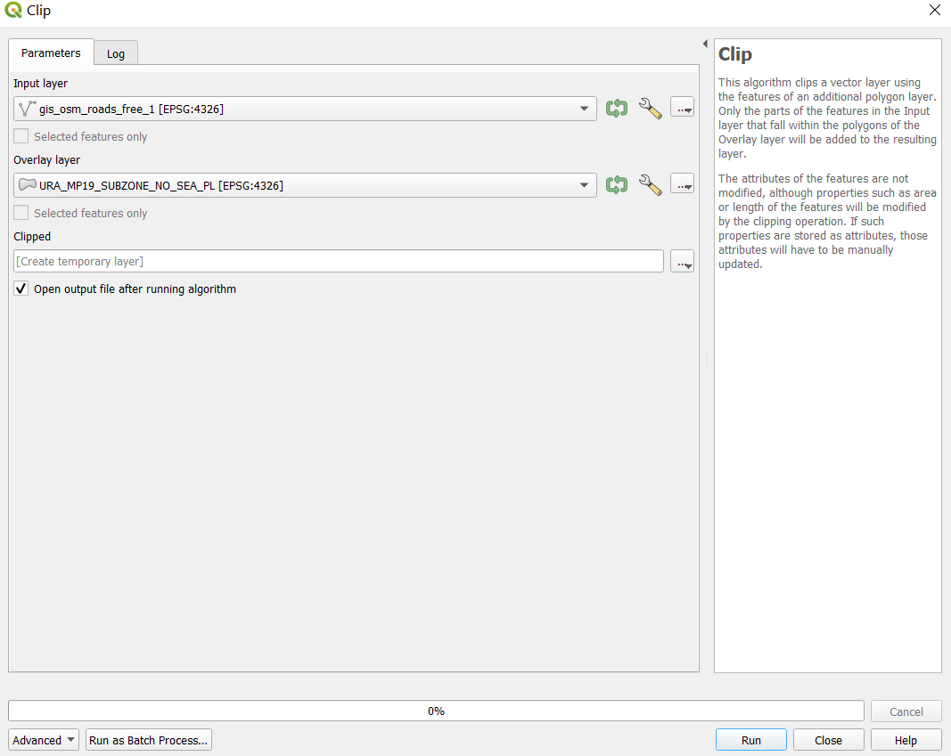

*Figure 21*

Click on the screwdriver icon for both layers, and change the invalid feature filtering option to ‘Do not filter (Better Performance), as shown in Figure 22

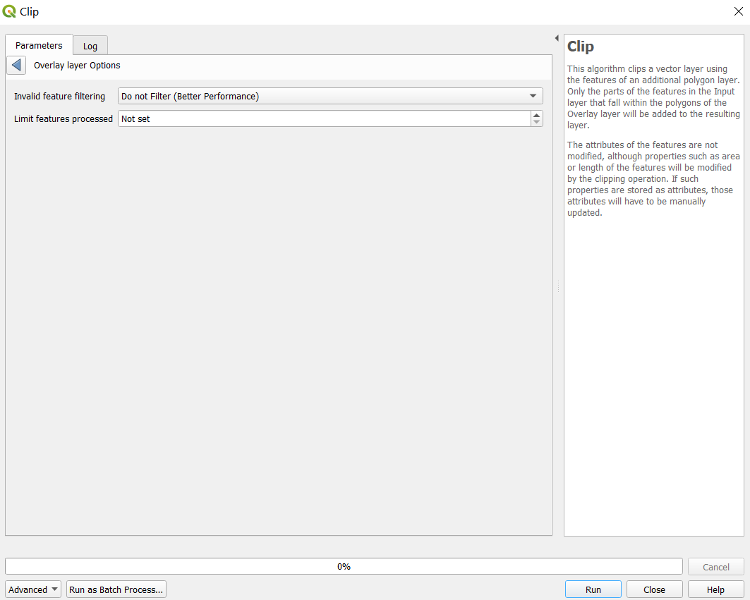

*Figure 22*

Go back to the parameters tab and click on run. After the process has finished running, a new layer, ‘Clipped’, should be added into your QGIS. The road networks in this layer should fall into the MP19 subzone boundary only, as seen in Figure 23, where the green roads are the clipped layer.

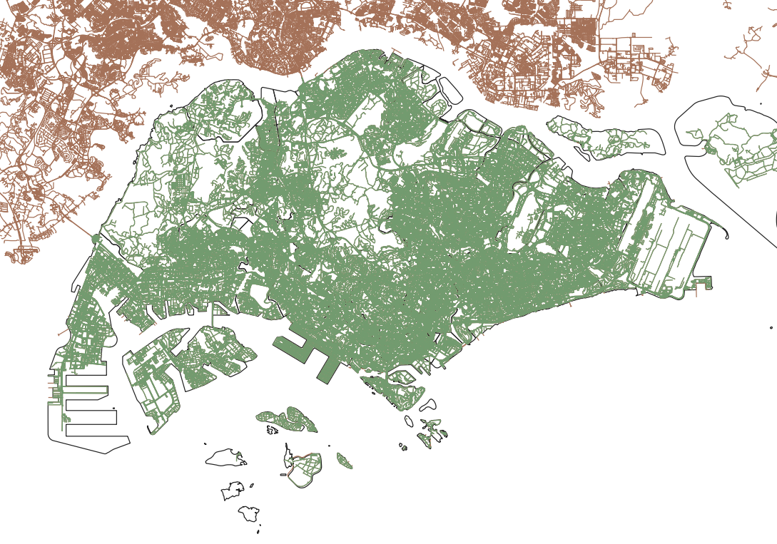

*Figure 23*

Right click on this clipped layer and save it as a geopackage. Make sure that the CRS system is set to EPSG3414. Name this layer ‘all roads’

## **7.2 Data Preparation**

### 7.2.1 Separating schools into their education levels

Next, we have to separate the primary, secondary, and post-secondary schools for each year.

Right click on the ‘all schools 2019’ layer and open the attribute table. We first have to identify the schools with mixed levels, as they may be left out while we are separating the schools.

Click on the select features by expression icon . Select the schools which have mixed levels, as shown in the code in Figure 24.

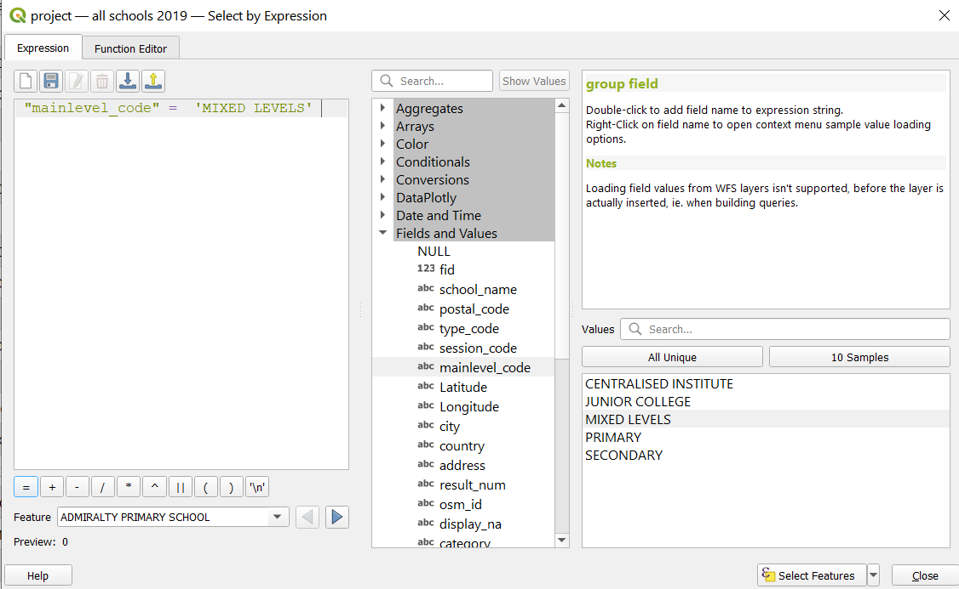

*Figure 24*

Click on select features and close the pop up window. The schools with mixed levels should be selected, as shown in Figure 25. Take a screenshot of this list for reference.

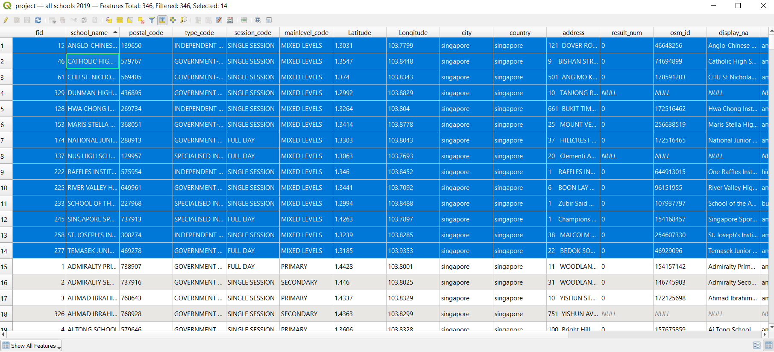

*Figure 25*

The mixed levels can be discovered easily using a simple Google search. They can be compiled into a table as shown in Figure 26.

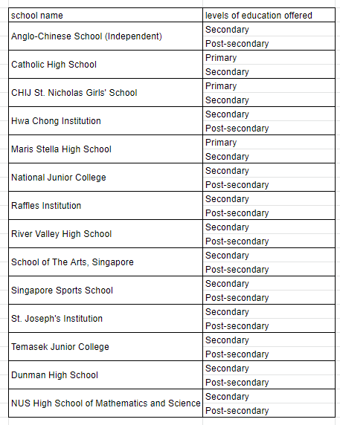

*Figure 26*

We have to take note of this list and their respective education levels since we have to add them in manually when selecting schools according to their education level.

Unselect the schools with mixed levels. Click on the select features by expression icon . Select the primary schools using this code, as shown in Figure 27.

"mainlevel_code" = 'PRIMARY' or "school_name" = 'CATHOLIC HIGH SCHOOL' or "school_name" = 'CHIJ ST. NICHOLAS GIRLS'' SCHOOL' or "school_name" = 'MARIS STELLA HIGH SCHOOL'

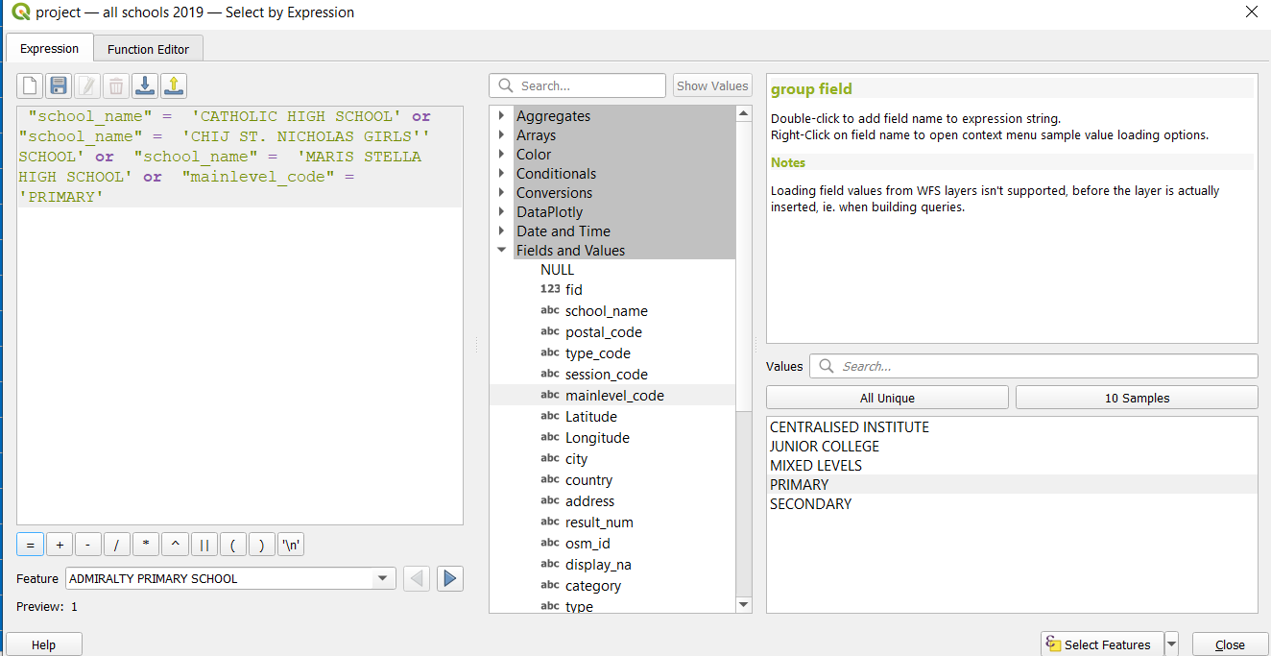

*Figure 27*

Click on the select features button, and close the attribute table. Right click on the ‘all schools 2019’ layer and export the selected features as a geopackage. Make sure that the CRS is set to EPSG3414 and that the ‘save selected features only’ checkbox is checked. Name this layer ‘primary schools 2019’

To select the secondary schools, right click on the ‘all schools 2019’ layer and open the attribute table again. Click on the select features by expression icon . Select the secondary schools using this code, as shown in Figure 28.

"mainlevel_code" = 'SECONDARY' or "school_name" = 'ANGLO-CHINESE SCHOOL (INDEPENDENT)' or "school_name" = 'CATHOLIC HIGH SCHOOL' or "school_name" = 'CHIJ ST. NICHOLAS GIRLS'' SCHOOL' or "school_name" = 'DUNMAN HIGH SCHOOL' or "school_name" = 'HWA CHONG INSTITUTION' or "school_name" = 'MARIS STELLA HIGH SCHOOL' or "school_name" = 'NATIONAL JUNIOR COLLEGE' or "school_name" = 'NUS HIGH SCHOOL OF MATHEMATICS AND SCIENCE' or "school_name" = 'RAFFLES INSTITUTION' or "school_name" = 'RIVER VALLEY HIGH SCHOOL' or "school_name" = 'SCHOOL OF THE ARTS, SINGAPORE' or "school_name" = 'SINGAPORE SPORTS SCHOOL' or "school_name" = 'ST. JOSEPH''S INSTITUTION' or "school_name" = 'TEMASEK JUNIOR COLLEGE'

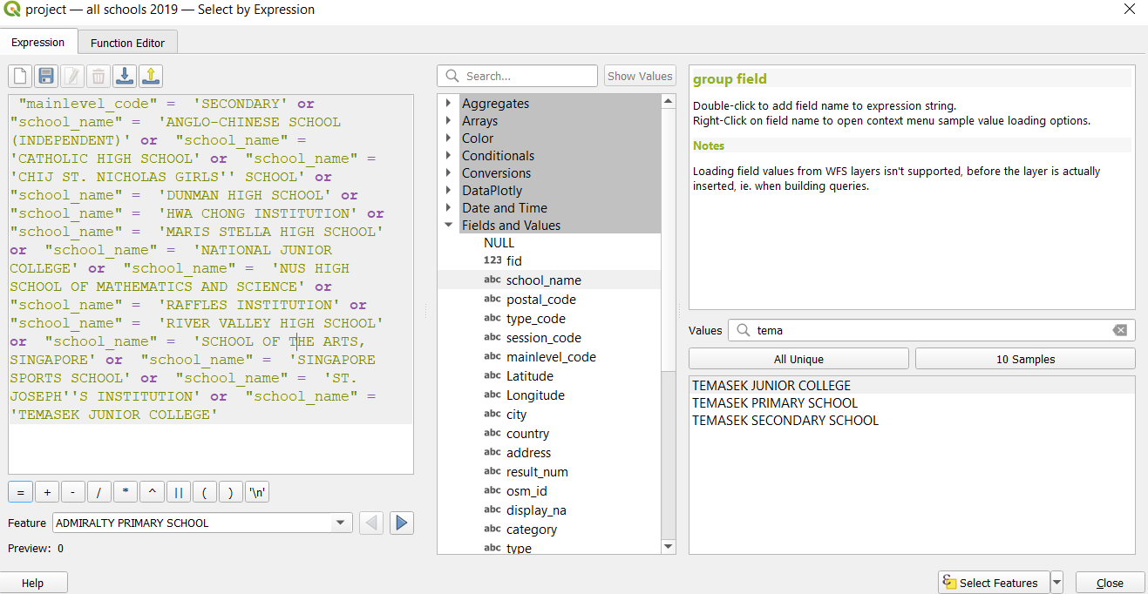

*Figure 28*

Click on the select features button, and close the attribute table. Right click on the ‘all schools 2019’ layer and export the selected features as a geopackage. Make sure that the CRS is set to EPSG3414 and that the ‘save selected features only’ checkbox is checked. Name this layer ‘secondary schools 2019’

Lastly, to select the post-secondary schools, right click on the ‘all schools 2019’ layer and open the attribute table again. Click on the select features by expression icon . Select the post-secondary schools using this code, as shown in Figure 29.

"mainlevel_code" = 'CENTRALISED INSTITUTE' or "mainlevel_code" = 'JUNIOR COLLEGE' or "school_name" = 'ANGLO-CHINESE SCHOOL (INDEPENDENT)' or "school_name" = 'DUNMAN HIGH SCHOOL' or "school_name" = 'HWA CHONG INSTITUTION' or "school_name" = 'NATIONAL JUNIOR COLLEGE' or "school_name" = 'NUS HIGH SCHOOL OF MATHEMATICS AND SCIENCE' or "school_name" = 'RAFFLES INSTITUTION' or "school_name" = 'RIVER VALLEY HIGH SCHOOL' or "school_name" = 'SCHOOL OF THE ARTS, SINGAPORE' or "school_name" = 'SINGAPORE SPORTS SCHOOL' or "school_name" = 'ST. JOSEPH''S INSTITUTION' or "school_name" = 'TEMASEK JUNIOR COLLEGE'

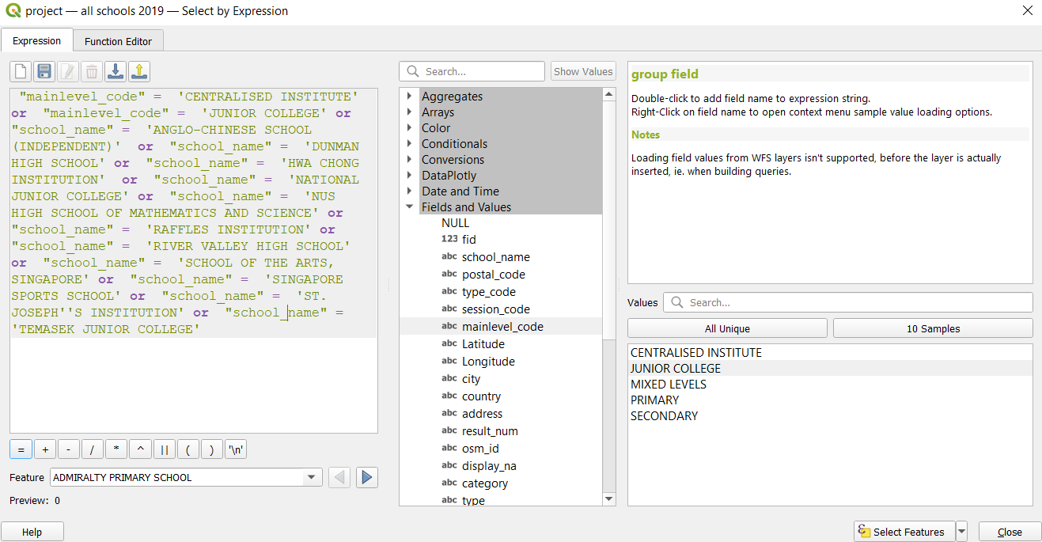

*Figure 29*

Click on the select features button, and close the attribute table. Right click on the ‘all schools 2019’ layer and export the selected features as a geopackage. Make sure that the CRS is set to EPSG3414 and that the ‘save selected features only’ checkbox is checked. Name this layer ‘post-secondary schools 2019’

Repeat section 4.2.1. to separate the schools from all years into primary, secondary and post-secondary levels.

### 7.2.2 Separating roads according to education levels

#### 7.2.2.1 Primary School Road Network

As we derived that students attending primary schools either walk or drive to school, we have extracted the roads highlighted in yellow for our analysis. The description of these roads can be seen in Figure 30 as well.

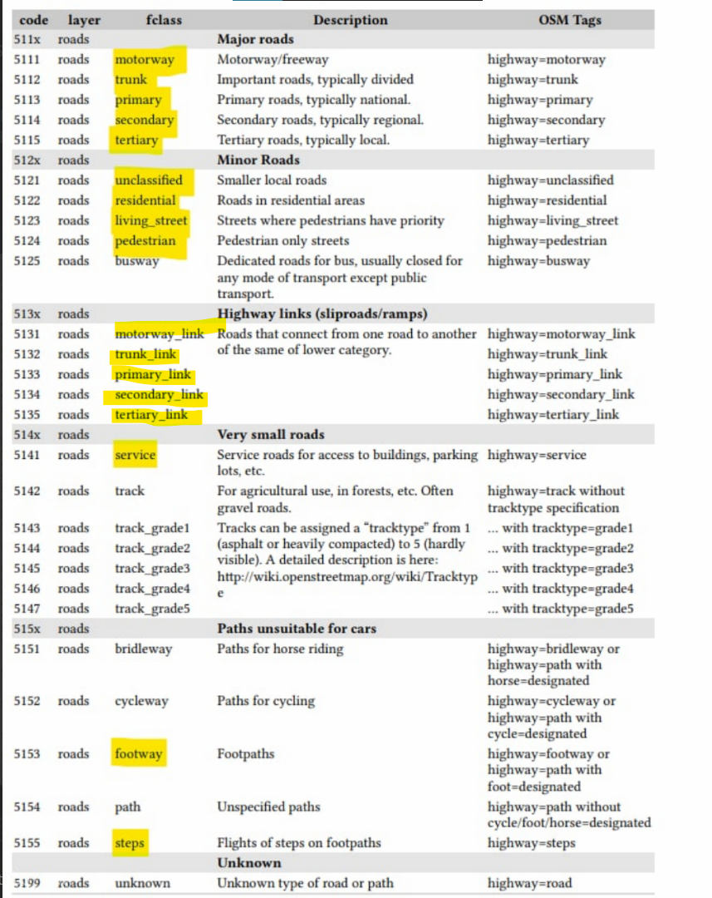

*Figure 30*

Right click on the ‘all roads’ layer to open the attribute table. Click on the select features by expression icon . Use this code to extract the roads that we need, as shown in Figure 31.

"fclass" in ( 'motorway_link' , 'primary_link' , 'secondary_link' , 'tertiary_link' , 'trunk_link' ,'footway' , 'motorway' , 'pedestrian' ,'primary' , 'residential' , 'secondary', 'service' ,'steps' ,'tertiary', 'trunk' , 'unclassified' ,'living_street' )

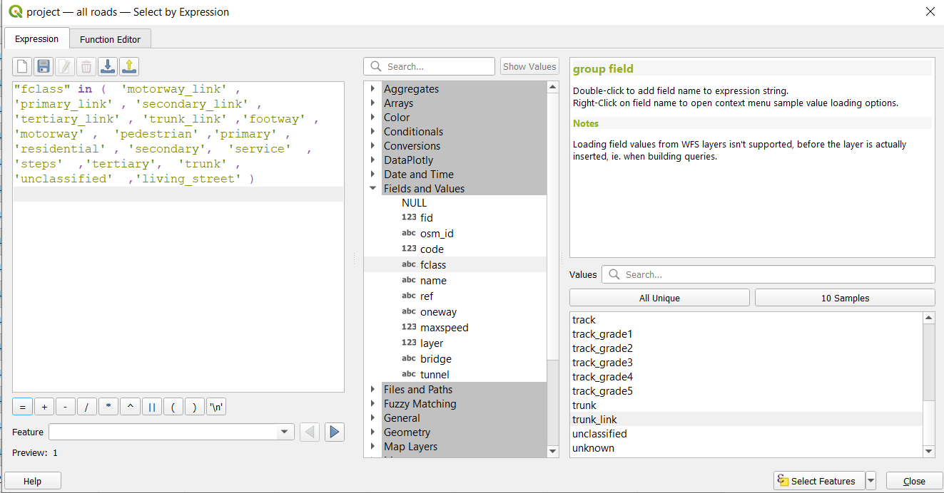

*Figure 31*

Click on the select features button. Close the attribute table. The selected road network should be highlighted in yellow, as shown in Figure 32.

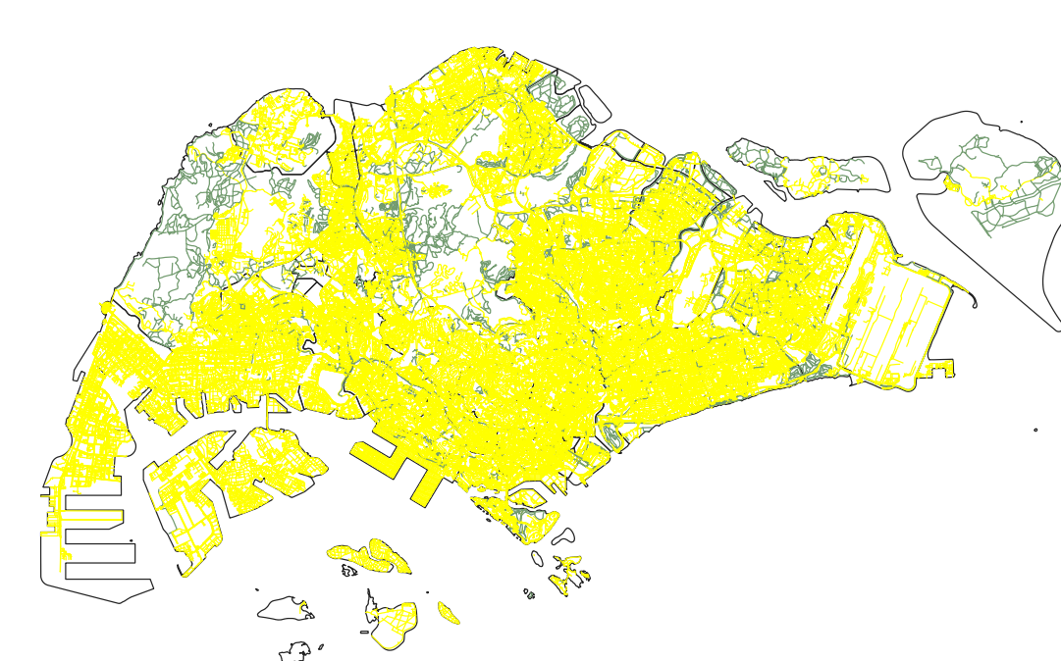

*Figure 32*

Right click on this layer and export the selected features into a geopackage. Make sure that the CRS is set to EPSG3414 and the ‘save selected features only’ checkbox is ticked. Name this layer ‘pri sch roads’.

#### 7.2.2.2 Secondary and Post-secondary Road Network

Unlike Primary school students, students in Secondary and Post-secondary schools rely on public transport networks, such as the MRT, to commute to and from school. Hence, we need to build a different road network from the one used for Primary schools.

Right click on the ‘all roads’ layer and open the attribute table. Click on the select features by expression icon . Select all roads except for bridleways, as shown in the code in Figure 33.



Right click on this layer and export it as a geopackage file. Make sure that the CRS is set to EPSG3414 and that the ‘save selected features only’ checkbox is ticked. Name this layer ‘no bridleways’

Import the ‘gis_osm_railways_free_1’ layer from the OSM zip file into QGIS. Right click on this layer to open the attribute table. Click on the select features by expression icon . Remove all the depots and unrelated railways as shown in Figure 34.



Click on select features and close the query window. Click on the inverse selection icon  and close the attribute table. From the main map, check the data to make sure that all the MRT lines are selected and connected properly. You may have to manually select the Punggol LRT line.

Right click on this layer and save it as a geopackage. Make sure that the CRS is set to EPSG3414 and that the ‘save selected features only’ checkbox is selected. Name this layer as ‘MRT network’.

From the menu bar, click on Vector > Data Management Tools > Merge Vector Layers. Select the input layers to be ‘MRT network’ and ‘no bridleways’ . Select the Destination CRS to be EPSG3414. Your window should look similar to Figure 35. Click on run.



Right click on the merged layer and open the attribute table. Click on the field calculator  icon. Update the FID such that there are no null values.This can be done via selecting ‘Update existing field’ and selecting fid. Enter the expression as shown in Figure 36, and click on ok.

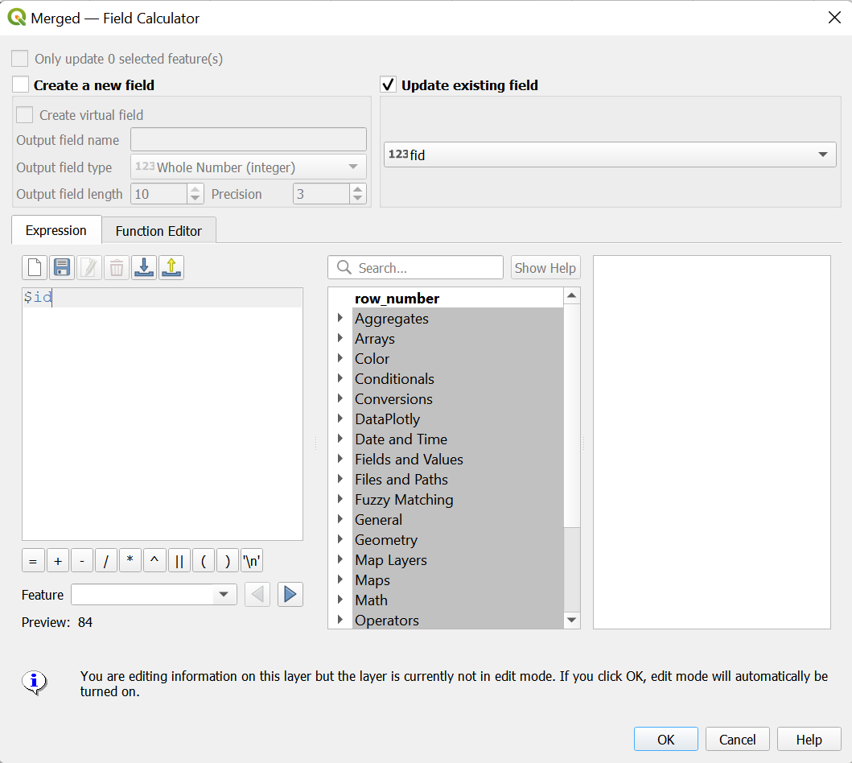

*Figure 36*

Click on toggle editing to save edits. Close the attribute table. Right click on the merged layer and export it as a geopackage. Name this layer as ‘mrt and no bridleways’. Make sure that the CRS is set to EPSG3414.

Right click on this layer to open the attribute table. Click on the field calculator  icon. Create a new field called ‘speed’. Select the output field type to be Integer (32 bit), and input the code as shown in Figure 37.

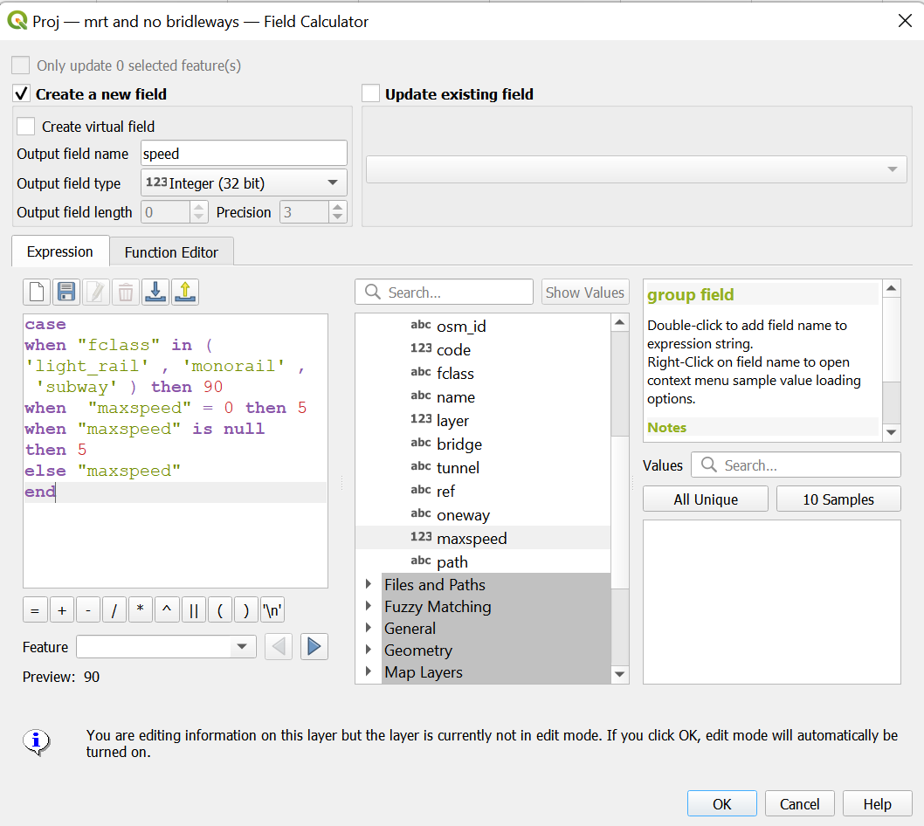

*Figure 37*

This makes the speed of the railway lines 90. This also corrects the maxspeed of the normal footpaths, since a speed of 0 does not make sense. Click on ok, and click on the pencil icon to save changes.

## **7.3 Preparing Maps for Analysis**

#### 7.3.1 Creating a hexagonal grid with centroids for Singapore

From the menu bar, select Vector > Research Tools > Create Grids

Select the grid type to be Hexagon (Polygon), and select the grid extent to be mpsz.

Set horizontal and vertical spacing to be 500

Set the Grid CRS as EPSG3414.

Click on the ‘open output file after running algorithm’ checkbox.

Your window should look like Figure 38. Click on run.

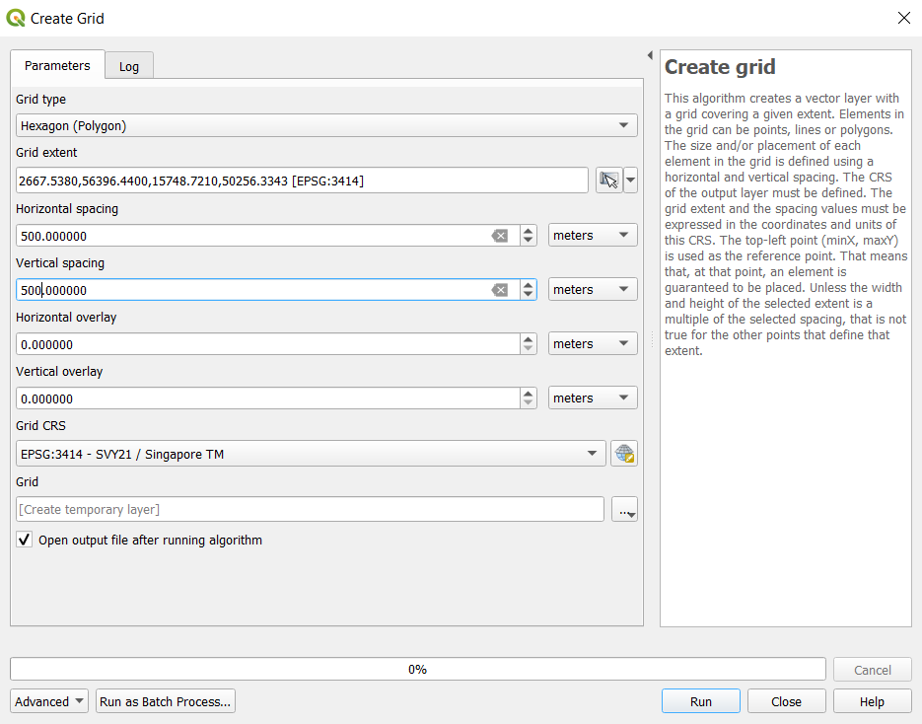

*Figure 38*

After the process has finished running, a new temporary layer, Grid, should be added into your QGIS. Place the mpsz layer on top of the grid layer. Your map should look like Figure 39

*Figure 39*

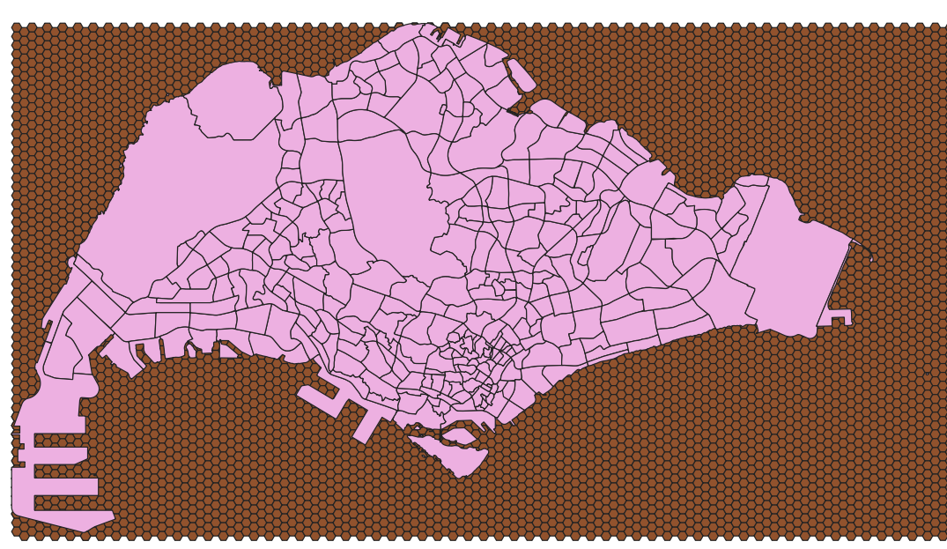

From the menu bar, click on the select by location icon .

Input the layers as shown in Figure 40, and run the process.

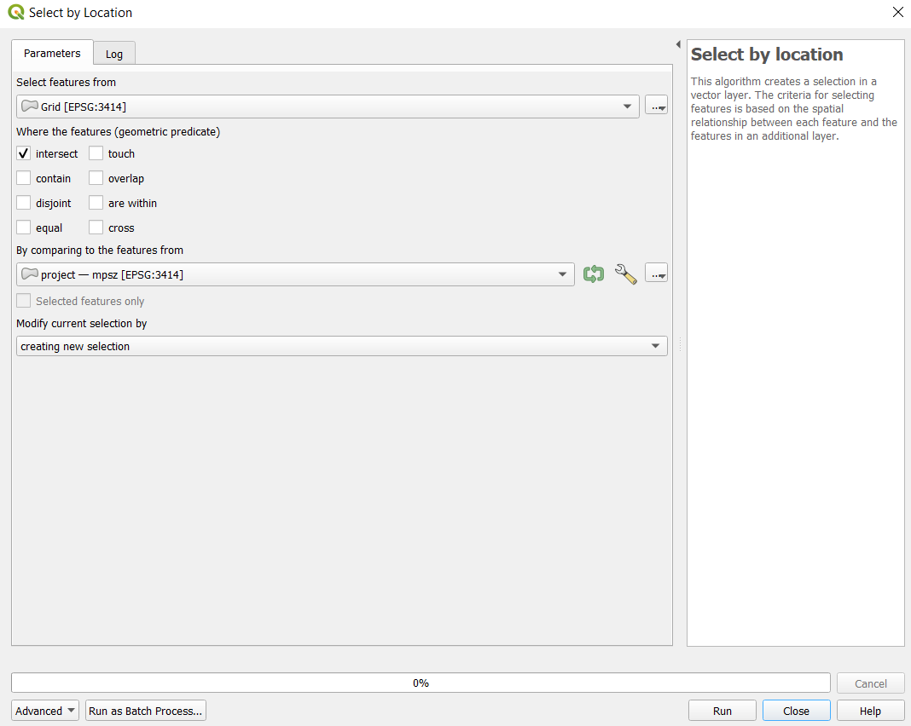

*Figure 40*

Your map should look like Figure 41 after the process has finished running. Clean the selection by removing the hexagons that are not within the Singapore Island boundary, and select those who are supposed to be in the boundary.

*Figure 41*

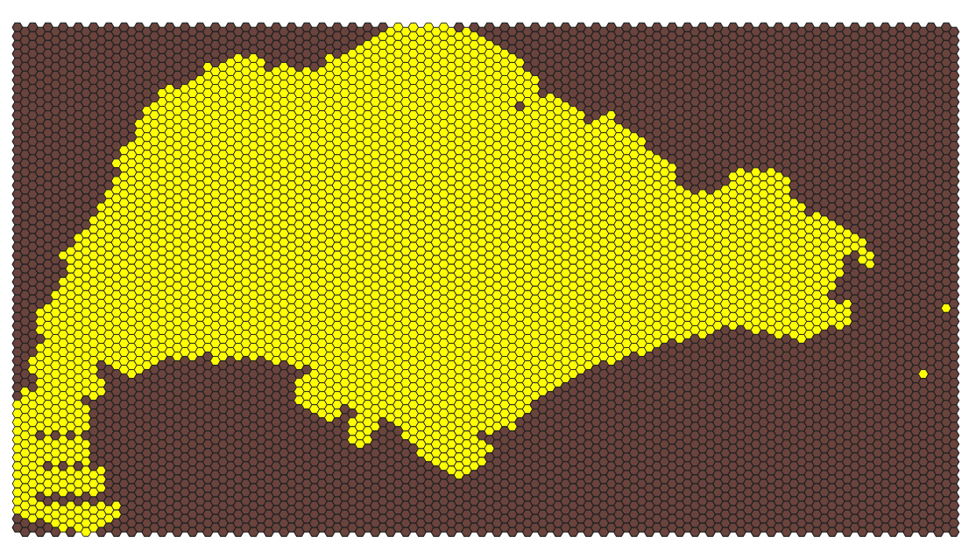

Right click on the Grid layer and export the selected features as a geopackage. Make sure that the CRS is set to EPSG3414 and that the ‘save selected features only’ checkbox is ticked. Name this layer ‘hexagonal grid’. Your new layer should look like Figure 42.

*Figure 42*

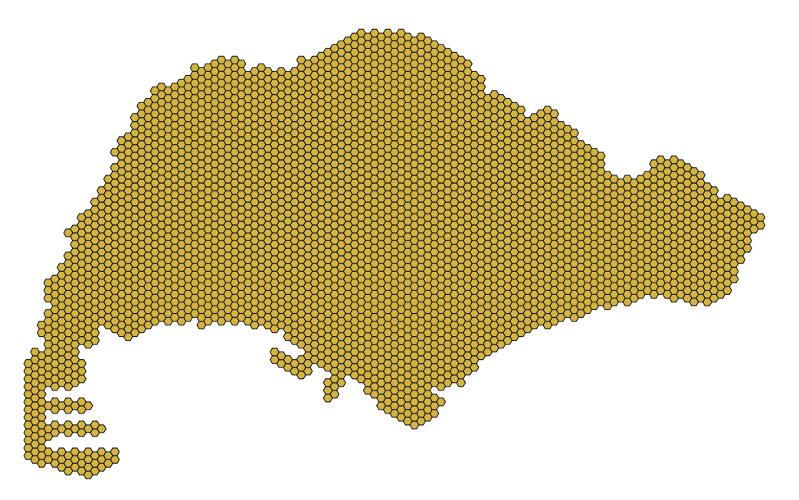

To compute the hexagon centroids, from the menu bar, select Vector -> Geometry Tools -> Centroids.

Select the input layer to be hexagon grid, and run the process. Your window should look similar to Figure 43.

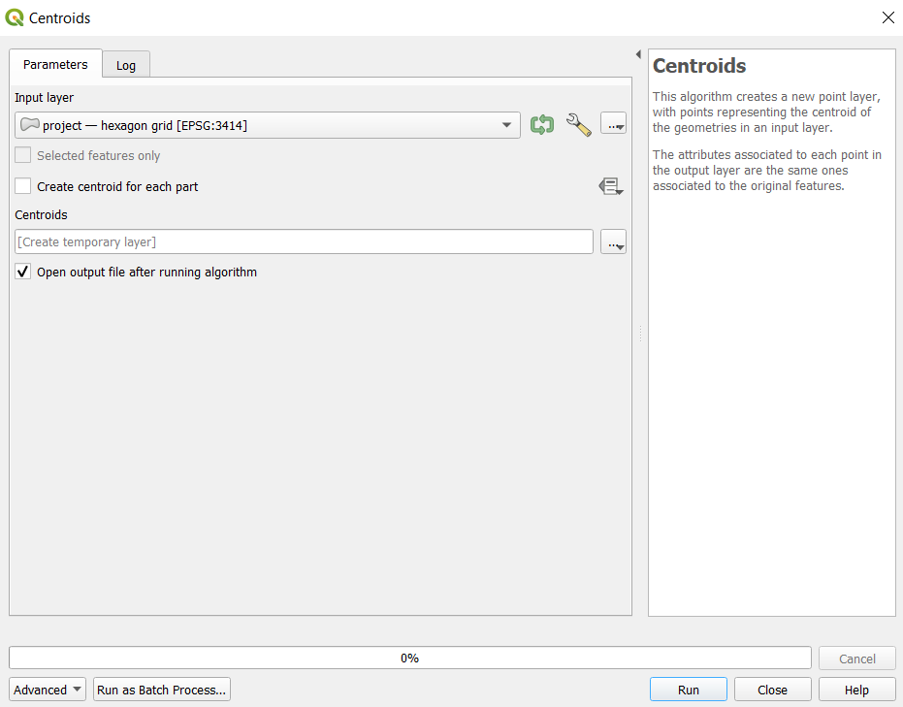

*Figure 43*

A new temporary layer called Centroids should be created after the process has finished running. Save this layer as a geopackage and name it ‘hex_centroids’. Make sure the CRS is set to EPSG3414. Your layer should look similar to Figure 44.

*Figure 44*

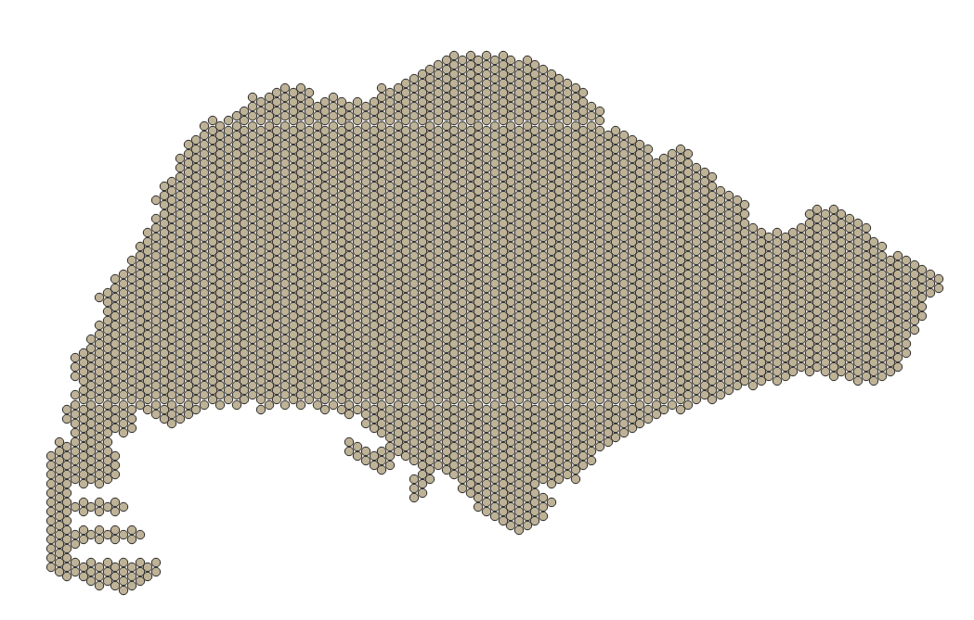

#### 7.3.2 Network accessibility analysis

Next, we will be performing network accessibility analysis using QNEAT3, a QGIS network analysis toolbox on QGIS. We will be using the OD Matrix From Layers as table (m:n) tool.

This tool allows us to calculate the shortest distance from a hexagon centroid to a school, using the road network analysis.

From the menu bar, click on Processing > Toolbox to open the Processing Toolbox. In the search bar, type in ‘OD Matrix’, and click on OD Matrix From Layers as table (m:n).

We will first be performing analysis on the primary schools.

For the network layer, select ‘pri sch roads’

For the From-Point layer, select ‘hex_centroid’

Select fid as the Unique Point ID Fields.

For the To-Point Layer, select ‘ primary schools 2018’

Choose ‘Shortest Path (distance optimization)’ for the Optimization Criterion.

For the advanced parameters:

* Select ‘Ellipsoidal’ for the Entry Cost calculation method’
* Select ‘oneway’ for the Direction Field
* For the values for the directions, set ‘F’ as the forward direction, ‘T’ as the backward direction, and ‘B’ as the value for both directions.
* Scroll down and set the Topology tolerance as 0.5

Click on run. This process might take a long time to run. Your window should look similar to Figure 45 before running the process.

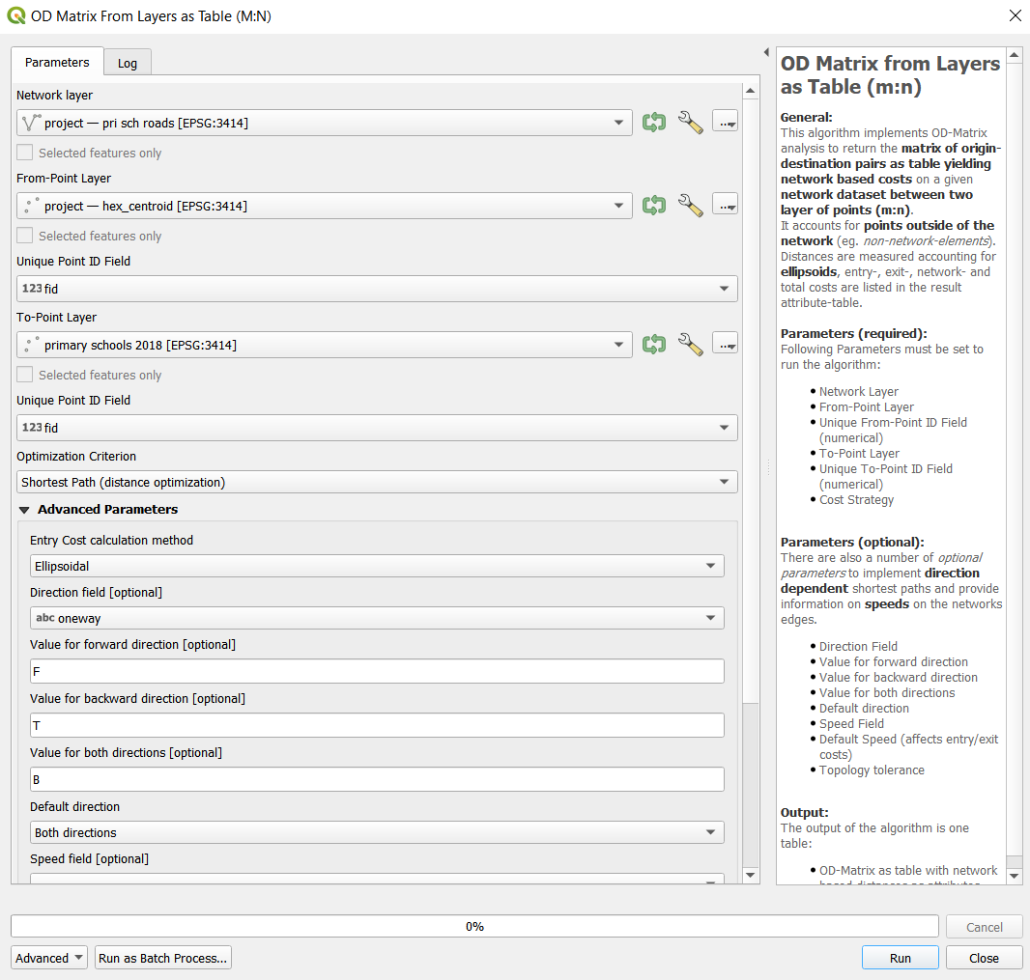

*Figure 45*

After the process finishes running, a new temporary layer should be added into QGIS. Save this new layer as a geopackage and title it ‘OD pri sch 2018’.

Next, we will use the SQL tool of QGIS to select destination points with the shortest distance.

At the Search pane of Processing Toolbox, type SQL.

Double-click on Execute SQL of Vector general.

Execute SQL dialog window appears.

For Additional input datasources, select on the button at the right end. Click on the checkbox Output OD Matrix. Your window should look like Figure 46. Click on ok to return to the parameter tab.

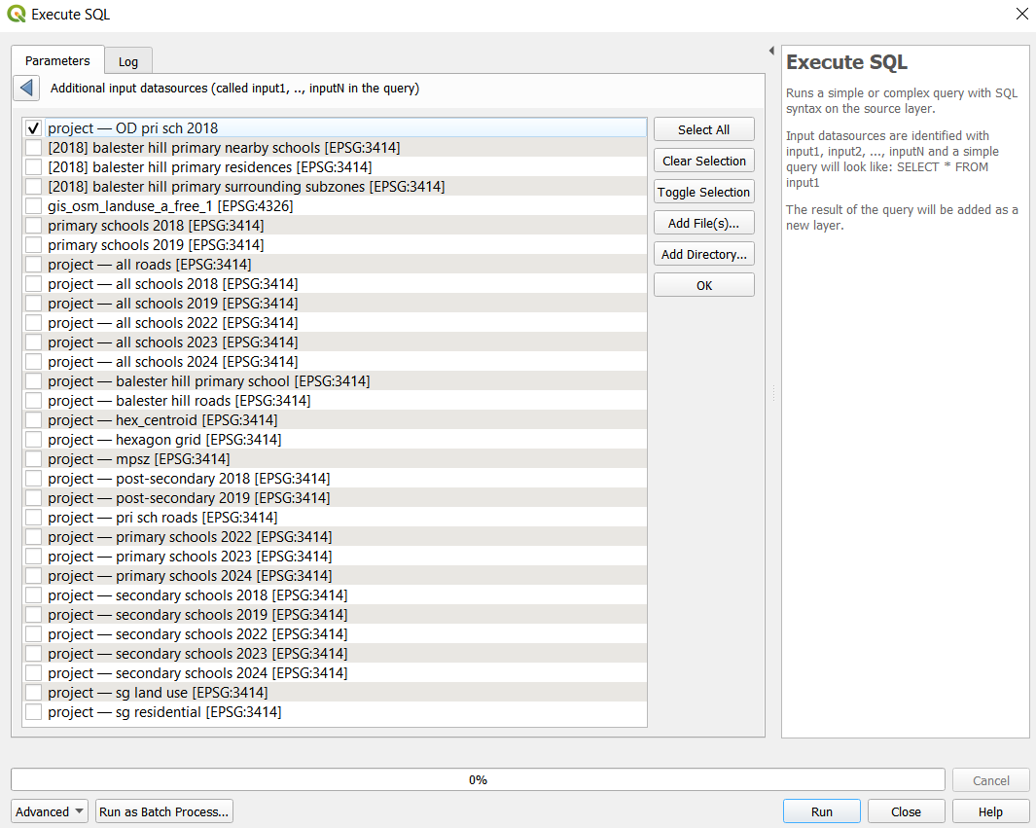

*Figure 46*

At SQL query panel, type the following SQL

select origin_id, destination_id, min(total_cost) as shortest_distance

from input1 group by origin_id

For Geometry type, select No Geometry from the drop-down list.

Run the process.

After the process has finished running, there should be a new temporary SQL query layer in your QGIS. Right click on this layer to open the attribute table. It should look similar to Figure 47.

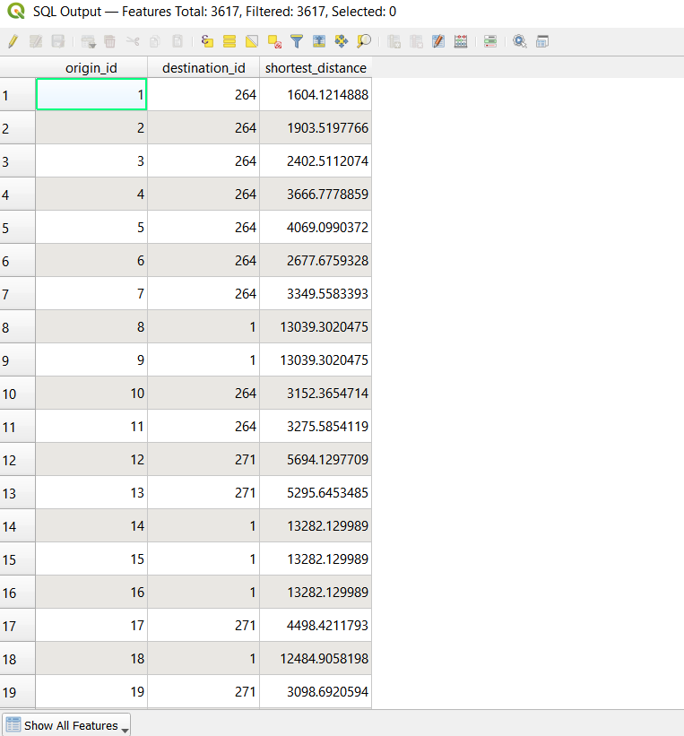

*Figure 47*

Save this output as a geopackage and name it ‘acc_prisch_2018’.

Next, we have to map the accessibility values. At the Layers panel right-click on ‘hexagon grid’ layer and select Duplicate Layer from the context menu. Rename the layer to ‘accessibility to pri sch 2018’

We will need to join ‘acc_prisch_2018’ to ‘accessibility to pri sch 2018’ using the fid of both layers.

At the Layer panel, right-click on ‘accessibility to pri sch 2018’ and select Properties from the context menu.

The Properties dialog window appears.

At the option panel, click on Joins.

Click on + button to add a join.

The Add Vector Join dialog window appears.

For Join layer, select ‘acc_prisch_2018’ from the drop-down list.

For Join field, select fid from the drop-down list.

For Target field, select fid from the drop-down lsit.

Keep the checkbox in front of Cache join layer in memory checked.

Your window should look like Figure 48

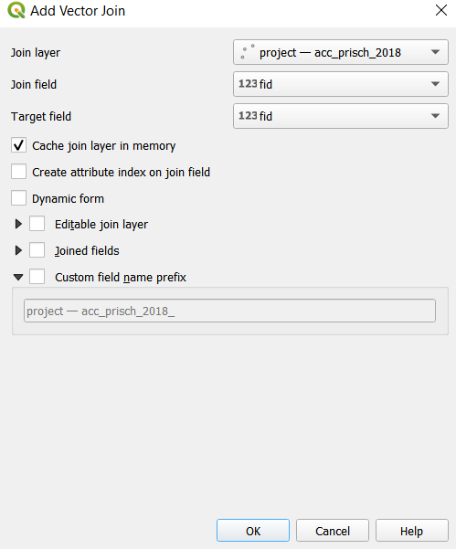

*Figure 48*

Click on ok, then click on apply. Right click on the ‘accessibility to pri sch 2018’ layer and open the attribute table. You should see the new columns from the ‘acc_prisch_2018’ layer in the attribute table, as shown in Figure 49.

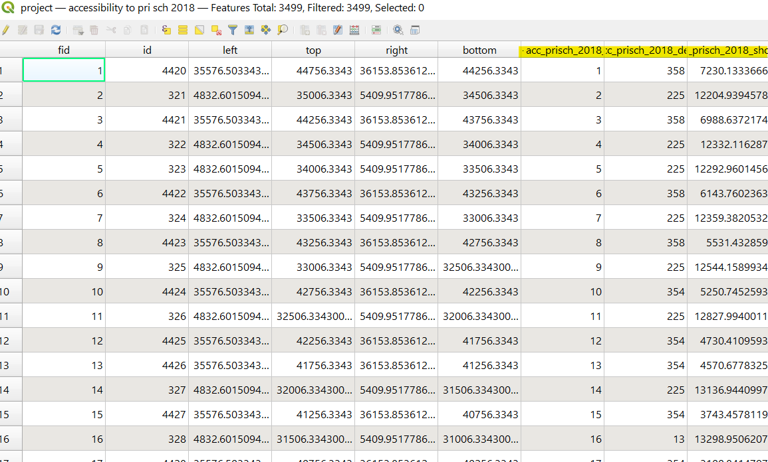

*Figure 49*

Double click on this layer to open the properties window. Toggle to the symbology tab. We will now make the choropleth map.

From the drop-down box, select ‘graduated’

Select the value as the shortest_distance column

At the bottom left, select the mode to be ‘Natural Breaks (Jenks)’.

Adjust the number of classes to be 20.

Reselect the colour ramp reds to get a wider range of colours on the map.

Click on classify. Your window should look like Figure 50

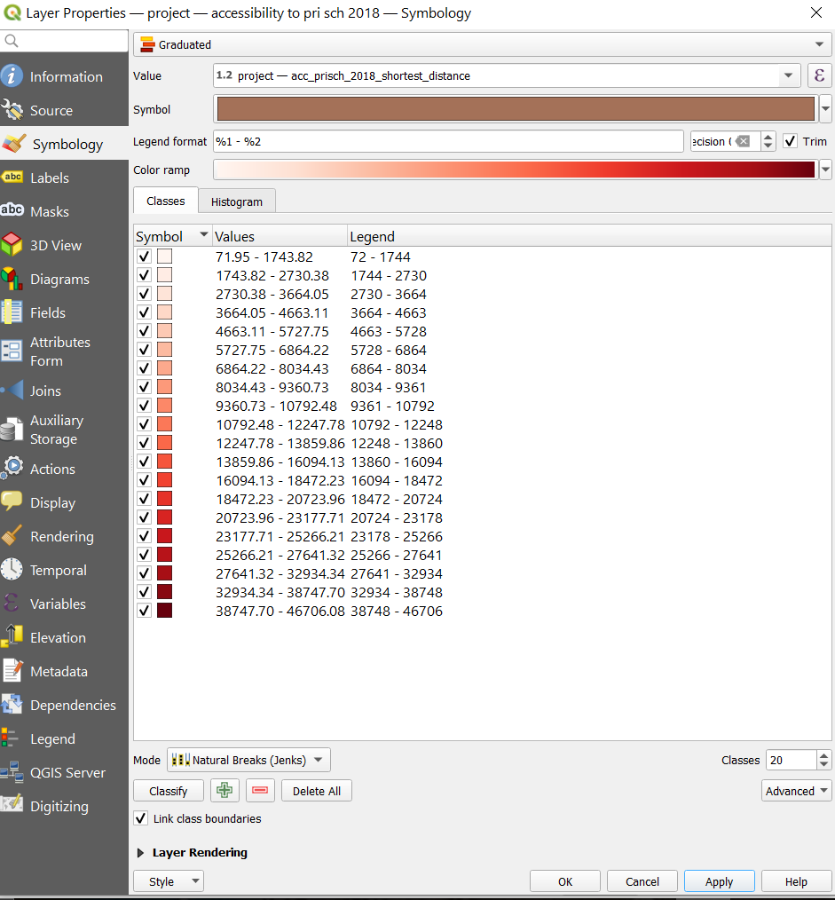

*Figure 50*

Click on apply and close the window. Your map should look like Figure 51.

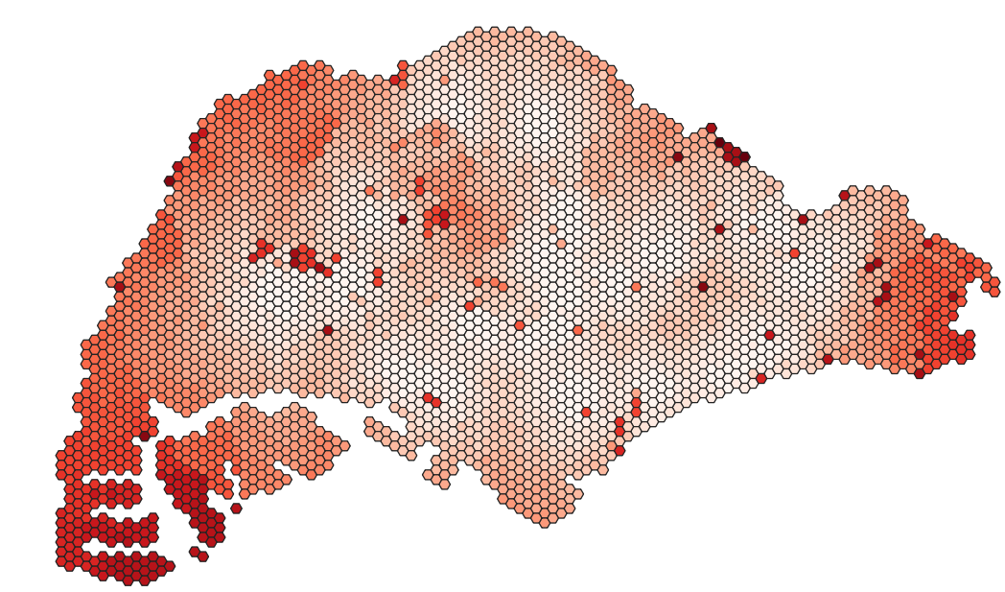

*Figure 51*



Repeat the steps in section 5.3 to create hexagonal choropleth maps for these layers:

* 2018
  + Primary schools
  + Secondary schools
  + Post-secondary schools
* 2019
  + Primary schools
  + Secondary Schools
  + Post-secondary schools
* 2024
  + Primary schools
  + Secondary schools

#### 7.3.3 Creating a changes map

As the changes over the years for some maps are barely visible, we will create a changes map which identifies the hexagons in the grids that have had changes to accessibility.

Duplicate one of the accessibility map layers (e.g. 2019 sec schs). Right click on the layer and click on ‘duplicate layer’.

Double click on the duplicated layer and open the ‘joins’ tab. Click the plus button at the bottom to create a new join layer. As we will be comparing the changes in secondary schools between 2018 and 2019, we will select the 2018 secondary school layer as the layer to be joined to. Ensure that the join and target field are both fid, as shown in Figure 52.

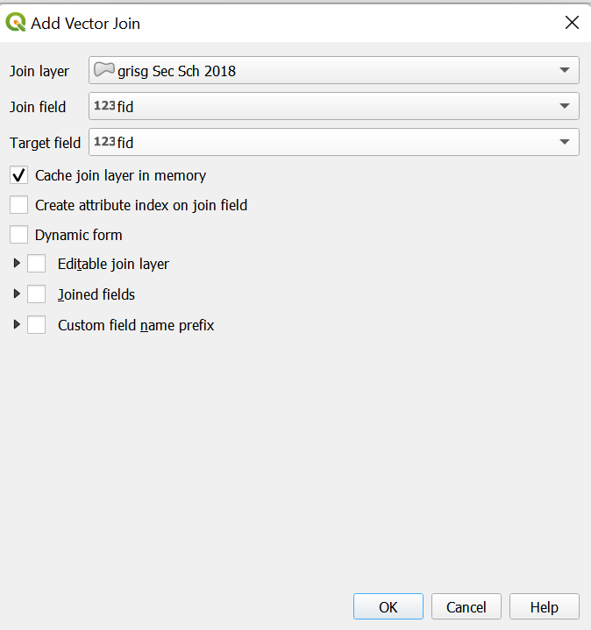

*Figure 52*

Click on OK. Close the dialog window and right click on the layer to open the attribute table.

Click on open field calculator  to create a new field

Create a new field called ‘differences’ as shown using the code in Figure 53. Select the output field type to be ‘Decimal number (real).



Click on ok. This value should be difference between the shortest distance between both years. This would show either a positive or negative change.

Save the changes by clicking on the edit button and closing the attribute table. Double click on the layer and open the symbology tab.

Change the Symbology to Graduated, and choose the newly created difference field for the value

Choose Natural Breaks (Jenks) as the mode and enter in 20 classes. Click classify

Choose Red Blues as the colour ramp. Your window should look like Figure 54.

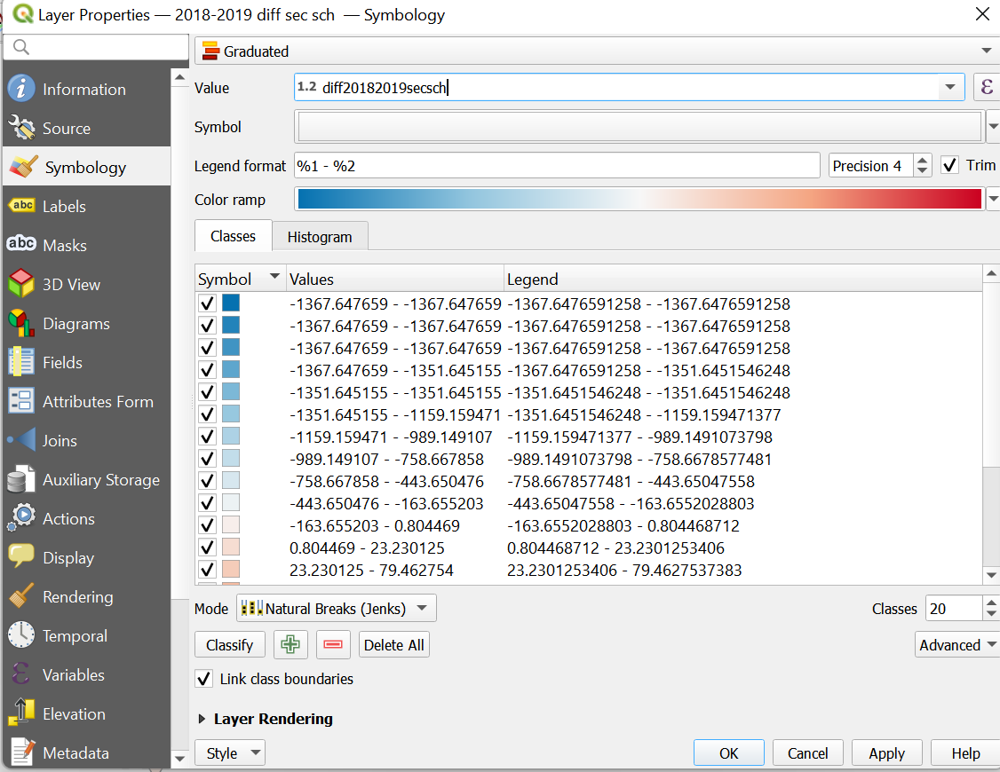

*Figure 54*

We will next edit the colour ramp to adjust the colours such that the interval where 0 is will be white.

Click on the colour ramp to open the window as shown in Figure 55. Drag the points around to make the value of 0 as close to the colour white as possible.

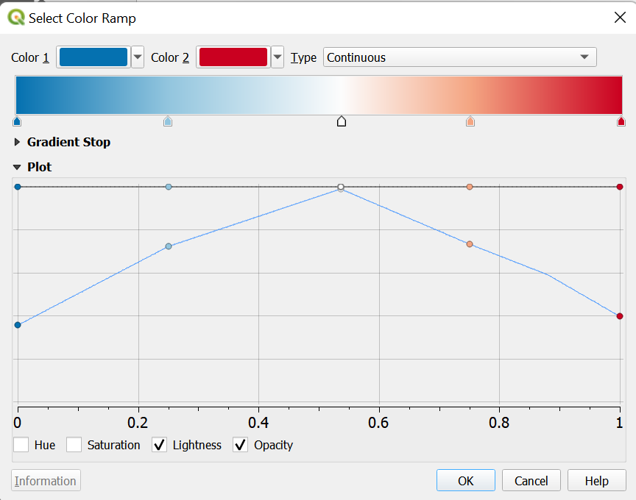

*Figure 55*

Click on ok. Add a class using the  button to make 0 white.

Move the 0 class right where the blues and reds meet

Edit the values above and below the new 0 class, as shown in Figure 56

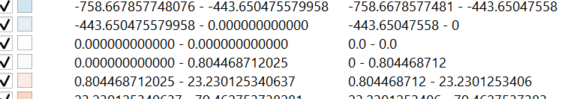

*Figure 56*

Ensure that the ramp is such that blue is for negative values and red is for positive values. Your resulting map should be similar to Figure 57.

*Figure 57*

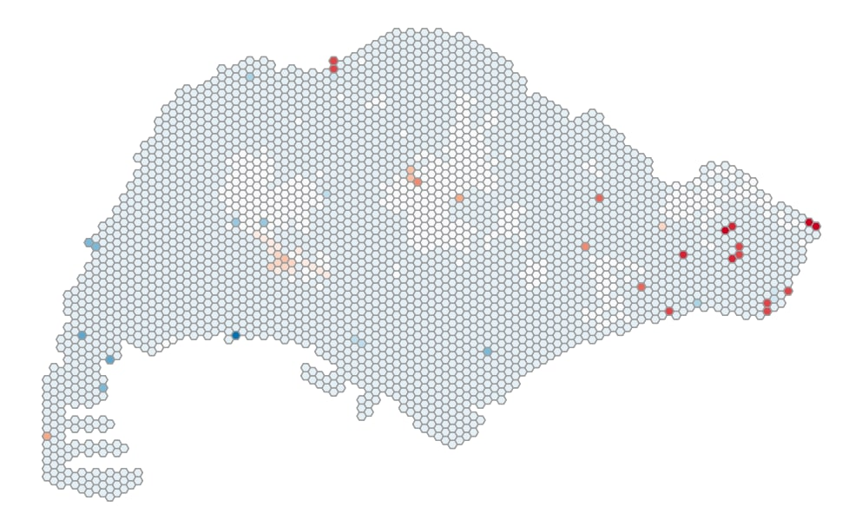

Repeat the steps to create a changes map for these years:

* Primary schools 2018-2019
* Primary schools 2019-2024
* Secondary schools 2018-2019
* Secondary schools 2019-2024
* Post-secondary schools 2018-2019

#### 7.3.4 Symbolization of schools

Next, we will be adding symbols to the different school layers to better differentiate them on our map. We will first be preparing the map which shows the location of all schools that have existed from 2018 to 2024. However, we will classify them in different colours, based on:

* Schools which have been merged in 2018
* Schools which have been merged in 2022-2024.

We will need these layers:

* Hexagonal grid of Singapore
* ‘Pri sch 2019 merged’
* ‘Pri sch 2022-2024 merged’
* Pri schs 2019

Import the hexagonal grid layer into QGIS. Double click on it and toggle to the symbology tab. Click on simple fill and select ‘simple marker’ instead. Change the colour to be #9c9c9c. Your window should look like Figure 58.

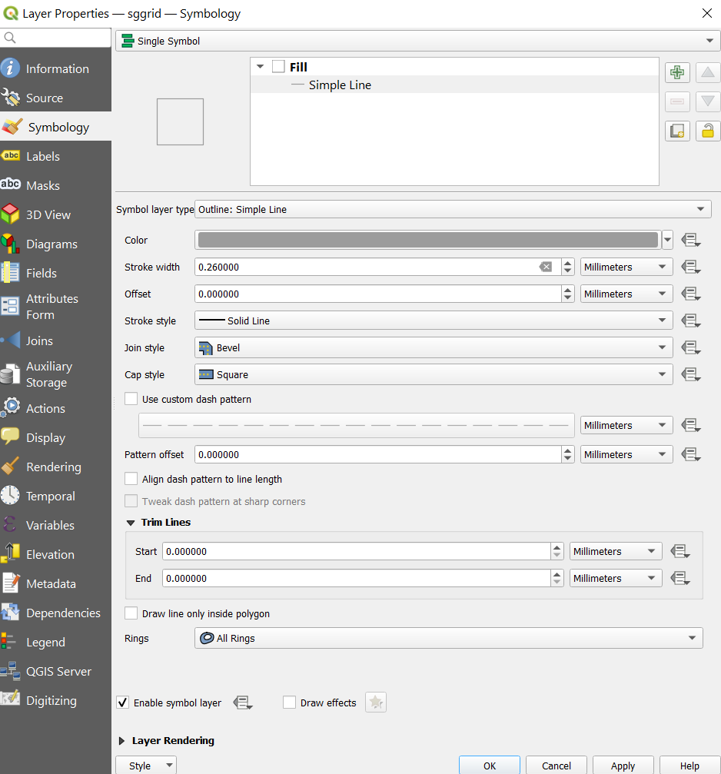

*Figure 58*

Click on ok. Your grid should look like Figure 59.

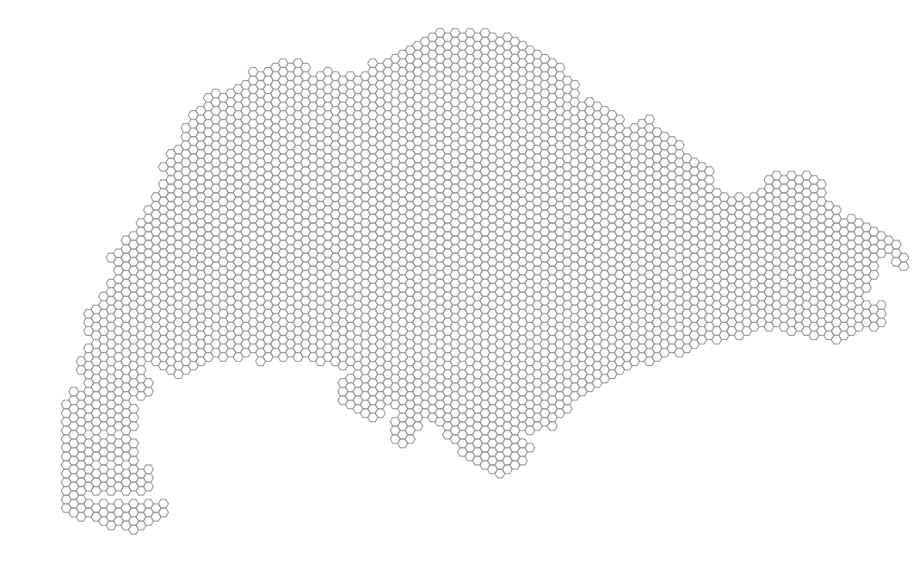

*Figure 59*

Next, open the ‘pri schs 2019’ layer. Double click on it and toggle to the symbology tab.

Click on simple fill and select ‘SVG marker’. Select the blackboard symbol  and set the icon size to be 3.0mm. Change the colour of the icon to #1a7623. Your window should look like Figure 60. Click on apply and close the window.

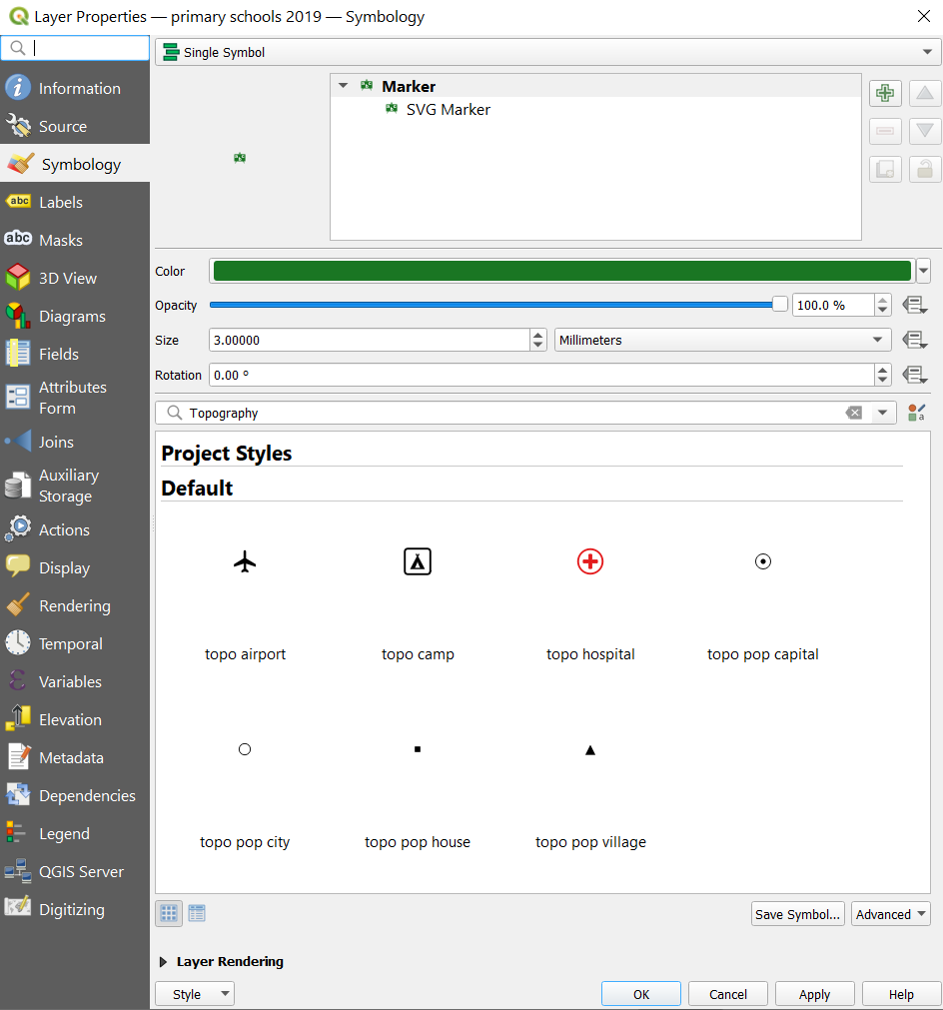

*Figure 60*

Next, open the ‘pri sch 2019 merged’ layer. Double click on it and toggle to the symbology tab. Click on simple fill and select ‘SVG marker’. Select the blackboard symbol  and set the icon size to be 3.0mm. Change the colour of the icon to #ff0501. Your window should look like Figure 61. Click on apply and close the window.

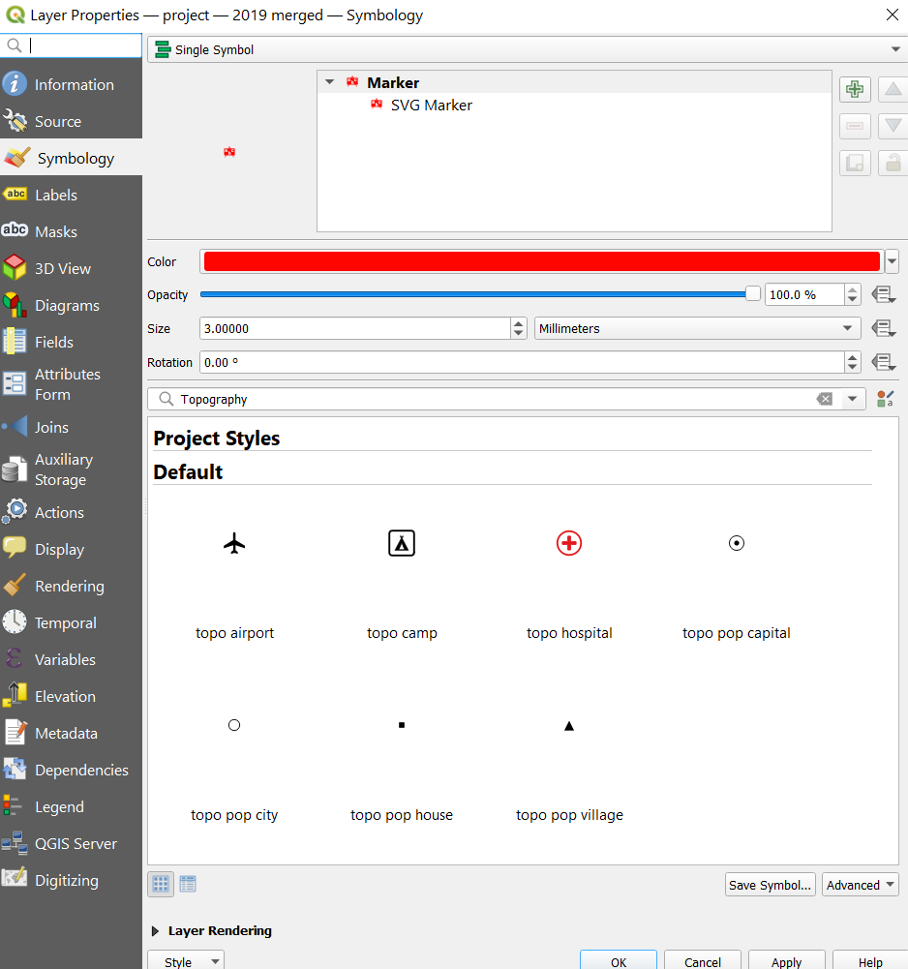

*Figure 61*

Lastly, open the ‘pri schs 2022-2024 merged’ layer. Double click on it and toggle to the symbology tab. Click on simple fill and select ‘SVG marker’. Select the blackboard symbol  and set the icon size to be 3.0mm. Change the colour of the icon to #ffc801. Your window should look like Figure 62. Click on apply and close the window.

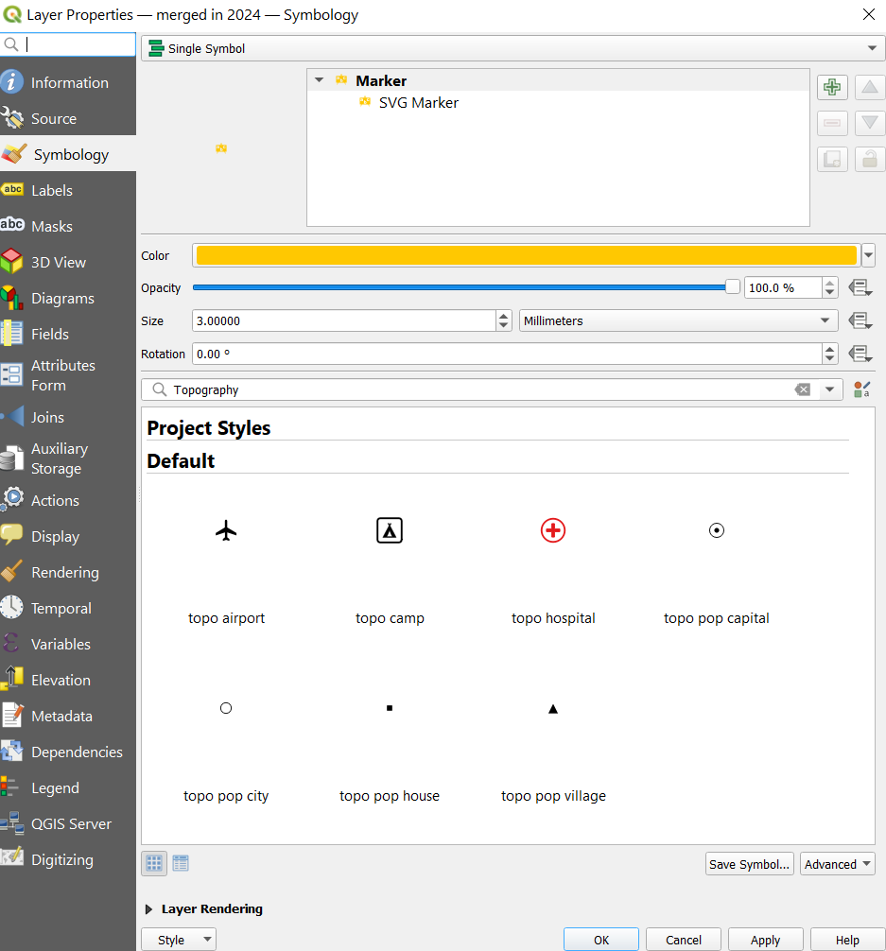

*Figure 62*

In order to see all layers and their respective colours, the layers should be arranged as shown in Figure 63 in the layers panel.

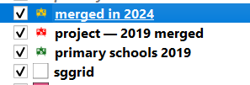

*Figure 63*

Your map should look like Figure 64.

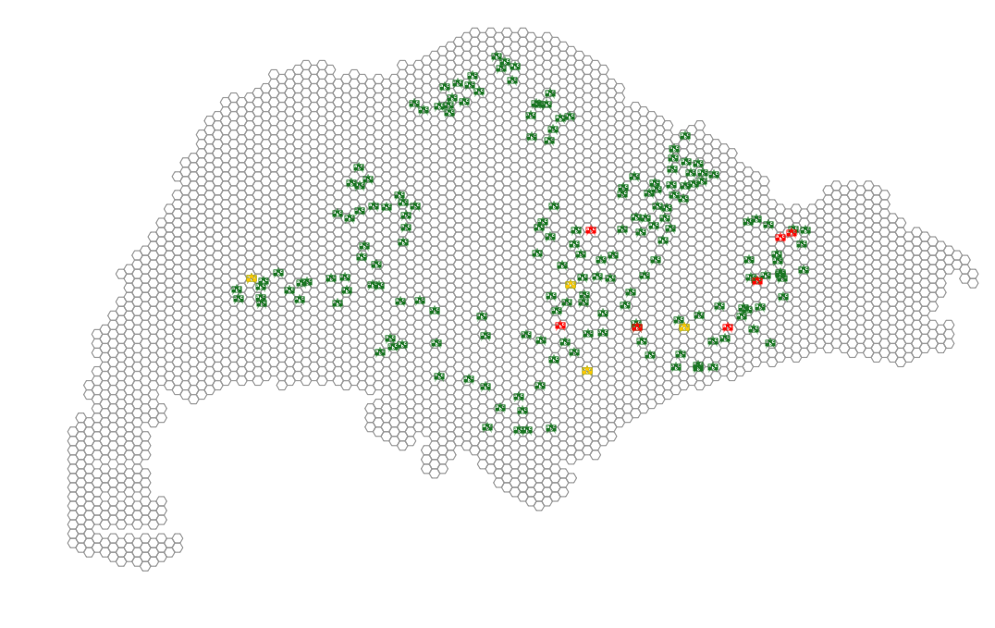

*Figure 64*

Repeat section 6.3.4 so as to represent:

* Primary schools 2018-2024 (already done)
* Secondary schools 2018-2024
* Post-secondary schools 2018-2019
  + *There were no mergers of post-secondary schools after the 2019 merger

## 7.4 Creating Printed Map Layouts

# **8 Additional:**

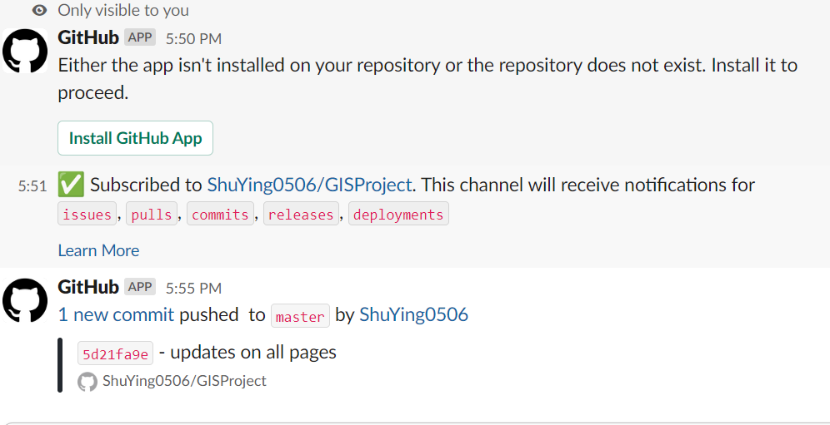

Slack is used as a platform to communicate and to observe new pushes to our github repository, we linked slack to github and we have frequent pushes on Github once to twice a week whenever we make any changes.